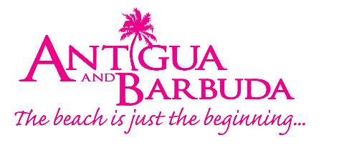

Canadian Win All-Inclusive Trip to Antigua & Barbuda in Inaugural Radio Contest

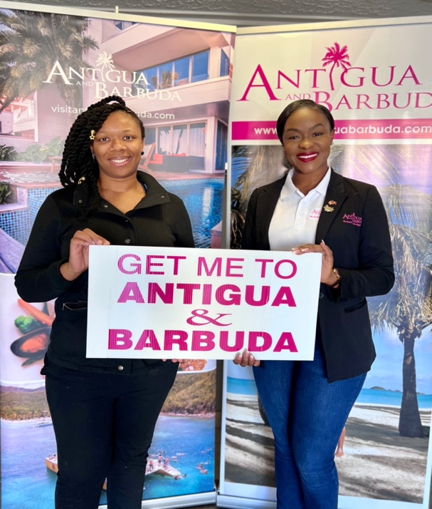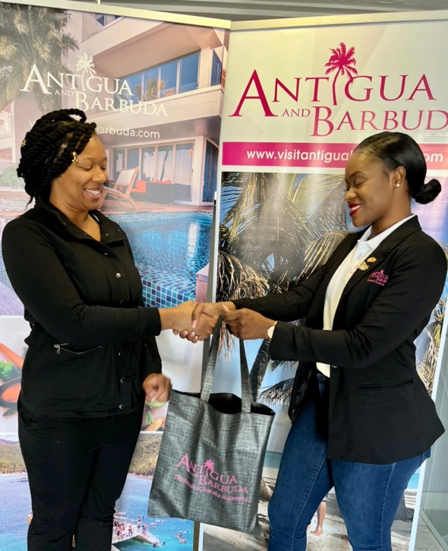
Photo Caption: Canadian radio contest winner, Kella Thompson with Ms. Raynel Carroll
Business Development Manager Antigua & Barbuda Tourism Authority – Canada .
(Photos courtesy, The Antigua, and Barbuda Tourism Authority)

(St. John’s Antigua) November 9, 2022- Canadian radio contest winner, Kella Thompson will soon be saying “goodbye” to the cold weather and “hello!” to a week of sunshine in Antigua & Barbuda after winning an all-inclusive stay at the Gallery Bay Resort and Spa. Thompson, who won a trip for two, was the randomly selected winner of the destination’s first-ever radio promotion, announced live on air through Zoomer Radio and The New Classical FM on October 31st.

“On behalf of Antigua & Barbuda, I want to extend the warmest congratulations to the winners,” said Tameka Wharton, Director of Tourism Ag. “We were pleased with the level of participation in the contest and thrilled to be able to bring Antigua & Barbuda to an expanded Canadian audience, and we look forward to welcoming the winner and her guest when they arrive.”

The contest was born from a collaboration between the Antigua & Barbuda Tourism Authority, Air Canada Rouge, Elite Island Resorts, and Zoomer Radio. It ran throughout October, directing Canadian listeners of Zoomer Radio and its affiliate New Classical FM to enter digitally for their chance to win a vacation package valued at $13,000 CAD. The contest reached over 2 million Canadian listeners through Zoomer Radio and nearly 1.5 million through Classical 96.3.

The promotion also saw the debut of all-new radio spots highlighting the many reasons to visit Antigua & Barbuda, including better-than-ever accessibility thanks to tri-weekly direct flights from Air Canada Rouge.

The winning duo will spend their week in paradise in one of Galley Bay’s Premium Beachfront suites, renowned for their generous amenities and direct proximity to a stunning beach. The intimate, adults-only resort offers luxurious accommodations, farm-to-table cuisine, and inspired wellness programs at the nexus between the blue sea and green tropical gardens. With airfare included by Air Canada Rouge, the winner will be free to focus on a week of rest and relaxation in the Caribbean sun.

###

ABOUT THE ANTIGUA AND BARBUDA TOURISM AUTHORITY
The Antigua & Barbuda Tourism Authority is a statutory body dedicated to realizing the tourism potential of Antigua & Barbuda by promoting the twin island state as a unique, quality tourist destination with the overall objective of increasing visitor arrivals thereby providing sustainable economic growth. The Antigua and Barbuda Tourism Authority is headquartered in St. John’s Antigua, where regional marketing is directed. The Authority has three offices overseas in the United Kingdom, United States and Canada.
ABOUT ANTIGUA AND BARBUDA
Antigua (pronounced An-tee'ga) and Barbuda (Bar-byew’da) is in the heart of the Caribbean Sea. The twin-island paradise offers visitors two uniquely distinct experiences, ideal temperatures year-round, a rich history, vibrant culture, exhilarating excursions, award-winning resorts, mouth-watering cuisine and 365 stunning pink and white-sand beaches - one for every day of the year. The largest of the English-speaking Leeward Islands, Antigua comprises 108-square miles with rich history and spectacular topography that provides a variety of popular sightseeing opportunities. Nelson’s Dockyard, the only remaining example of a Georgian fort a listed UNESCO World Heritage site, is perhaps the most renowned landmark. Antigua’s tourism events calendar includes the prestigious Antigua Sailing Week, Antigua Classic Yacht Regatta, and the annual Antigua Carnival; known as the Caribbean’s Greatest Summer Festival. Barbuda, Antigua’s smaller sister island, is the ultimate celebrity hideaway. The island lies 27 miles north-east of Antigua and is just a 15-minute plane ride away. Barbuda is known for its untouched 11-mile stretch of pink sand beach and as the home of the largest Frigate Bird Sanctuary in the Western Hemisphere. Find information on Antigua & Barbuda at: www.visitantiguabarbuda.com or follow us on Twitter: http://twitter.com/antiguabarbuda Facebook: www.facebook.com/antiguabarbuda; Instagram: www.instagram.com/AntiguaandBarbuda

For Antigua and Barbuda media enquiries, please contact:
Maria Blackman
Marketing Communications Manager
Antigua and Barbuda Tourism Authority
T: 1 (268) 562 7600/464-7601
E: maria.blackman@visitaandb.com

Antigua and Barbuda Images: aandbtourism.fotoseeker.com

