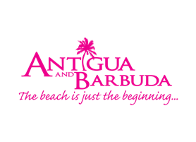

**ANTIGUA AND BARBUDA EMBRACES GREEN**

*Destination launches Green Corridor*

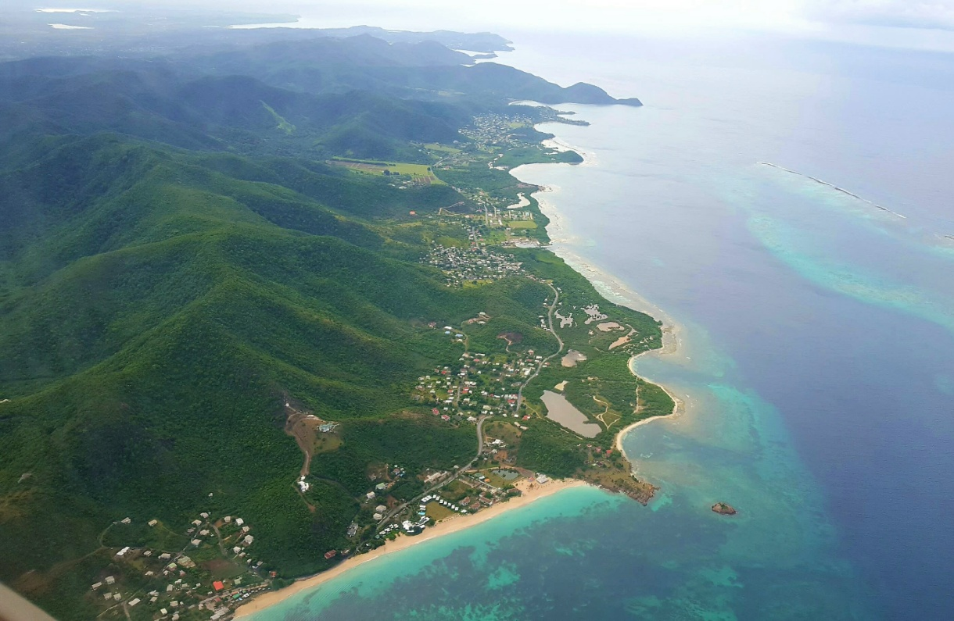

*Antigua and Barbuda’s Green Corridor stretches from*

*Sugar Ridge to the village of John Hughes*

In a destination known for 365 of the bluest blues with turquoise seas and azure skies, Antigua and Barbuda is highlighting another side of its gorgeous landscape on the south-west coastline; focusing on its lush green rainforest, rolling hills, environmentally aware hotels, restaurants and activities that surround the area now known as ‘The Green Corridor’.

Visitors are being encouraged to journey to Antigua and Barbuda to experience the Green Corridor, which stretches along the south-west coast from the village of Bolans to the village of John Hughes in Antigua.

Antigua and Barbuda’s Minister of Tourism, The Hon. Asot Michael said “One of the biggest trends in travel and tourism presently is the growth of the responsible traveller, and today’s traveller is aware of the impact that their travel could have on the environment and the people. They are opting to either stay close to home or travel to places where they can have a positive economic, social and environmental impact on the destination.”

The Green Corridor launched in July 2017, during the International Year of Sustainable Tourism. It is a designated area of Antigua where the businesses that are directly and indirectly related to tourism have agreed to a set of principles based on respect for local culture, positive influence on the local community, environmental stewardship and economic viability while maintaining all of these, are highlighted and promoted.

Senior Sustainable Tourism Officer and head of the Sustainable Tourism Unit in Antigua and Barbuda’s Ministry of Tourism, Vashti Ramsey-Casimir says, “The South side was chosen as it has the highest scenic value on island. It also has the highest concentration of locally owned and managed tourism businesses that are all making steps towards achieving the aforementioned principles.”

Visitors planning to experience the Green Corridor can expect excursions, restaurants and hotels that promote environmental stewardship, local economic benefits, social responsibility and cultural preservation.

Popular beach bars and restaurants such as Dennis’ Beach Bar & Restaurant, Darkwood Beach Bar & Restaurant, Jacqui O’s Love Beach, Turner’s Beach Bar and Restaurant and Cavell’s street side restaurant offer visitors a ‘Farm to Table’ experience within the Corridor. Cuisine is prepared using herbs and vegetables picked fresh from vegetable gardens on the properties or sourced at the local market.

One of the sweetest pineapples in the world, the Antigua Black pineapple is also grown in the area at the Cades Bay Agriculture Station’s Pineapple Farm. While the pineapple farm is visible from the main road, visitors wishing to explore the farm are asked to enquire at the station. The pineapples and other fresh fruits and vegetables can be found at fruit stalls along Fig Tree Drive which are overflowing with produce grown in the rainforest.

The dramatic and undulating landscape of the Green Corridor also presents a wonderful opportunity to take on many moderate to strenuous hiking trails. Popular hikes in the area include: Antigua and Barbuda’s highest peak *Mount Obama*, and the second highest *Signal Hill* with Wallings Dam at the base providing the perfect cool-down picnic spot. The adventurous and more skilled hiker may also explore the *Rendezvous Bay* hike with multiple trails to one of the island’s untouched beaches, and scenic views of the Caribbean Sea, Montserrat, Guadeloupe and Redonda which are all visible on a clear day.

Green Corridor visitors can also visit the Wallings Nature Reserve operated by villagers in the John Hughes community. Participants receive historic information on the location, and are able to book scenic hikes through Wallings. (www.facebook.com/naturereserveantigua)

And in Turtle-watching season which runs from July – September, the Darkwood beach becomes a turtle-watching spot, with visitors welcomed at beach bars to search for nesting turtles or to witness turtles hatching under the moonlight.

Antigua’s sister island Barbuda is also heading in the green direction. Already labeled as a nature lover’s paradise, Barbuda is filled with experiences that are sure to appeal to eco-aware travellers. One of the few Caribbean islands with pink sand beaches, Barbuda boasts a spectacular 17 mile stretch of pristine, unbroken beach.

The island is also home to the largest Frigate Bird sanctuary in the western hemisphere. Accessible only by boat, the Frigate Bird Sanctuary contains over 170 species of birds in addition to the more than 5,000 Frigate birds that call Barbuda their home.　 Barbuda’s caves, to include the *Darby Cave*, *Indian Cave* and the *Caves at Two Foot Bay* are also worth exploring. And, visitors on a hike through *Indian Cave* will discover ancient Amerindian petroglyphs.

So, while the islands are best known for their 365 fine white and pink sandy beaches, friendly people and year-round sunshine with the demand by travelers for more eco-friendly and authentic experiences, Antigua and Barbuda’s natural environment answers the call.

###

**ABOUT ANTIGUA AND BARBUDA**

Antigua (pronounced An-tee'ga) and Barbuda (Bar-byew’da) is located in the heart of the Caribbean Sea. Voted the World Travel Awards 2015, 2016 and 2017 *Caribbean’s Most Romantic Destination*, the twin-island paradise offers visitors two uniquely distinct experiences, ideal temperatures year-round, a rich history, vibrant culture, exhilarating excursions, award-winning resorts, mouth-watering cuisine and 365 stunning pink and white-sand beaches - one for every day of the year. The largest of the Leeward Islands, Antigua comprises 108-square miles with rich history and spectacular topography that provides a variety of popular sightseeing opportunities. Nelson’s Dockyard, the only remaining example of a Georgian fort a listed UNESCO World Heritage site, is perhaps the most renowned landmark. Antigua’s tourism events calendar includes the prestigious Antigua Sailing Week, Antigua Classic Yacht Regatta, and the annual Antigua Carnival; known as the Caribbean’s Greatest Summer Festival. Barbuda, Antigua’s smaller sister island, is the ultimate celebrity hideaway. The island lies 27 miles north-east of Antigua and is just a 15-minute plane ride away. Barbuda is known for its untouched 17 mile stretch of pink sand beach and as the home of the largest Frigate Bird Sanctuary in the Western Hemisphere. Find information on Antigua & Barbuda at: [www.visitantiguabarbuda.com](http://www.visitantiguabarbuda.com) or follow us on **Twitter**. <http://twitter.com/antiguabarbuda> **Facebook** [www.facebook.com/antiguabarbuda](http://www.facebook.com/antiguabarbuda); **Instagram**: [www.instagram.com/AntiguaandBarbuda](http://www.instagram.com/AntiguaandBarbuda)

**MEDIA CONTACT:**

**Maria Blackman**

**Marketing Communications|**

**Antigua & Barbuda Tourism Authority – HEAD OFFICE |**  
3rd Floor  | ACB Building | Corner of High and Temple Sts.| St. John’s Antigua  
: **Office** +1 268 562 7600  **(Direct Line)**:  +1 268 464 7601

[visitantiguabarbuda](http://www.visitantiguabarbuda.com/) or join us on www.facebook.com/antiguabarbuda