FOR IMMEDIATE RELEASE :

ANTIGUA AND BARBUDA LIFTS TRAVEL-TESTING REQUIREMENT
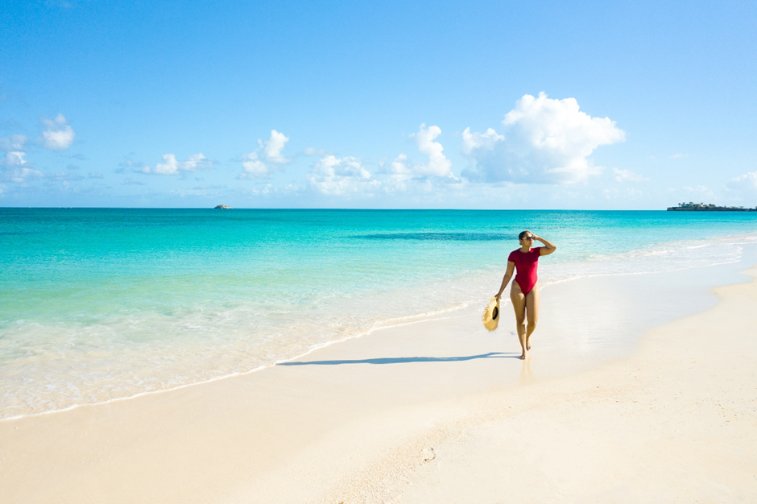
Photo caption: As travel testing requirements are removed for fully vaccinated travellers to Antigua and Barbuda, visitors are now able to travel with ease to the twin-island nation . (Photo courtesy: The Antigua and Barbuda Tourism Authority)

ST. JOHN’S, ANTIGUA (March 16, 2022) – The Caribbean twin-island nation of Antigua and Barbuda has as of March 16, 2022, lifted the travel testing requirement for fully vaccinated visitors to the destination.
Antigua and Barbuda’s Minister of Tourism and Investment, The Honourable Charles Fernandez said, “Our aim is to continue to ensure travellers have a safe vacation in Antigua and Barbuda, in adherence with the covid-19 protocols created by the Government to responsibly manage the various stages of the pandemic and maintain the health and safety of the population.”
CEO of the Antigua and Barbuda Tourism Authority said, “The announcement of the removal of the travel testing requirement, will reduce travel costs and prove to be a compelling enough incentive for fully vaccinated visitors to book travel to the destination. It is a development that will make a positive impact on our tourism rebound, and most importantly to the persons who are employed within the industry.”
Antigua and Barbuda’s latest travel advisory as outlined by the Government of Antigua and Barbuda includes:
1. Fully vaccinated arriving passengers are not required to present a PCR/Rapid Antigen Test negative result to be permitted entry into Antigua and Barbuda, (unless they show symptoms of possible infection). This includes transiting passengers.

2. Fully vaccinated passengers showing symptoms of possible infection may be required to submit to a RT PCR test for SARS-CoV-2 upon arrival at their own expense. Instructions on permissible activities while awaiting results will be provided by Port Health officials.
3. Partially/unvaccinated British citizens en route to, and partially/unvaccinated residents of, Montserrat are permitted to land in Antigua and Barbuda and transit via aeroplane from V.C. Bird International Airport to Montserrat. Such passengers will not be permitted to leave the airport prior to departure.
4. Unvaccinated minors between the ages of five and eighteen years old must present a negative RT PCR test of four days or fewer from date of testing.
5. Children below the age of five (5) years entering Antigua and Barbuda, DO NOT REQUIRE a COVID -19 RT-PCR test.
6. The wearing of face masks in public spaces is actively encouraged throughout Antigua and Barbuda and social/physical distancing protocols should still be adhered to. Therefore, all passengers arriving in Antigua and Barbuda are encouraged to wear face masks wherever there are gatherings of significant numbers of people e.g., ports, supermarkets, bars and clubs.

Antigua and Barbuda is fully open, and visitors to the destination can expect to enjoy a range of excursions, attractions and dining experiences, to include newly opened restaurants and tours. Beaches are open and all curfew restrictions have been removed.
For the March 16, 2022 updated travel advisory go to www.visitantiguabarbuda.com
###

NOTE TO EDITORS:

For Antigua and Barbuda media enquiries, please contact:
Maria Blackman
Marketing Communications Manager
Antigua and Barbuda Tourism Authority
T: 1 (268) 562 7600/464-7601
E: maria.blackman@visitaandb.com

Antigua and Barbuda Images: aandbtourism.fotoseeker.com

ABOUT THE ANTIGUA AND BARBUDA TOURISM AUTHORITY
The Antigua & Barbuda Tourism Authority is a statutory body dedicated to realizing the tourism potential of Antigua & Barbuda by promoting the twin island state as a unique, quality tourist destination with the overall objective of increasing visitor arrivals thereby providing sustainable economic growth. The Antigua and Barbuda Tourism Authority is headquartered in St. John’s Antigua, where regional marketing is directed. The Authority has three offices overseas in the United Kingdom, United States and Canada.

ABOUT ANTIGUA AND BARBUDA
Antigua (pronounced An-tee'ga) and Barbuda (Bar-byew’da) is located in the heart of the Caribbean Sea. The twin-island paradise offers visitors two uniquely distinct experiences, ideal temperatures year-round, a rich history, vibrant culture, exhilarating excursions, award-winning resorts, mouth-watering cuisine and 365 stunning pink and white-sand beaches - one for every day of the year. The largest of the English-speaking Leeward Islands, Antigua comprises 108-square miles with rich history and spectacular topography that provides a variety of popular sightseeing opportunities. Nelson’s Dockyard, the only remaining example of a Georgian fort a listed UNESCO World Heritage site, is perhaps the most renowned landmark. Antigua’s tourism events calendar includes the prestigious Antigua Sailing Week, Antigua Classic Yacht Regatta, and the annual Antigua Carnival; known as the Caribbean’s Greatest Summer Festival. Barbuda, Antigua’s smaller sister island, is the ultimate celebrity hideaway. The island lies 27 miles north-east of Antigua and is just a 15-minute plane ride away. Barbuda is known for its untouched 11-mile stretch of pink sand beach and as the home of the largest Frigate Bird Sanctuary in the Western Hemisphere. Find information on Antigua & Barbuda at: www.visitantiguabarbuda.com or follow us on Twitter: http://twitter.com/antiguabarbuda Facebook: www.facebook.com/antiguabarbuda; Instagram: www.instagram.com/AntiguaandBarbuda

