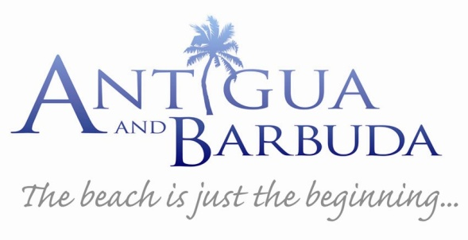
ANTIGUA & BARBUDA FACT sheet

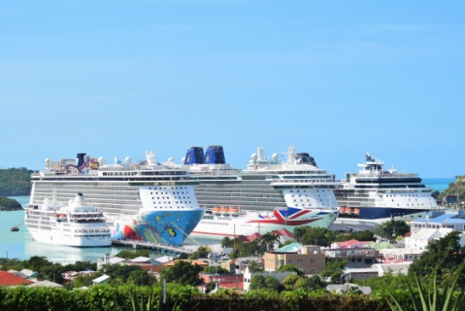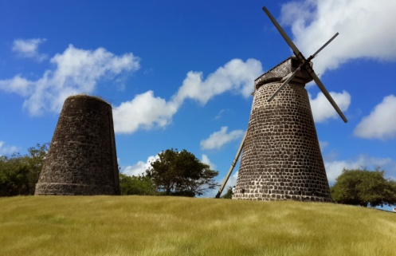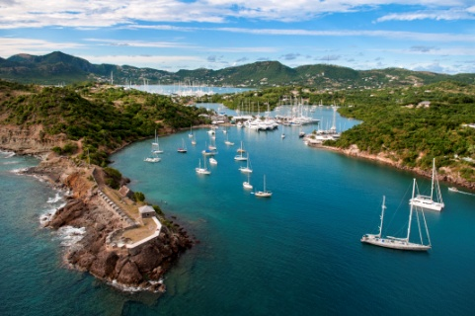

Location Antigua (An-tee'ga) located in the North Eastern Caribbean is a 108-square-mile island recognized for its collection of 365 white sandy beaches. The sister island of Barbuda (Bar-byew’ da) lies 27 miles north of Antigua with a land area of 62 square miles.

Capital The capital of Antigua is St. John’s with two distinctive waterfront areas and a selection of shops and restaurants.

Climate Sunny and warm year-round with soothing trade winds.

Language English is the spoken language.

Transportation Renting a car is an ideal way to discover more of Antigua. A valid driver's license and an EC$50 fee are required to obtain a permit to drive in Antigua. Taxis are also available throughout the destination. Fares between the airport, harbour, and many hotels and destinations are fixed and can be obtained upon arrival. While there is an easily accessible public bus transportation service, the most popular mode of transportation is by car or taxi.

Sights From the capital city of St. John’s, the 108 square miles of Antigua can be easily explored. With its relatively flat landscape, the island’s 365 picturesque beaches, attractions and activities are no further than a 45-minute taxi ride.

Nelson’s Dockyard, English Harbour featured on UNESCO’s tentative listing as a World Heritage Site is the only remaining example of a Georgian fort, and perhaps the most renowned landmark in Antigua. The Dockyard houses a museum, bakery and gift shop, while the surrounding area of English Harbour is filled with a variety of quaint restaurants, lively bars and marinas.

Dow’s Hill Interpretation Centre provides a historic overview of six periods of Antiguan history through a multimedia presentation.

Shirley Heights Lookout offers visitors a panoramic view of Nelson’s Dockyard, one of Antigua’s iconic images.

The Bust of Sir VC Bird Senior, Antigua and Barbuda’s first Premier and Prime Minister, is displayed within the area of the St. John’s Market.

St. John’s Anglican Cathedral, visible from around the capital, is regarded as one of Antigua’s national monuments.

The Museum of Antigua and Barbuda, housed in the old St. John’s Court House, provides a wealth of information and insight into the history of Antigua and Barbuda.

Betty’s Hope is the site of one of the first full-scale sugar plantations on Antigua, and offers a chance to step back in time by visiting the only twin restored sugar mills on the island.

Fig Tree Drive is where sightseers can explore the lush vegetation of the rainforest, and sample fresh fruit including the Antigua Black Pineapple at fruit stalls on the journey.

Devil’s Bridge is located at the eastern tip of the island in Indian Town National Park, where Atlantic breakers have carved out a natural limestone arch.

Beaches All beaches are open to the public. Popular spots along the west coast of the island include Fort James, Beach, Dickenson Bay, Galley Bay, Ffryes Beach, Darkwood Beach, Turners Beach and Morris Bay. The shoreline along the east side of the island
includes Half Moon Bay and Long Bay.

Accommodations In keeping with its reputation as a top tourist destination, Antigua offers a wide range of accommodations in hotels and private houses. Hotel options range from charming bungalows to five-star resorts and a choice of luxurious villas are guaranteed to provide the perfect haven for an idyllic vacation. There are also real estate agencies in Antigua, which help customers find rental houses or apartments, as well as seasonal vacation rentals.

Among some of the hotels and resorts on the island are:

Jumby Bay
Jumby Bay Island

Hermitage Bay
Jennings New Extension, Saint Mary’s

Pineapple Beach Club
Long Bay, St. Phillip’s, Willikies

Curtain Bluff
Old Road, Saint Mary’s

Carlisle Bay
Old Road, Saint Mary’s

Galley Bay Resort
Gray’s Farm Main Road, Five Islands Village

St James’s Club & Villas
Mamora Bay

Sugar Ridge
Jolly Harbour

The Verandah Resort & Spa
Indian Town Road, Saint Phillips

Dining Antigua’s diverse culinary scene is on display at award-winning restaurants with menus consisting of native dishes featuring French, Italian, Creole, Caribbean and International cuisine. Local seafood specialties include spiny lobster, fish, and conch. Innovative chefs can be found at more than 60 restaurants across the island.

Some of Antigua’s restaurants include:

Carmichael’s Restaurant
Sugar Ridge, Tottenham Park, Bolans, St Mary’s

Sheer Rocks Restaurant
Coco Bay Resort, Valley Church

Al Portos Restaurant
Jolly Harbour

Dennis’s Cocktail Bar & Restaurant
Little Ffryes & Ffryes Bay

Turners Beach Restaurant
Johnson’s Point

OJ’s Bar & Restaurant
Crabbe Hill

Jacqui Os Beach House
Crabbe Hill

The Larder
Royal Palms Place, Friar’s Hill Road, St. John’s

C&C Wine Bar
Redcliffe Quay

Papa Zouk Fish n’ Rum
Hilda Davis Drive

Ana’s on the Beach
Dickenson Bay

Le Bistro French Restaurant
Hodges Bay, St. John’s

The Bay @Nonsuch
Hughes Point, Freetown

Shopping Two charming shopping areas of Antigua are located in downtown St. John’s close to the waterfront at Heritage Quay and Redcliffe Quay. Duty-free shopping is available in the Heritage Quay, where purchasers need only show their valid departure details to purchase duty-free items from internationally recognized brands. The nearby Vendors Mall offers a selection of local arts and crafts, straw goods, pottery and jewelry, while the boutiques at the historic Redcliffe Quay provides artisan products, trendy wine bars and cafes. Most shops are open Monday through Saturday from 9 a.m. to 5 p.m.

Activities A variety of land and sea activities await the adventure-seeker. Water sports abound from sailing, boat cruising, day trips to Barbuda, scuba diving, swimming with stingrays and snorkeling. The island also offers the unforgettable Antigua Rainforest Canopy Tour, a high wire course through the verdant forest. For land lovers, an 18-hole golf course is accessible and open to the public. In addition, Antigua offers other popular recreational activities such as horseback riding, helicopter tours, hiking and biking.

Entertainment Entertainment hubs in Antigua can be found in St. John’s City and along stretches of Dickenson Bay, Jolly Harbour and English Harbour. A relaxed nightlife includes entertainment by steel bands, calypsonians, jazz groups, limbo dancing and moonlit cruises at most major hotels and restaurants. Several nightclubs operate on the island, while there are two cinemas and two major casinos. Guests can enjoy weekly ‘Seafood Fridays’ while on Sunday evening visitors to the Shirley Heights Lookout Point in English Harbour can enjoy steelpan and live band music at the longest running party in the Caribbean, the Shirley Heights Sunset Party and BBQ.

Currency The unit of currency is the Eastern Caribbean dollar (EC$) although U.S. dollars are widely accepted on the island. Traveller’s checks and major credit cards are accepted and ATM’s are available around the island. The exchange rate is USD$1 = EC$2.70. Most Banks are open from 8 a.m. – 2 p.m. Monday through Thursday, and until 4 p.m. on Fridays.

Taxes An 12.5 percent government tax is added to all hotel rates. Most hotels and restaurants also add a 10 percent service charge in lieu of tipping. There is no departure tax payable for Antigua & Barbuda.

Tipping Usually 10-15 percent depending on the level of service, while some restaurants and hotels will automatically add a 10 percent gratuity. If in doubt, just ask. Porters and bellboys should receive US$1 per bag and taxi drivers expect 10-15 percent of the fare.

Medical Facilities Medical services are provided by the Mount St. John Medical Centre, Tel: +1 268.484.2700, as well as several general practitioners and specialists on the island operating privately. There are also community clinics and a private clinic.

For more information on Antigua and Barbuda, please visit www.visitantiguabarbuda.com or contact The Antigua and Barbuda Tourism Authority at +1 268.562.7600 or by email at maria.blackman@visitaandb.com

