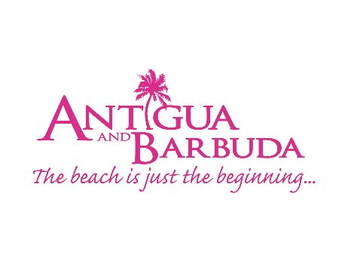
FOR IMMEDIATE RELEASE:

EXPRESS YOURSELF
Antigua and Barbuda Art and Creativity Connects
Global Agents and Travel Media
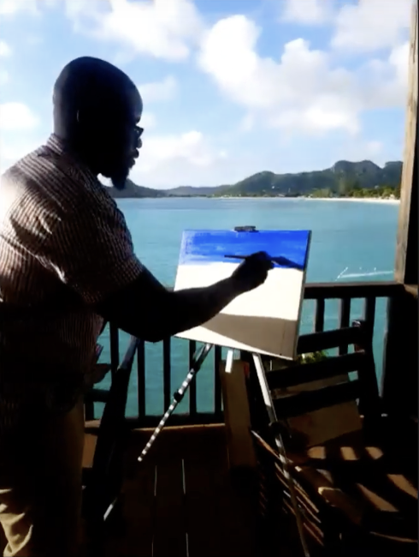
(Photo Caption: The Antigua and Barbuda Tourism Authority and artist Glenroy Aarron use art to connect Canadian travel agents and media to Antigua and Barbuda and inspire travel)
(St. John’s Antigua) September 9, 2020: The Antigua and Barbuda Tourism Authority partnered with one of Antigua and Barbuda’s leading artists for a night of creativity and passion to inspire agents across the globe. With travel restrictions still in place, last week the Tourism Authority virtually connected with 35 industry professionals in Canada through the inspiring medium of art to bring agents and travel media a flash of colour from the vibrant twin-island nation.

Glenroy Aaron, one of the country’s most loved artists, utilised the breath-taking backdrop of COCOS Hotel for his creative vision and took agents and media through a journey of performative art and creativity. Maximising the recently launched Space Travel campaign and capturing the island of Antigua with creative flair, Glenroy demonstrated the space for creativity, inspiration and passion that can be found through the idyllic Caribbean island.

With Antigua and Barbuda’s 365 beaches and amazing rainforests in mind, the Space Travel concept speaks to people’s newfound desire of space and freedom to move and explore after months of being trapped indoors and restricted access to the outside world. The campaign shows Antigua and Barbuda has the perfect antidote to the months of lockdown and invites people to broaden their horizons and enjoy all the space they need. With the new mind-set of the post COVID-19 traveller in mind, the campaign showcases the island as a hub of creativity and inspiration to reset and rejuvenate the minds of travellers.

“Following months of lockdown and restricted travel, we want to inspire travellers to pick a holiday destination that offers space for creativity, innovation and passion,” stated Colin James, CEO of the Antigua and Barbuda Tourism Authority. “We launched this campaign with the view to reach people from a variety of platforms and to utilise the bounty of talent and creativity that can be found here on this island, whether that’s through the medium of art, cooking or showcasing our culture and adventures. Highlighting our bountiful space and all the amazing things you can do in it, will hopefully inspire people to confidently and safely explore the wonder and beauty of our destination”.

For more information on travel to Antigua and Barbuda go to: www.visitantiguabarbuda.com.

ENDS

FOR EDITORS:
IMAGESARE AVAILABLE: https://www.dropbox.com/sh/qhsg0y1n151blbd/AAAfhVN5y-2SA43vUS4v2GnOa?dl=0

ABOUT ANTIGUA AND BARBUDA
Antigua (pronounced An-tee'ga) and Barbuda (Bar-byew’da) is located in the heart of the Caribbean Sea. Voted the World Travel Awards 2015, 2016, 2017 and 2018 Caribbean’s Most Romantic Destination, the twin-island paradise offers visitors two uniquely distinct experiences, ideal temperatures year-round, a rich history, vibrant culture, exhilarating excursions, award-winning resorts, mouth-watering cuisine and 365 stunning pink and white-sand beaches - one for every day of the year. The largest of the Leeward Islands, Antigua comprises 108-square miles with rich history and spectacular topography that provides a variety of popular sightseeing opportunities. Nelson’s Dockyard, the only remaining example of a Georgian fort a listed UNESCO World Heritage site, is perhaps the most renowned landmark. Antigua’s tourism events calendar includes the prestigious Antigua Sailing Week, Antigua Classic Yacht Regatta, and the annual Antigua Carnival; known as the Caribbean’s Greatest Summer Festival. Barbuda, Antigua’s smaller sister island, is the ultimate celebrity hideaway. The island lies 27 miles north-east of Antigua and is just a 15-minute plane ride away. Barbuda is known for its untouched 17 mile stretch of pink sand beach and as the home of the largest Frigate Bird Sanctuary in the Western Hemisphere.

Find information on Antigua & Barbuda at: www.visitantiguabarbuda.com
Or follow us on:
Twitter. http://twitter.com/antiguabarbuda
Facebook www.facebook.com/antiguabarbuda
Instagram: www.instagram.com/AntiguaandBarbuda

ABOUT COCOS HOTEL ANTIGUA
Perched on a lush green hillside, encircled by miles of heavenly turquoise sea and sandwiched between two gorgeous white sand beaches is COCOS Hotel, an all-inclusive Antigua resort for couples and adults only. This rustic yet luxurious boutique resort is located on the sunset side of the beautiful Caribbean Island of Antigua and comprises of a collection of 35 quaint wooden Cottages positioned on a picturesque ocean bluff. All Cottages boast large private balconies with hammocks, Adirondack chairs and breath taking sea vistas. Avant-garde private outdoor showers with a view, air conditioning and free WIFI are also included. Some cottages even come with your own private cliff-side infinity pool. A quiet and intimate resort, COCOS is ideal for couples and honeymooners seeking a romantic getaway in a peaceful sanctuary away from the stresses of a hectic Metropolitan life.
Find information on COCOS Hotel Antigua at www.cocoshotel.com and follow us on Twitter https://twitter.com/cocos_hotel; Facebook https:/m.facebook.com/COCOSHotelAnu/ and Instagram https://www.instagram.com/cocoshotelantigua/
For reservations contact email Reservations@cocoshotel.com and telephone 1 268 562 3444

