FOR IMMEDIATE RELEASE
ANTIGUA AND BARBUDA’S WEST INDIAN WHISTLING DUCK IS ENDANGERED
Tourism Board and Frontier Airlines create sweepstakes to raise awareness
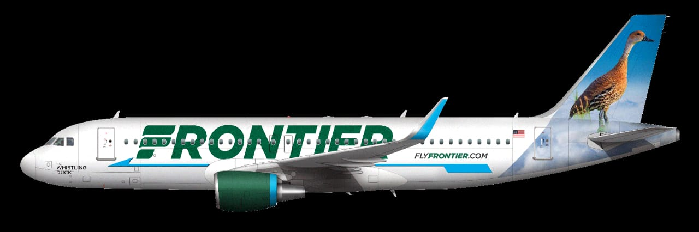

(ANTIGUA & BARBUDA, February 2, 2022) – As 2021 ended, Frontier Airlines, an American carrier headquartered in Colorado, launched service to Antigua and Barbuda with flights on Saturday out of Orlando, Florida that began on December 6.
Frontier’s expansion into 17 Caribbean islands was welcome news. With a commitment to growth, Frontier’s message to consumers is, “the Caribbean has never been easier to get to, as we continue to be able to deliver on our promise of, low fares done right”.
Building on their pledge to the region, Frontier has now launched a competition to brand the tail of their next plane with one of the native and endangered species in the destinations they serve. In a statement to launch the initiative Frontier announced, “By voting to select the species that will be emblazoned on our next plane tail, you are not only entering to win a dream vacation, but you are helping bring awareness to the native, and endangered species in these destinations as well”. Antigua and Barbuda’s, West Indian Whistling-Duck has been selected as one of the finalists in the competition.
In sharing that news, Dean Fenton, Director of Tourism for the Antigua and Barbuda Tourism Authority in the USA said, “The launch of the new service out of the Orlando airport is indicative of the confidence Frontier Airlines has in Antigua and Barbuda. Having the West Indian Whistling-Duck selected to brand the tail of their next plane would not only be an honor, but it will also bring the needed attention to one of the rarest ducks in the Americas”. Fenton continued, “I encourage everyone to vote for Antigua and Barbuda’s West Indian Whistling-Duck. Additionally, contestants that select the West Indian Whistling-Duck are automatically entered into a sweepstake to win a 7-night dream vacation for two in Antigua and Barbuda”.
Voting began and ends on Feb 14, 2022, at 11:59pm Mountain Time and takes place via the URL https://1.shortstack.com/1zRmmg?utm_source=referral&utm_medium=AntiguaandBarbudaTourismAuthority&utm_campaign=AntiguaandBarbudaTourismAuthority_tropical_tails

-more-
About Antigua and Barbuda:
The tropical islands of Antigua and Barbuda are located in the heart of the Caribbean about a thousand miles to the east of Jamaica and half that distance from Trinidad on the coast of South America. They are at 17- N latitude, about the same as the Cape Verde Islands and Bombay and 61- W longitude. The island of Antigua was born out of the sea by a volcano about 30 million years ago. A young island in geologic time. On the northern flank of this volcano, reefs were formed, hence the greater part of Antigua is low lying and is composed of limestone rock. Barbuda became separated from Antigua by about 28 miles, when the sea-levels of the world rose considerably at about 10,000 BC. Today parts of Barbuda are geologically flooded to form interesting lagoons.

