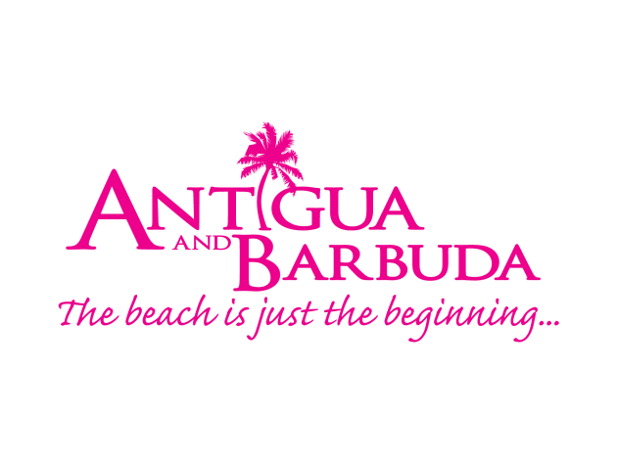

FOR IMMEDIATE RELEASE:

ANTIGUA AND BARBUDA #WHATCOOLOOKSLIKE SUMMER CAMPAIGN CULMINATES WITH HUNDREDS OF MILLENNIAL TRAVELLERS VISITING ANTIGUA
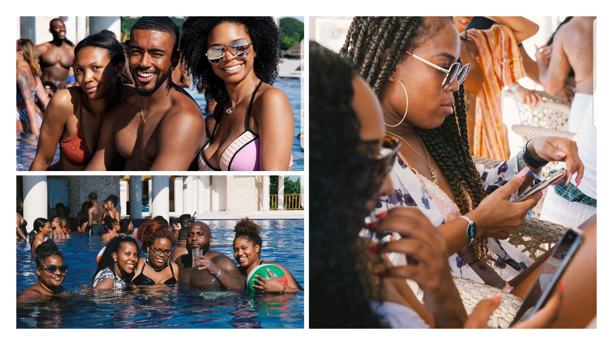
A group of five hundred millennial travellers are currently enjoying Antigua during a trip organized by Collin Devon Events in partnership with the Antigua and Barbuda Tourism Authority. The group is staying at Royalton, and are spending the week exploring Antigua, partying and participating in community development activities. (Photo Credits: Jarrod Anderson (@CreatedbyJarrod) of CDE: ANTIGUA.)

St. John’s, Antigua (Monday, October 28, 2019) – While the Antigua and Barbuda Tourism Authority’s highly engaging #WhatCoolLooksLike summer marketing campaign wraps up on October 31, the tourism marketing office is still enticing audiences to experience Antigua and Barbuda’s cool vibes. This time, through the eyes of five hundred millennials from the United States, who have travelled to Antigua for ‘CDE: Antigua’ hosted by Collin Devon Events.
Over the last two years, the Antigua and Barbuda Tourism Authority has partnered with ‘Collin Devon Events (CDE) Antigua’, to build their Antigua getaway event, and by extension attract the millennial visitors to Antigua and Barbuda during the summer months.
CEO of the Antigua and Barbuda Tourism Authority, Colin C. James said: “This millennial group is making a huge impact on our tourism figures, as they are visiting during what is usually a quiet time in the country, when stayover visitor numbers are in need of a boost. Restaurants, excursion providers, taxi operators and event planners are also benefiting from the extra business being generated by the group’s visit.”
James noted that through the partnership with CDE, the destination also stands to gain a tremendous amount of publicity, as fifteen celebrity and prominent social media influencers are amongst the group.
These include Christian Combs, the musician son of American rap mogul Sean Combs. Christian Combs who has a following of 2.1 million on Instagram alone, is travelling with model, Breah Hicks. Model, Briah Myles is also on island sharing with her 1 million+ followers, as are Broderick Hunter, model and actor from HBO’s hit show ‘Insecure’, Mariana Diallo, and Royal.g whose Instagram followers are all over 200k.
“These influencers, are posting amazing images and videos of Antigua and Barbuda, that are flooding the timelines of their vast number of followers, who are being mesmerized by the destination.”
James hopes that the group, will encourage their friends and followers to visit Antigua and Barbuda, and that many of the CDE Antigua 2019 visitors who are in Antigua for the first time, will become repeat visitors.
The Antigua and Barbuda Tourism Authority will continue to promote the destination to the millennial travelers as a way of bringing younger visitors to the country during the summer months, and keeping Antigua and Barbuda top of mind as the young professionals go through the various phases of life to include marriage, starting a family, and even as far as retirement.
CDE Antigua was founded by Collin Williams, a local Antiguan raised in the U.S. who started vacationing with friends in Antigua for fun, five years ago. Since then, the yearly Antigua getaway has grown exponentially.

###

ABOUT ANTIGUA AND BARBUDA
Antigua (pronounced An-tee'ga) and Barbuda (Bar-byew’da) is located in the heart of the Caribbean Sea. Voted the World Travel Awards 2015, 2016, 2017 and 2018 Caribbean’s Most Romantic Destination, the twin-island paradise offers visitors two uniquely distinct experiences, ideal temperatures year-round, a rich history, vibrant culture, exhilarating excursions, award-winning resorts, mouth-watering cuisine and 365 stunning pink and white-sand beaches - one for every day of the year. The largest of the Leeward Islands, Antigua comprises 108-square miles with rich history and spectacular topography that provides a variety of popular sightseeing opportunities. Nelson’s Dockyard, the only remaining example of a Georgian fort a listed UNESCO World Heritage site, is perhaps the most renowned landmark. Antigua’s tourism events calendar includes the prestigious Antigua Sailing Week, Antigua Classic Yacht Regatta, and the annual Antigua Carnival; known as the Caribbean’s Greatest Summer Festival. Barbuda, Antigua’s smaller sister island, is the ultimate celebrity hideaway. The island lies 27 miles north-east of Antigua and is just a 15-minute plane ride away. Barbuda is known for its untouched 17 mile stretch of pink sand beach and as the home of the largest Frigate Bird Sanctuary in the Western Hemisphere. Find information on Antigua & Barbuda at: www.visitantiguabarbuda.com or follow us on Twitter. http://twitter.com/antiguabarbuda Facebook www.facebook.com/antiguabarbuda; Instagram: www.instagram.com/AntiguaandBarbuda

For media enquiries, please contact:
Maria Blackman
Antigua and Barbuda Tourism Authority
T: 1 (268) 562 7600/464-7601
E: maria.blackman@visitaandb.com

