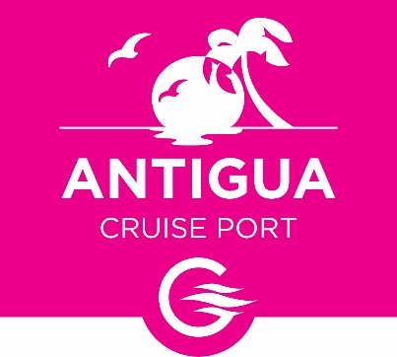

PRESS STATEMENT

CONTACT INFORMATION:

Antigua Cruise Port
Dona Lisel Regis-Prosper, General Manager
[268] 714-6969
donaliselr@antiguacruiseport.com

RELEASE DATE:
August 19, 2021
FOR IMMEDIATE RELEASE
ANTIGUA CRUISE PORT WELCOMES CELEBRITY EQUINOX AFTER ENHANCING COVID-19 PROTOCOLS

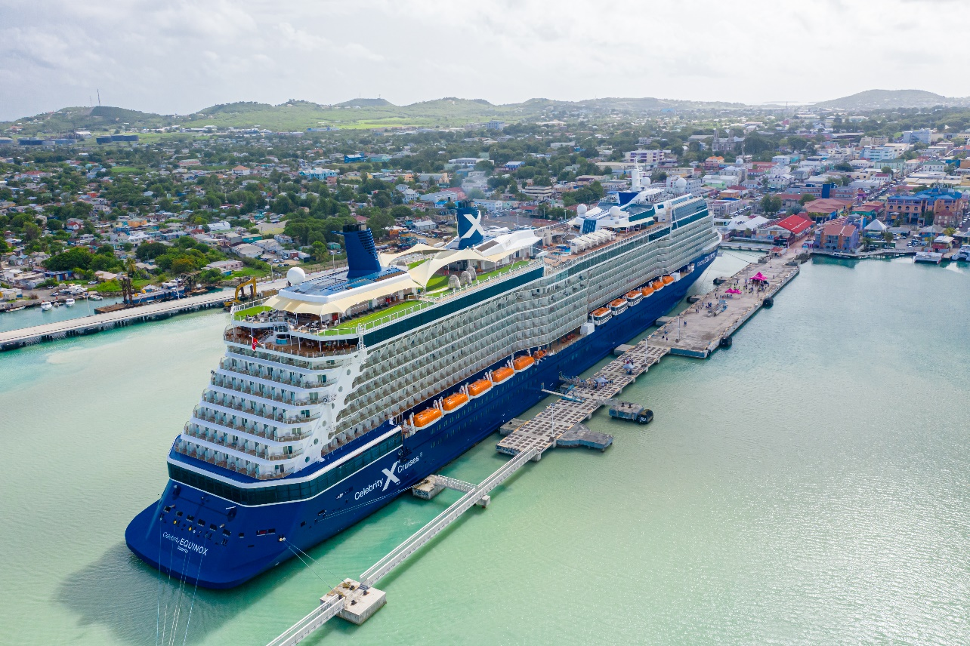
Celebrity Equinox sails into Antigua’s St. John’s Harbour, making it the first large cruise vessel to return to Antigua and Barbuda since the pandemic started in 2020.

[St. John’s, Antigua – August 19, 2021] — Premium cruising continued its return to Antigua & Barbuda today as the magnificent Celebrity Equinox sailed into Antigua Cruise Port. Over 2,000 passengers were warmly welcomed to St. John’s by the Minister of State in the Ministry of Tourism and Investment: Senator, The Honourable Mary-Clare Hurst along with other tourism executives and representatives of Antigua Cruise Port, the Antigua & Barbuda Port Authority, and the Antigua and Barbuda Tourism Authority. This Solstice-class ship was the first large vessel to dock at St. John’s since the restart of the Antigua & Barbuda cruise season in July.

“We have truly missed the breathtaking sight of the colossal, larger cruise vessels here at the port, so we are extremely excited to welcome Celebrity Equinox,” Dona Regis-Prosper, General Manager at Antigua Cruise Port, stated enthusiastically. “As with other recent cruise ship visits, the disembarkation of passengers was carefully managed to reduce the risk of spreading COVID-19. At Antigua Cruise Port, we continue to maintain and enhance our COVID-19 risk mitigation protocols daily to ensure that our facility is as safe as possible for every passenger on every voyage.”
In welcoming the cruise ship, Minister of State in the Ministry of Tourism and Investment, The Hon. Mary-Clare Hurst said, “The Government of Antigua and Barbuda remains committed to increasing the cruise calls to our port, and throughout the pandemic we have been working with the relevant authorities and cruise operators to ensure that we remain a strategic hub for safety, synergy and innovation.”
She indicated that the Government remains committed to ongoing collaboration with cruise line partners on the development of heath protocols.
The Government of Antigua & Barbuda recently revised its COVID-19 protocols, requiring that all cruise passengers over 12 years old are vaccinated. Passengers who are over 2 years old but are not fully vaccinated prior to embarkation were required to present a negative RT PCR COVID-19 test before boarding the ship in Fort Lauderdale.
Regarding tours, Antigua Cruise Port’s Regis-Prosper noted that “We are following the government’s established protocols to the letter. Shore excursion experiences will only operate as “bubble” or small-group tours. Fully vaccinated crew members will be allowed ashore on pre-approved tours. We have also arranged escorted private tours with the merchants at Heritage Quay.”
“We are so excited to return to the beautiful island of Antigua and to continue to help our Caribbean family regain the benefits of tourism their communities depend on,” said Captain Dimitris Manetas of Celebrity Equinox. “This is just the beginning. We look forward to many more return visits with guests who are excited to enjoy the island’s legendary beaches and hospitality.”

Remedial works at Heritage Quay, including safety and security upgrades to the facility and passenger experience enhancements to further support reducing the risk of spread of COVID-19, will begin soon. We continue to enhance the port through the implementation of ISPS requirements. Upgrades to the ground transportation area are also included in the works.
Antigua Cruise Port continues to remain a port of choice for the world’s top cruise brands, particularly for luxury liners and discussions about homeporting are ongoing.
***
ABOUT ANTIGUA CRUISE PORT
Located İn St. John’s harbor, Antigua Cruise Port is the gateway to the city, serving over 800,000 passengers annually. The port will be redeveloped under the Antigua Cruise Port Development Project through a 30-year lease agreement between the Government of Antigua & Barbuda and Global Ports Holding. The newest pier constructed at the port, which was completed in November 2020, can accommodate Oasis Class vessels, making it possible for the destination to serve as many as 1 million cruise passengers per year. The new port will also have brand-new retail and food and beverage facilities, plus an additional 50,000 sq. ft. of commercial space to be leased to Antiguans and Barbudans.

Antigua Cruise Port launched operations in October 2019. Learn more about Antigua Cruise Port at www.antiguacruiseport.com.

ABOUT ANTIGUA AND BARBUDA

Antigua (pronounced An-tee'ga) and Barbuda (Bar-byew’da) is located in the heart of the Caribbean Sea. Voted the World Travel Awards 2015, 2016, 2017 and 2018 Caribbean’s Most Romantic Destination, the twin-island paradise offers visitors two uniquely distinct experiences, ideal temperatures year-round, a rich history, vibrant culture, exhilarating excursions, award-winning resorts, mouth-watering cuisine and 365 stunning pink and white-sand beaches - one for every day of the year. The largest of the Leeward Islands, Antigua comprises 108-square miles with rich history and spectacular topography that provides a variety of popular sightseeing opportunities. Nelson’s Dockyard, the only remaining example of a Georgian fort a listed UNESCO World Heritage site, is perhaps the most renowned landmark. Antigua’s tourism events calendar includes the prestigious Antigua Sailing Week, Antigua Classic Yacht Regatta, and the annual Antigua Carnival; known as the Caribbean’s Greatest Summer Festival. Barbuda, Antigua’s smaller sister island, is the ultimate celebrity hideaway. The island lies 27 miles north-east of Antigua and is just a 15-minute plane ride away. Barbuda is known for its untouched 17 mile stretch of pink sand beach and as the home of the largest Frigate Bird Sanctuary in the Western Hemisphere. Find information on Antigua & Barbuda at: www.visitantiguabarbuda.com or follow us on Twitter. http://twitter.com/antiguabarbuda, Facebook www.facebook.com/antiguabarbuda; Instagram: www.instagram.com/AntiguaandBarbuda

