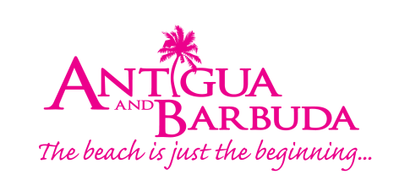

FOR IMMEDIATE RELEASE
ANTIGUA AND BARBUDA READY TO ROLL OUT THE RED CARPET FOR ADVENTUROUS TEAM ANTIGUA ISLAND GIRLS

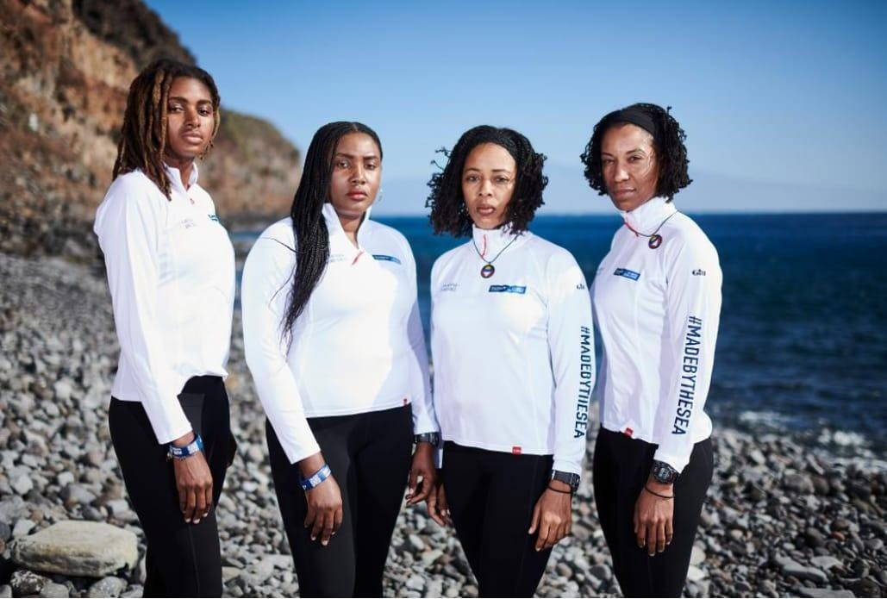
Photo Caption: Team Antigua Island Girls will make history when they become the first all-black female team in the world to row across the Atlantic Ocean, completing the Talisker Whisky Atlantic Challenge (photo credits: Ben Duffy Photography Ltd.)

St. John’s, Antigua (January 16, 2018) - Antigua and Barbuda, with its strong heritage of yacht racing and moniker as the Sailing Capital of the Caribbean, is always keen for a good nautical adventure. And with history about to be made, the destination is more than ready to roll out the red carpet to welcome adventurous Atlantic rowers “Team Antigua Island Girls”, when they row into the historic Nelson’s Dockyard and into the record books as the first all-black female team in the world to row across the Atlantic Ocean, completing the Talisker Whisky Atlantic Challenge this Jan/Feb.
Dubbed the world’s toughest row, the Talisker Whisky Atlantic Challenge is a premier ocean rowing experience that begins in La Gomera in the Canary Islands. On December 12 2018, the teams, twenty-eight in total, set off on their journey braving the Atlantic Ocean, crossing 3000 miles with over 1.5 million oar strokes and little sleep, to get to their destination in Antigua. The first team to finish the Challenge, ‘Dutch Atlantic Four’ was welcomed into Antigua, with much fanfare on the evening of January 15, having spent 34 days out at sea.
The Team Antigua Island Girls rowers: Elvira Bell, Christal Clashing, Samara Emanuel and Captain Kevinia Francis are expected to arrive later this month, where family, friends and mammoth crowds of well-wishers will gather at the Nelson’s Dockyard, a UNESCO World Heritage Site to cheer them on as they row in and celebrate the successful end of their journey. Junella King, the alternate and fifth member of Team Antigua Island Girls, will meet her teammates in Antigua.
“Antigua and Barbuda’s rich nautical heritage, and the unrivalled setting that competitors rowing into the Dockyard will encounter, makes Antigua and Barbuda the ideal location for this event. We are excited to welcome all the rowers, their families and friends to Antigua and Barbuda for this experience,” said Antigua and Barbuda Minister of Tourism, The Honourable Charles Fernandez.
“While this is the third time a team from Antigua and Barbuda has entered the Challenge, we are truly proud that the first all-black female team to row the Atlantic is comprised of four courageous Antiguan women. The entire nation is rooting for our girls and we are really looking forward to welcoming them home and celebrating the strength of women. This is history in the making, and it will truly be a momentous occasion for Antigua and Barbuda.”
Team Antigua Island Girls have identified local charity, Cottage of Hope as one of the main reasons for their row. Cottage of Hope is a non-profit organization founded in 2009 that houses and/or serves girls who have been abused, neglected or orphaned. Cottage of Hope with the aid of funds raised by Team Antigua Island Girls will offer expanded services to young women who have come of age who are transitioning from a group home setting to living on their own. To donate to the charity and for more information about Team Antigua Island Girls go to: https://www.antiguabarbudaislandgirls.com/donate/

###

ABOUT ANTIGUA AND BARBUDA
Antigua (pronounced An-tee'ga) and Barbuda (Bar-byew’da) is located in the heart of the Caribbean Sea. Voted the World Travel Awards 2015, 2016 and 2017 Caribbean’s Most Romantic Destination, the twin-island paradise offers visitors two uniquely distinct experiences, ideal temperatures year-round, a rich history, vibrant culture, exhilarating excursions, award-winning resorts, mouth-watering cuisine and 365 stunning pink and white-sand beaches - one for every day of the year. The largest of the Leeward Islands, Antigua comprises 108-square miles with rich history and spectacular topography that provides a variety of popular sightseeing opportunities. Nelson’s Dockyard, the only remaining example of a Georgian fort a listed UNESCO World Heritage site, is perhaps the most renowned landmark. Antigua’s tourism events calendar includes the prestigious Antigua Sailing Week, Antigua Classic Yacht Regatta, and the annual Antigua Carnival; known as the Caribbean’s Greatest Summer Festival. Barbuda, Antigua’s smaller sister island, is the ultimate celebrity hideaway. The island lies 27 miles north-east of Antigua and is just a 15-minute plane ride away. Barbuda is known for its untouched 17 mile stretch of pink sand beach and as the home of the largest Frigate Bird Sanctuary in the Western Hemisphere. Find information on Antigua & Barbuda at: www.visitantiguabarbuda.com or follow us on Twitter. http://twitter.com/antiguabarbuda Facebook www.facebook.com/antiguabarbuda; Instagram: www.instagram.com/AntiguaandBarbuda

For Antigua and Barbuda media queries, contact:
Maria Blackman
Marketing Communications
Antigua and Barbuda Tourism Authority
T: 1 268 464 7601 /1 268 562 7600
E: Maria.blackman@visitaandb.com

FOR MORE DETAILS ON TEAM ANTIGUA ISLAND GIRLS CONTACT:
Mickel Brann
T: +1268-725-5961
E: mickelbrann@gmail.com

