
FOR IMMEDIATE RELEASE

CTO’S CARIBBEAN WEEK A MONUMENTAL SUCCESS FOR ANTIGUA & BARBUDA
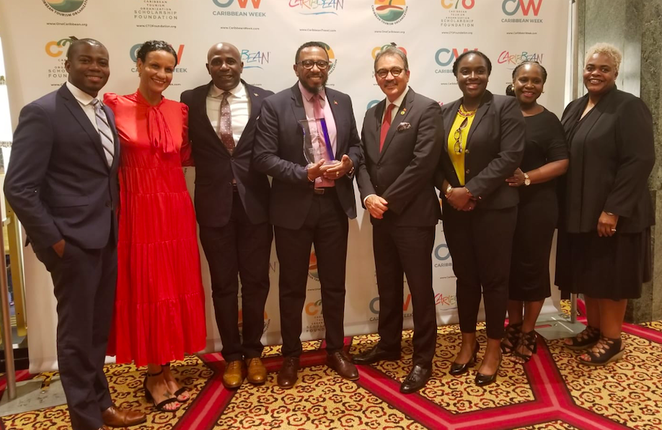

From left to right; Norell Joseph, Sales Officer (USA) Antigua & Barbuda Tourism Authority; Donyelle Bird-Browne, Tourism and Investment Manager (USA), Antigua and Barbuda Tourism Authority; Dean Fenton, US Director of Tourism, Antigua and Barbuda Tourism Authority, Colin C. James, CEO of the Antigua and Barbuda Tourism Authority; Hon. Charles ‘Max’ Fernandez, Antigua and Barbuda’s Minister of Tourism and Investment; Abena Merchant, Coordinator of Online Marketing, Antigua and Barbuda Tourism Authority, Arah Robins, Tourism Marketing Officer (USA), Antigua and Barbuda Tourism Authority, Carolyn Punter, Tourism Marketing Officer (USA), Antigua & Barbuda Tourism Authority

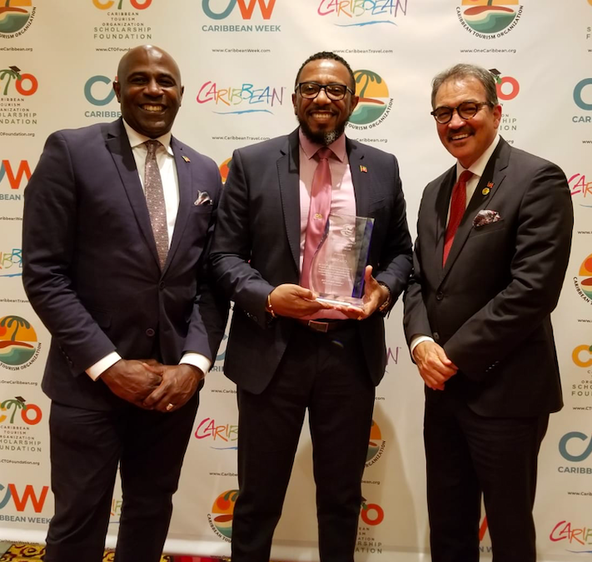
From left to right; Dean Fenton, US Director of Tourism, Antigua and Barbuda Tourism Authority, Colin C. James, CEO of the Antigua and Barbuda Tourism Authority; Hon. Charles ‘Max’ Fernandez, Antigua and Barbuda’s Minister of Tourism and Investment;

St. John’s, Antigua (June 11, 2019) – The Antigua and Barbuda Tourism Authority (ABTA) concluded a week of highly productive meetings and successful activations at the Caribbean Tourism Organisation’s (CTO’s) Caribbean Week in New York, from June 1 - 7, 2019. The Hon. Charles ‘Max’ Fernandez, Antigua and Barbuda’s Minister of Tourism and Investment, led the Antigua and Barbuda delegation, comprised of ABTA representatives Colin James, CEO; Dean Fenton, US-Director of Tourism; Donyelle Bird-Browne, Tourism & Investment Manager–USA; and Abena Merchant, Coordinator of Online Marketing.

Ministers, Commissioners and Directors of Tourism from the 28 member countries of the CTO met to discuss marketing trends, the industry’s latest developments, and hold business meetings on the future and direction of the organisation. An important component was exclusive access to top travel journalists at the annual Media Marketplace. The ABTA showcased all that the island has to offer, and the Tourism Minister and CEO participated in a number of one-on-one interviews with leading print, social and broadcast media, speaking to both trade and consumer audiences.

Additional events during the week included a Facebook Live Event with CEO Colin James and US Director Dean Fenton at the Questex Travel Group to discuss the new global summer campaign #WhatCoolLooksLike, and update travel advisors on new airlift and resort developments on island. CEO Colin James also moderated the Caribbean Marketing Conference titled "Leveraging the Cultural Excitement of the Caribbean", which focused on opportunities for destinations to leverage travelers’ growing demand for more authentic cultural experiences. He was also honored at the Caribbean Tourism Industry Awards Dinner, receiving the Allied Award for outstanding contributions to the region’s development.

“Our meetings were fruitful and afforded us the opportunity to network and build new partnerships while strengthening our existing relationships,” said the Minister of Tourism and Investment, Hon. Charles ‘Max’ Fernandez. “I would like to thank the ABTA team, and our valued partners at the CTO, for all their hard work in promoting the destination and contributing to the success of our island’s tourism industry. We are incredibly proud of the positive results and the continuous accomplishments that our team has achieved,” he concluded.

In addition to the CTO schedule of events, the Minister and CEO also utilized their presence in New York to conduct several other meetings. Minister Fernandez participated in the Organisation of Eastern Caribbean States (OECS) Council of Ministers Tourism Meeting, while the Tourism Authority met with Dr. Collin Devon, CEO of Collin Devon Events, who will be bringing a diverse group of some 500 millennial professionals to Antigua and Barbuda in October for a week of fun and festivities.

The CTO Caribean Week in New York came to a close on Friday evening, June 7th, with Rum & Rhythm, a benefit for the CTO Foundation, at which Antigua & Barbuda hosted a stunning lounge featuring the best of the twin destinations’ culinary experiences.

# # #

ABOUT ANTIGUA AND BARBUDA

Antigua (pronounced An-tee'ga) and Barbuda (Bar-byew’da) is located in the heart of the Caribbean Sea. Voted the World Travel Awards Caribbean’s Most Romantic Destination, the twin-island paradise offers visitors two uniquely distinct experiences, ideal temperatures year-round, a rich history, vibrant culture, exhilarating excursions, award-winning resorts, mouth-watering cuisine and 365 stunning pink and white-sand beaches - one for every day of the year. The largest of the Leeward Islands, Antigua comprises 108-square miles with rich history and spectacular topography that provides a variety of popular sightseeing opportunities. Nelson’s Dockyard, the only remaining example of a Georgian fort a listed UNESCO World Heritage site, is perhaps the most renowned landmark. Antigua’s tourism events calendar includes the prestigious Antigua Sailing Week, Antigua Classic Yacht Regatta, and the annual Antigua Carnival; known as the Caribbean’s Greatest Summer Festival. Barbuda, Antigua’s smaller sister island, is the ultimate celebrity hideaway. The island lies 27 miles north-east of Antigua and is just a 15-minute plane ride away. Barbuda is known for its untouched 17 mile stretch of pink sand beach and as the home of the largest Frigate Bird Sanctuary in the Western Hemisphere. Find information on Antigua & Barbuda at: www.visitantiguabarbuda.com and follow us on Twitter. http://twitter.com/antiguabarbuda Facebook www.facebook.com/antiguabarbuda; Instagram: www.instagram.com/AntiguaandBarbuda

For media enquiries, please contact:
Antigua and Barbuda Tourism Authority
T: 1 (268) 562 7600

