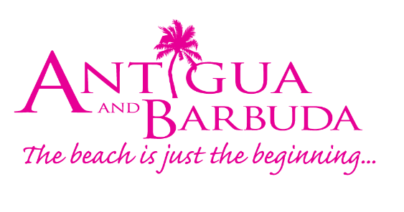

FOR IMMEDIATE RELEASE:

Antigua and Barbuda attends Seatrade Cruise Global 2021 as cruise rebuilding continues

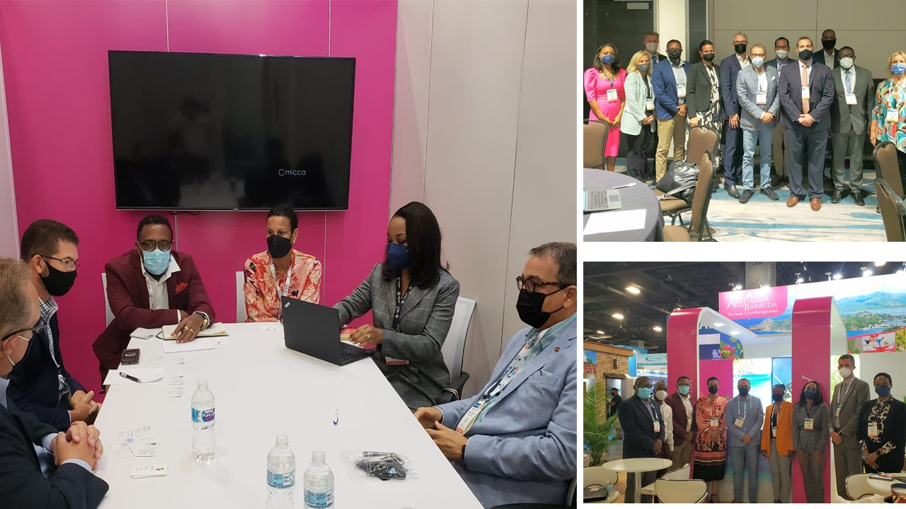

(Photo Caption: antigua and Barbuda’s delegation at the recently concluded Seatrade Cruise Global 2021 reported on the successful and safe re-building of the destination’s cruise sector)
St. John’s, Antigua (September 30, 2021) - Antigua and Barbuda’s delegation to the September 27- September 30, Seatrade Cruise Global Exhibition and Conference, led by Minister of Tourism and Investment the Honourable Charles Fernandez comprised of key partners and representatives from both the public and private sector. The Country’s attendance at the world’s largest global cruise industry event is critical to the rebuilding of the cruise sector post the covid-19 pandemic.
Minister Fernandez, CEO of the Antigua and Barbuda Tourism Authority, Colin C. James alongside other Tourism Authority representatives, and stakeholders from Calvin Air, The Rendezvous Company and Brysons Shipping have been conducting meetings and sharing information with industry partners, and cruise executives. This global forum, also attended by other Caribbean Tourism officials allows for updates within the cruise industry, insight on the latest trends and developments, and the discovery of marketing campaigns and strategic recovery plans going forward in a Covid-19 normal.
A total of 140 entities are participating with representation from focus areas such as tourism destinations, hospitality, ports, ship building and infrastructure, technology, sustainability.
The Antigua and Barbuda delegation held over a dozen face-to-face and virtual meetings with cruise executives, that provided the opportunity to inform the stakeholders about the nation’s capabilities pertaining to the massive port development project, tourism infrastructure investments, the transformation of eco-friendly Barbuda, and to place emphasis on the new mandatory vaccination mandate. Antigua and Barbuda’s ‘sun, sea, and safe’ protocols that seek to ensure the safety of the cruise passengers and local community alike, were also shared. These will help to make the destination a ‘must’ for inclusion in the respective cruise itineraries.
The cruise lines welcomed Antigua and Barbuda’s robust protocols, particularly as it related to the country’s mandatory vaccination policy for arriving passengers 12 years and older. The lines were excited at the efforts of the destination to now facilitate homeporting, fuel bunkering, and shortly, provide access to liquified natural gas LNG. This is now becoming the gold standard for fuel in the latest generation of luxury ships.
The destination was able to confirm 85 calls for the remainder of the season with Royal Caribbean’s Oasis class Harmony of the Seas the largest ship in the world, which will be making its inaugural call to Antigua on November 24, with a second call on December 22.
Another notable achievement in rebuilding the cruise sector is the advent of Virgin Cruises the world’s newest cruise line which will make its inaugural call on November 17, 2022 with an additional 14 calls to end of the 2022/23 season.
In offering his comments on the success achieved in the local cruise industry so far, Minister of Tourism and Investment, The Honourable Charles Fernandez said, “The entire tourism sector, and particularly our cruise partners, have had an extremely difficult journey over the past 18 months. The fact that the Seatrade Cruise Global Conference is taking place this year albeit as a hybrid of in-person and virtual meetings; it brings a positive element of hope to the industry and faith in its ability to recover in an impactful way for the success of all partners. We are confident that Antigua and Barbuda has implemented measures that will allow us to welcome cruise guests in a safe and sustainable manner as we work to rebuild the sector”.
CEO of the Tourism Authority Colin C. James reported that, Antigua & Barbuda has welcomed 12 port calls with 2,858 passengers, since the reopening of the port in July of this year. Our goal is to continue to negotiate for more calls and to work with the Antigua Cruise Port (Global Ports Holding) to improve the seamless passenger welcome and the product experience. We are known in the industry for providing unique shore excursions that include a UNESCO World Heritage site, guided tours, diving, hiking, and local culinary immersions. These will continue but will now be done against the backdrop of ensuring the health and safety of our locals and visiting cruise guests”.
The cruise industry sector has become an important contributor to the national economy over the years. Cruise tourism continues to be an important pillar in the tourism strategy for Antigua and Barbuda; and as such cruise executives from Royal Caribbean cruise Lines, Carnival, Disney, Princess, Holland America, Seaborne, Virgin Cruises, MSC, all confirmed that the current 35% - 40% capacity will grow exponentially over the next few months.
The destination’s ability to safely accommodate cruise passengers will be critical in allowing the cruise lines to increase the percentage of paying passengers back up to the 60% -70% by year-end. This commitment by the destination is directly aligned with that of the major cruise lines to carrying only fully vaccinated crew and passengers. Antigua and Barbuda looks forward to safely welcoming back all of its cruise line partners and their guests.
###
ABOUT ANTIGUA AND BARBUDA
Antigua (pronounced An-tee'ga) and Barbuda (Bar-byew’da) is located in the heart of the Caribbean Sea. Voted the World Travel Awards 2015, 2016, 2017 and 2018 Caribbean’s Most Romantic Destination, the twin-island paradise offers visitors two uniquely distinct experiences, ideal temperatures year-round, a rich history, vibrant culture, exhilarating excursions, award-winning resorts, mouth-watering cuisine and 365 stunning pink and white-sand beaches - one for every day of the year. The largest of the Leeward Islands, Antigua comprises 108-square miles with rich history and spectacular topography that provides a variety of popular sightseeing opportunities. Nelson’s Dockyard, the only remaining example of a Georgian fort a listed UNESCO World Heritage site, is perhaps the most renowned landmark. Antigua’s tourism events calendar includes the prestigious Antigua Sailing Week, Antigua Classic Yacht Regatta, and the annual Antigua Carnival; known as the Caribbean’s Greatest Summer Festival. Barbuda, Antigua’s smaller sister island, is the ultimate celebrity hideaway. The island lies 27 miles north-east of Antigua and is just a 15-minute plane ride away. Barbuda is known for its untouched 17 mile stretch of pink sand beach and as the home of the largest Frigate Bird Sanctuary in the Western Hemisphere. Find information on Antigua & Barbuda at: www.visitantiguabarbuda.com or follow us on Twitter. http://twitter.com/antiguabarbuda Facebook www.facebook.com/antiguabarbuda; Instagram: www.instagram.com/AntiguaandBarbuda

For media enquiries, please contact:
Maria Blackman
Antigua and Barbuda Tourism Authority
T: 1 (268) 562 7600/464-7601
E: maria.blackman@visitaandb.com

