FOR IMMEDIATE RELEASE:

ANTIGUA AND BARBUDA HEADS TO SPACE
Antigua and Barbuda’s Ministry of Tourism and Tourism Authority cheer on Keisha Schahaff’s space journey
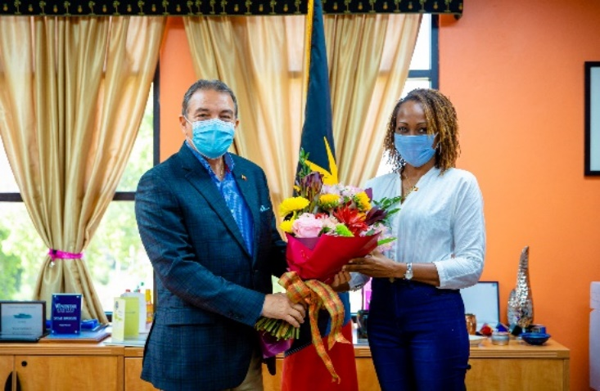
Photo 1: Antigua and Barbuda Minister of Tourism and Investment, The Honourable Charles Fernandez extends best wishes to Schahaff on her upcoming space voyage.
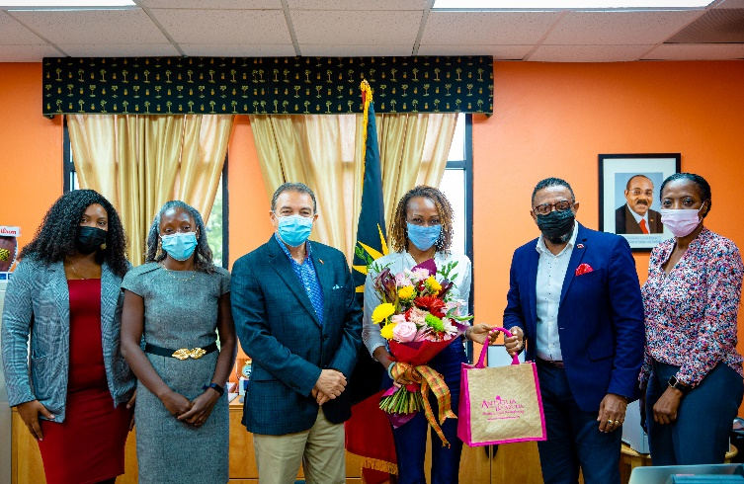
Photo 2: Celebrating the exciting news with Keisha Schahaff and offering their support are the Ministry of Tourism and the Antigua and Barbuda Tourism Authority. Pictured L-R: Julianne Christian Tourism Marketing Assistant, Maria Blackman Marketing Communications Manager, The Honourable Charles Fernandez Minister of Tourism and Investment, Keisha Schahaff Virgin Galactic sweepstakes winner, Colin. C James CEO of The Antigua and Barbuda Tourism Authority and Karen Joseph Sports Tourism Officer within the Ministry of Tourism. (Photo credits: The Antigua and Barbuda Tourism Authority)
ST. JOHN’S, ANTIGUA (December 8, 2021) – Antigua and Barbuda’s Minister of Tourism and Investment, The Honourable Charles Fernandez has extended congratulations to Keisha Schahaff who will be the first Antiguan and Barbudan and Caribbean woman to travel to space.
Schahaff, is expected to travel to space in 2022, having won two seats on a Virgin Galactic space flight during a sweepstakes organized by Virgin Galactic in partnership with fundraising platform Omaze.
“You will be carrying the whole of Antigua and Barbuda with you, and this type of recognition is priceless”, said the tourism minister as he extended best wishes to the future astronaut, during a meeting held yesterday.
Minister Fernandez presented Schahaff with a tropical bouquet and a tourism gift bag. The Minister offered the full support of the country and the Ministry of Tourism and Investment in assisting her on this “phenomenal” journey.
Schahaff stated that she is looking forward to representing her country and flying the Antigua and Barbuda national flag from space.
Also present at the meeting was CEO of The Antigua and Barbuda Tourism Authority Colin C. James, Marketing Communications Manager Maria Blackman and Sports Tourism Officer within the Ministry of Tourism Karen Joseph.
“This is a remarkable opportunity”, said the Antigua and Barbuda Tourism Authority CEO, Colin C. James. “Since your win, you have represented Antigua and Barbuda extremely well and have made us all feel proud”.
“We look forward to working with you, and hope that your journey to space increases awareness of Antigua and Barbuda and inspires more persons to visit our twin-island paradise”.
The Antigua and Barbuda Tourism Authority launched a successful #YourSpaceInTheSun marketing campaign in 2020, to encourage persons to find all the space they needed to relax and rejuvenate in Antigua and Barbuda, during the Covid-19 pandemic.

NOTE TO EDITORS:
For Antigua and Barbuda media enquiries, please contact:
Maria Blackman
Antigua and Barbuda Tourism Authority
T: 1 (268) 562 7600/464-7601
E: maria.blackman@visitaandb.com

Antigua and Barbuda Images: aandbtourism.fotoseeker.com

About Antigua & Barbuda:
The 365 white and pink sand beaches of Antigua & Barbuda, one for every day of the year, are just the beginning of the treasures that await visitors. Antigua’s rich history and spectacular topography provide a variety of popular sightseeing opportunities. Nelson’s Dockyard, the only remaining example of a Georgian fort commissioned by the British in 1755, is perhaps the most renowned landmark. Betty’s Hope, built in 1674, is the site of one of the first full-scale sugar plantations on Antigua, and offers a chance to step back into time by visiting the restored mills. Another unique attraction is Devil’s Bridge, located at the eastern tip of the island in Indian Town National Park, where Atlantic breakers have carved out a natural limestone arch. Antigua boasts a varied tourism calendar including events such as the World Class Antigua Sailing Week, Classic Yacht Regatta, Antigua Sports Fishing and the annual Carnival; known as the Caribbean’s Greatest Summer Festival. Island accommodation ranges from luxury resorts and all-inclusive hotels to smaller more intimate boutique guesthouses and cottages. For information about Antigua & Barbuda visit www.visitantiguabarbuda.com

About Keisha Schahaff:
Keisha Schahaff is a 44-year-old professional life coach from Antigua and Barbuda. Schahaff is the winner of tickets for two on Virgin Galactic’s first commercial space flight.

Schahaff won the prize after entering a fundraising lottery organized by Virgin Galactic on the Omaze platform, which raised $1.7 million in grants benefiting Space for Humanity and their Citizen Astronaut Program. Schahaff and her daughter will be the first Antiguans and Barbudans to embark on such a journey.

