FOR IMMEDIATE RELEASE
Antigua and Barbuda Takes Centre Stage on New ITV 1 Show, Ainsley’s Caribbean Kitchen
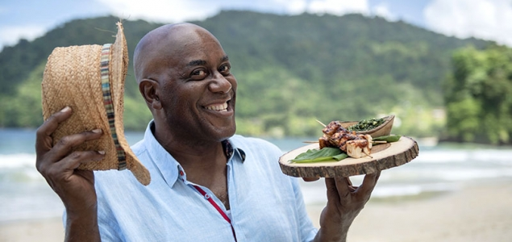

21st January 2019, London: British celebrity chef Ainsley Harriott is shining a light on Antigua and Barbuda’s culinary offerings in a new ITV 1 show, set to air on 20th January 2019. ITV is the largest commercial family of channels in the UK as well as on demand via the ITV Hub and across other platforms globally. The show will reach around 1 million households in the UK and will highlight the destinations key attractions. The airing of the show will kick start the launch of Antigua’s 2019 summer campaign.
Whilst on island Ainsley Harriot was hosted by the Antigua & Barbuda Tourism Authority and Carlisle Bay Resort and Spa. The two episodes will showcase the island life of Antigua, Ainsley will be seen enjoying the sweet pulsating rhythms of Hellsgate Steel Orchestra and trying his hand at playing the steelpans as well as cooking at Gina’s Food Café on Fig Tree Drive.
Filming also took place at popular Beach Limerz Restaurant which showcase Antigua’s famous Pepperpot and Fungi before learning how to make authentic rum cake with chef Nicole Arthurton Dennis who gives Caribbean cookery lessons through her business Nicole’s Table.
One of Antigua’s main tourist attractions Shirley’s Heights was also included in this series. Ainsley’s final interview was with Dr Reg. Murphy, the Director of Heritage Resources at the historic Nelson Dockyard and Clarence House, giving viewers the history of Antigua and Barbuda.
Ainsley’s Caribbean Kitchen airs on ITV 1 at 11.30am GMT and will run for 10-weeks from 20th January with the Antigua episodes on screen on the 17th and 24th March 2019.
Fans of the show will be able to buy the Ainsley’s Caribbean Kitchen recipe book, which will include the entire Caribbean recipes feature in the series. The book will be available from Penguin Books in the spring.
-Ends-

Notes to editors
Antigua and Barbuda
Antigua (pronounced An-tee'ga) and Barbuda (Bar-byew’da) is in the heart of the Caribbean Sea. The largest of the Leeward Islands, Antigua & Barbuda comprises 108-square miles. The 365 white and pink sand beaches, one for every day of the year, are just the beginning of the treasures that await visitors.
Antigua’s rich history and spectacular topography provide a variety of popular sightseeing opportunities. Nelson’s Dockyard, the only remaining example of a Georgian fort commissioned by the British in 1755, is perhaps the most renowned landmark. Betty’s Hope, built in 1674, is the site of one of the first full-scale sugar plantations on Antigua, and offers a chance to step back into time by visiting the restored mills.
Another unique attraction is Devil’s Bridge, located at the eastern tip of the island in Indian Town National Park, where Atlantic breakers have carved out a natural limestone arch. Antigua boasts a varied tourism calendar including events such as the World Class Antigua Sailing Week, Classic Yacht Regatta, Antigua Sports Fishing and the annual Carnival; known as the Caribbean’s Greatest Summer Festival.
Island accommodation ranges from luxury resorts and all-inclusive hotels to smaller more intimate boutique guesthouses and cottages.

