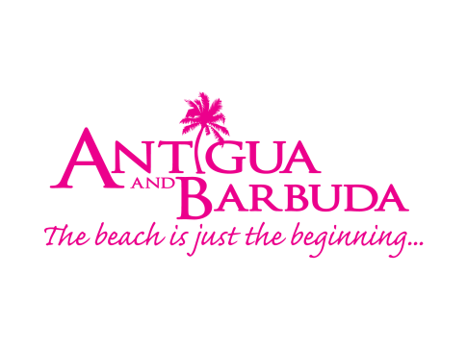

**FOR IMMEDIATE RELEASE:**

**ANTIGUA AND BARBUDA TO TAP INTO THE WELLNESS TRAVEL MARKET**

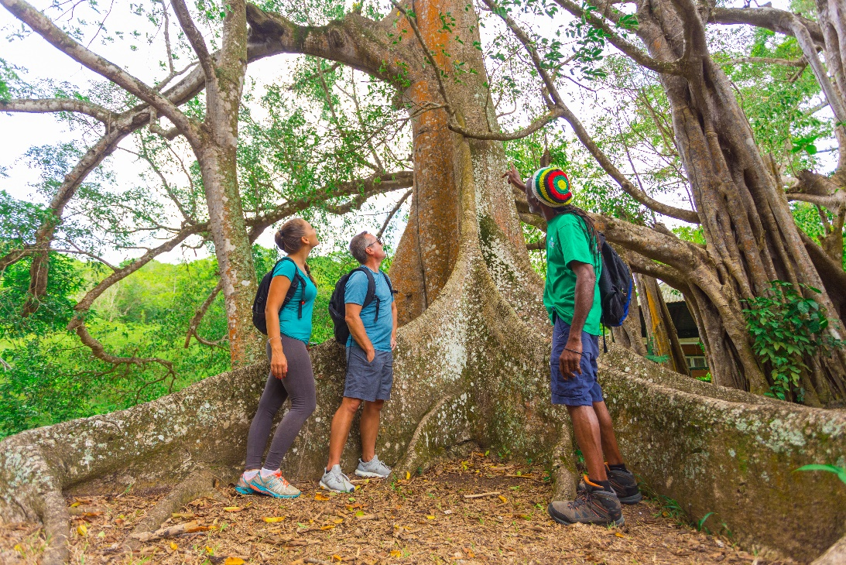

*Hikers explore a tree in the Wallings area during a hike in Antigua.*

*(Photo credits: Hike Caribbean)*

**ST. JOHN’S, ANTIGUA (March 4th 2019) -** Examining the current offerings available to the wellness traveller and discussing ways to increase the destination’s presence within the vastly growing wellness travel and tourism market, will be high on the agenda for the Antigua and Barbuda Tourism Authority, when they meet with wellness service providers during a Wellness Audit and Forum, scheduled to take place between March 16 – March 27 2019.

The Antigua and Barbuda Tourism Authority made the strategic decision to place a new focus on attracting the health and wellness traveller, during a tourism marketing planning meeting last November.

“We are confident that Antigua and Barbuda has the resources available on island for us to tap into this growing and lucrative market”, said Antigua and Barbuda’s Minister of Tourism, The Honourable Charles Fernandez.

“The Wellness audit and forum will assist us in identifying our untapped key selling points, gaps and marketable qualities within the wellness arena, that will support our strategic intention for 2019 and beyond, as it relates to enhancing our health and wellness experience for travellers and ensuring that our wellness service providers grow their business.”

This new wellness-centric focus has led to the Antigua and Barbuda Tourism Authority engaging with the Wellness Tourism Association, a non-profit organization with a mission to support and further the growth and development of the wellness tourism industry.

During the audit, Co-founder and President of the North American-based Wellness Tourism Association, Anne Dimon, will meet with local businesses, government officials and stakeholders in the wellness industry in both Antigua and Barbuda, to assess offerings and outline good practises and opportunities, as well as provide recommendations on improving the product.

The Wellness Forum on March 27 will bring together stakeholders within the three cornerstones of wellness travel – food, fitness and nature for a day of discussions that will allow attendees the opportunity to be educated on the needs of the wellness travel, and receive the support needed to be successful in their businesses.

The Tourism Authority is targeting agro-processors, farmers, restaurants, tour and excursion operators, fitness and outdoor activity providers, hotels and hospitality providers, spas, yoga, meditation and indoor fitness consultants, educators in food & beverage and hospitality, preventative medical care providers and anyone with an interest in providing a wellness product or experience in Antigua and Barbuda, for the forum.

In addition to addresses from Antigua and Barbuda’s tourism and health officials, on the topic of health and wellness, attendees will hear from national and international speakers to include: Wellness Travel Expert - Anne Dimon, Aidan McCauley - Owner of Sugar Ridge, Hike Caribbean and Antigua and Barbuda Wellness Ambassador 2018, Kat Byles - Owner of True Business Antigua Retreats and Antigua and Barbuda Wellness Ambassador 2018, Arica Hill - Executive Director of the Environmental Awareness Group and much more.

The general wellness-oriented public is invited to register for the forum before the deadline of March 15 with the Antigua and Barbuda Tourism Authority at 562-7600 or email rsvp@visitaandb.com.  The forum costs EC$75 inclusive of lunch and will be held at the White House Events Centre, Ffryes Beach.

# # #

**ABOUT ANTIGUA AND BARBUDA**

Antigua (pronounced An-tee'ga) and Barbuda (Bar-byew’da) is located in the heart of the Caribbean Sea. Voted the World Travel Awards *Caribbean’s Most Romantic Destination*, the twin-island paradise offers visitors two uniquely distinct experiences, ideal temperatures year-round, a rich history, vibrant culture, exhilarating excursions, award-winning resorts, mouth-watering cuisine and 365 stunning pink and white-sand beaches - one for every day of the year. The largest of the Leeward Islands, Antigua comprises 108-square miles with rich history and spectacular topography that provides a variety of popular sightseeing opportunities. Nelson’s Dockyard, the only remaining example of a Georgian fort a listed UNESCO World Heritage site, is perhaps the most renowned landmark. Antigua’s tourism events calendar includes the prestigious Antigua Sailing Week, Antigua Classic Yacht Regatta, and the annual Antigua Carnival; known as the Caribbean’s Greatest Summer Festival. Barbuda, Antigua’s smaller sister island, is the ultimate celebrity hideaway. The island lies 27 miles north-east of Antigua and is just a 15-minute plane ride away. Barbuda is known for its untouched 17 mile stretch of pink sand beach and as the home of the largest Frigate Bird Sanctuary in the Western Hemisphere.  Find information on Antigua & Barbuda at: [www.visitantiguabarbuda.com](https://urldefense.proofpoint.com/v2/url?u=http-3A__www.visitantiguabarbuda.com&d=DwMF-g&c=gOrgfQB8xVH7F0lP7MQhi8CyVXMBvYqNyP3LuSSb8Lw&r=Sikww-u5U7crjB0ZWB4QweOumf9Se8r42AkVmzb2QKg&m=epF3E7FKFR7NA0Nw643qATsr5pkfQO08fGj5b7Uvwhw&s=xUBue1f7SkVwzWug3NYnrS33DVWC4yo4RX3v3EraWsY&e=) and follow us on:

Twitter: [http://twitter.com/antiguabarbuda](https://urldefense.proofpoint.com/v2/url?u=http-3A__twitter.com_antiguabarbuda&d=DwMF-g&c=gOrgfQB8xVH7F0lP7MQhi8CyVXMBvYqNyP3LuSSb8Lw&r=Sikww-u5U7crjB0ZWB4QweOumf9Se8r42AkVmzb2QKg&m=epF3E7FKFR7NA0Nw643qATsr5pkfQO08fGj5b7Uvwhw&s=C7zwqTbtoiryOBWX7l2mAdeIapBGt3fm1lV_BezpvbM&e=)

Facebook: [www.facebook.com/antiguabarbuda](http://www.facebook.com/antiguabarbuda);

Instagram: [www.instagram.com/AntiguaandBarbuda](https://urldefense.proofpoint.com/v2/url?u=http-3A__www.instagram.com_AntiguaandBarbuda&d=DwMF-g&c=gOrgfQB8xVH7F0lP7MQhi8CyVXMBvYqNyP3LuSSb8Lw&r=Sikww-u5U7crjB0ZWB4QweOumf9Se8r42AkVmzb2QKg&m=epF3E7FKFR7NA0Nw643qATsr5pkfQO08fGj5b7Uvwhw&s=URVO85T4CzUL_myg6UHc2etMg7oZEt9mLqWy4fyOjGQ&e=)

**For media enquiries, please contact:**

Maria Blackman

Antigua and Barbuda Tourism Authority

T: 1 (268) 562 7600/464-7601

E: [maria.blackman@visitaandb.com](mailto:maria.blackman@visitaandb.com)