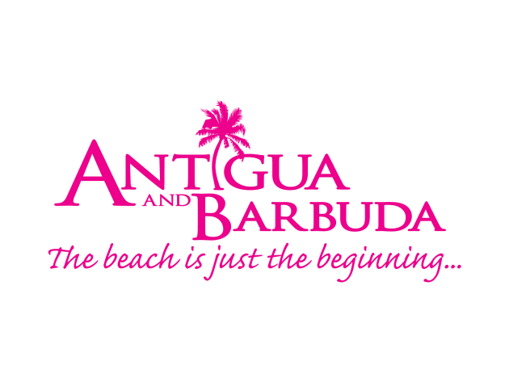
Antigua and Barbuda WINS BEST social media campaign, best broadcast FEATURE and best consumer FEATURE at cto media awards
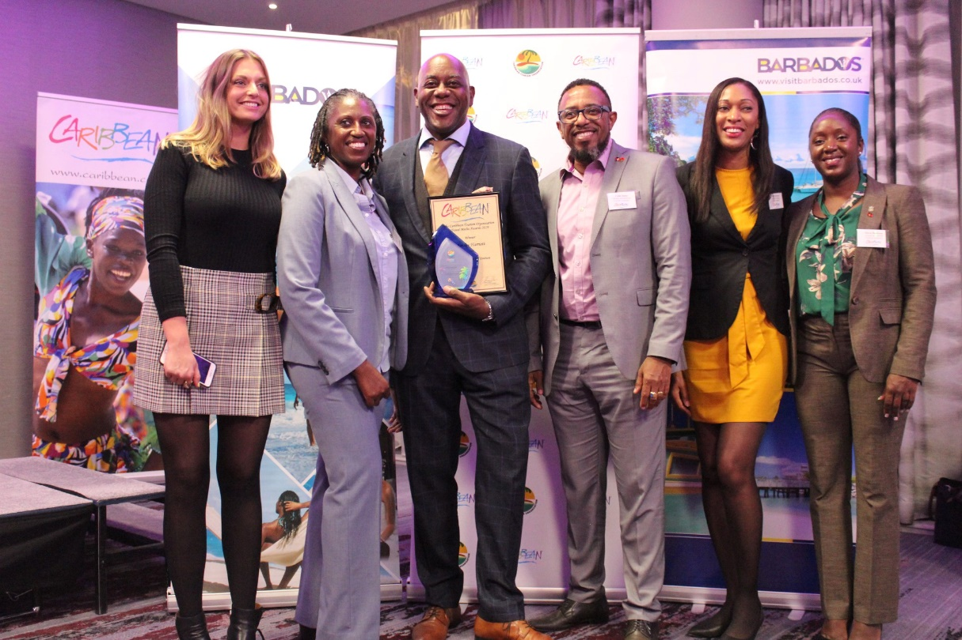
(Photo Caption: The Antigua and Barbuda Tourism Authority celebrates with noted TV Chef Ainsley Harriott a win for Best Broadcast Feature for ‘Ainsley’s Caribbean Kitchen – Antigua’ TV Episode. Antigua and Barbuda also received awards for Best Consumer Feature, and Best Social Media Campaign.)

LONDON, ENGLAND (Tuesday, November 5 2019): It was an evening of big wins for The Antigua and Barbuda Tourism Authority as the destination took home awards for Best Social Media Campaign, Best Broadcast Feature, and Best Consumer Feature at last evening’s 2019 Caribbean Tourism Organisation’s (CTO) Media Awards, held during World Travel Market, in the United Kingdom.

The Travel Industry continues to recognise the Antigua and Barbuda Tourism Authority’s summer marketing campaign #WhatCoolLooksLike, for its innovativeness and effectiveness, rewarding the destination with Best Social Media Campaign, having staged the impactful ‘Traverse Antigua Conference 2019’, which saw over 30 social media influencers visiting Antigua. In the judges’ words “This campaign, which brought thirty plus creators to Antigua, hit the top score, highlighting a unique way to approach destination coverage. The diverse range of photos taken by the influencers effectively highlighted the destination. Instagram, Facebook and Twitter were well utilised, and reporting was clearly presented. Content generated clearly showcased Antigua’s key USPs.”

Judges also selected Ainsley’s Caribbean Kitchen – Antigua as Best Broadcast Feature. Ainsley Harriott, who is one of the UK’s favourite TV Chefs, journeyed to the destination in 2018 for a culinary adventure. In his 9th episode of Ainsley’s Caribbean Kitchen Series, Ainsley explores amazing Antigua, taking in the sea, the sights and tastes of the island which leads him to trying his hand at local cuisine at Gina’s Cook Show and Beach Limerz, as well as dabbling with rums at Nicole’s Table and Carlisle Bay.

For his article, ‘Antigua beyond the Beaches’ which prominently featured in Escapism Magazine, Ronan O’ Shea hit top scores. “This piece is written, as if one was there, encapsulating all the elements that a Caribbean destination has to offer and highlighting the destination’s diversity of culture, history and modern well-being – with inspiring photography”, comments the judges.

Antigua and Barbuda Tourism Authority CEO Colin C. James said, “We are honoured by this recognition from our industry peers and judges from throughout the media and travel fraternity. The Antigua and Barbuda Tourism Authority remains committed to engaging and introducing the travel media, and by extension their readers, and viewers to the very best of Antigua and Barbuda – our uniqueness, our culture, amazing cuisine, attractions, hotel properties, beautiful scenery and most importantly our warm and hospitable people. “We continue to adapt to the changing media landscape, utilising new ways of reaching the consumer, and are extremely pleased that our #WhatCoolLooksLike social media campaign, has resonated with our target audiences and has been rewarded for its excellence by our industry partners.”

The Caribbean Tourism Organisation’s Media Awards are held annually and are adjudged by travel trade and media professionals. The event honours the exceptional work of media in promoting the Caribbean via print, broadcast and online. The 2019 awards within the UK market, saw over 130 entries submitted across eight categories. The CTO Media Awards are also hosted within the US and Canadian markets.

###

For media enquiries, please contact:
Maria Blackman
Antigua and Barbuda Tourism Authority
T: 1 (268) 562 7600/464-7601
E: maria.blackman@visitaandb.com

Notes to editors
Antigua and Barbuda
Antigua (pronounced An-tee'ga) and Barbuda (Bar-byew’da) is located in the heart of the Caribbean Sea. The largest of the Leeward Islands, Antigua & Barbuda comprises 108-square miles. The 365 white and pink sand beaches, one for every day of the year, are just the beginning of the treasures that await visitors. Antigua’s rich history and spectacular topography provide a variety of popular sightseeing opportunities. Nelson’s Dockyard, the only remaining example of a Georgian fort commissioned by the British in 1755, is perhaps the most renowned landmark. Betty’s Hope, built in 1674, is the site of one of the first full-scale sugar plantations on Antigua, and offers a chance to step back into time by visiting the restored mills. Another unique attraction is Devil’s Bridge, located at the eastern tip of the island in Indian Town National Park, where Atlantic breakers have carved out a natural limestone arch. Antigua boasts a varied tourism calendar including events such as the World Class Antigua Sailing Week, Classic Yacht Regatta, Antigua Sports Fishing and also the annual Carnival; known as the Caribbean’s Greatest Summer Festival. Island accommodation ranges from luxury resorts and all-inclusive hotels to smaller more intimate boutique guesthouses and cottages.

