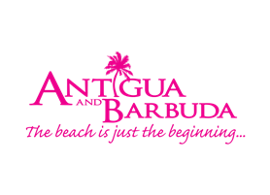

**ANTIGUA AND BARBUDA RECOGNIZED IN PRESITIGOUS CARIBBEAN JOURNAL’S ‘2021 CARIBBEAN TRAVEL AWARDS’**

*Twin-Isle National Wins Three Awards Including ‘Caribbean Tourism Minister of the Year’*

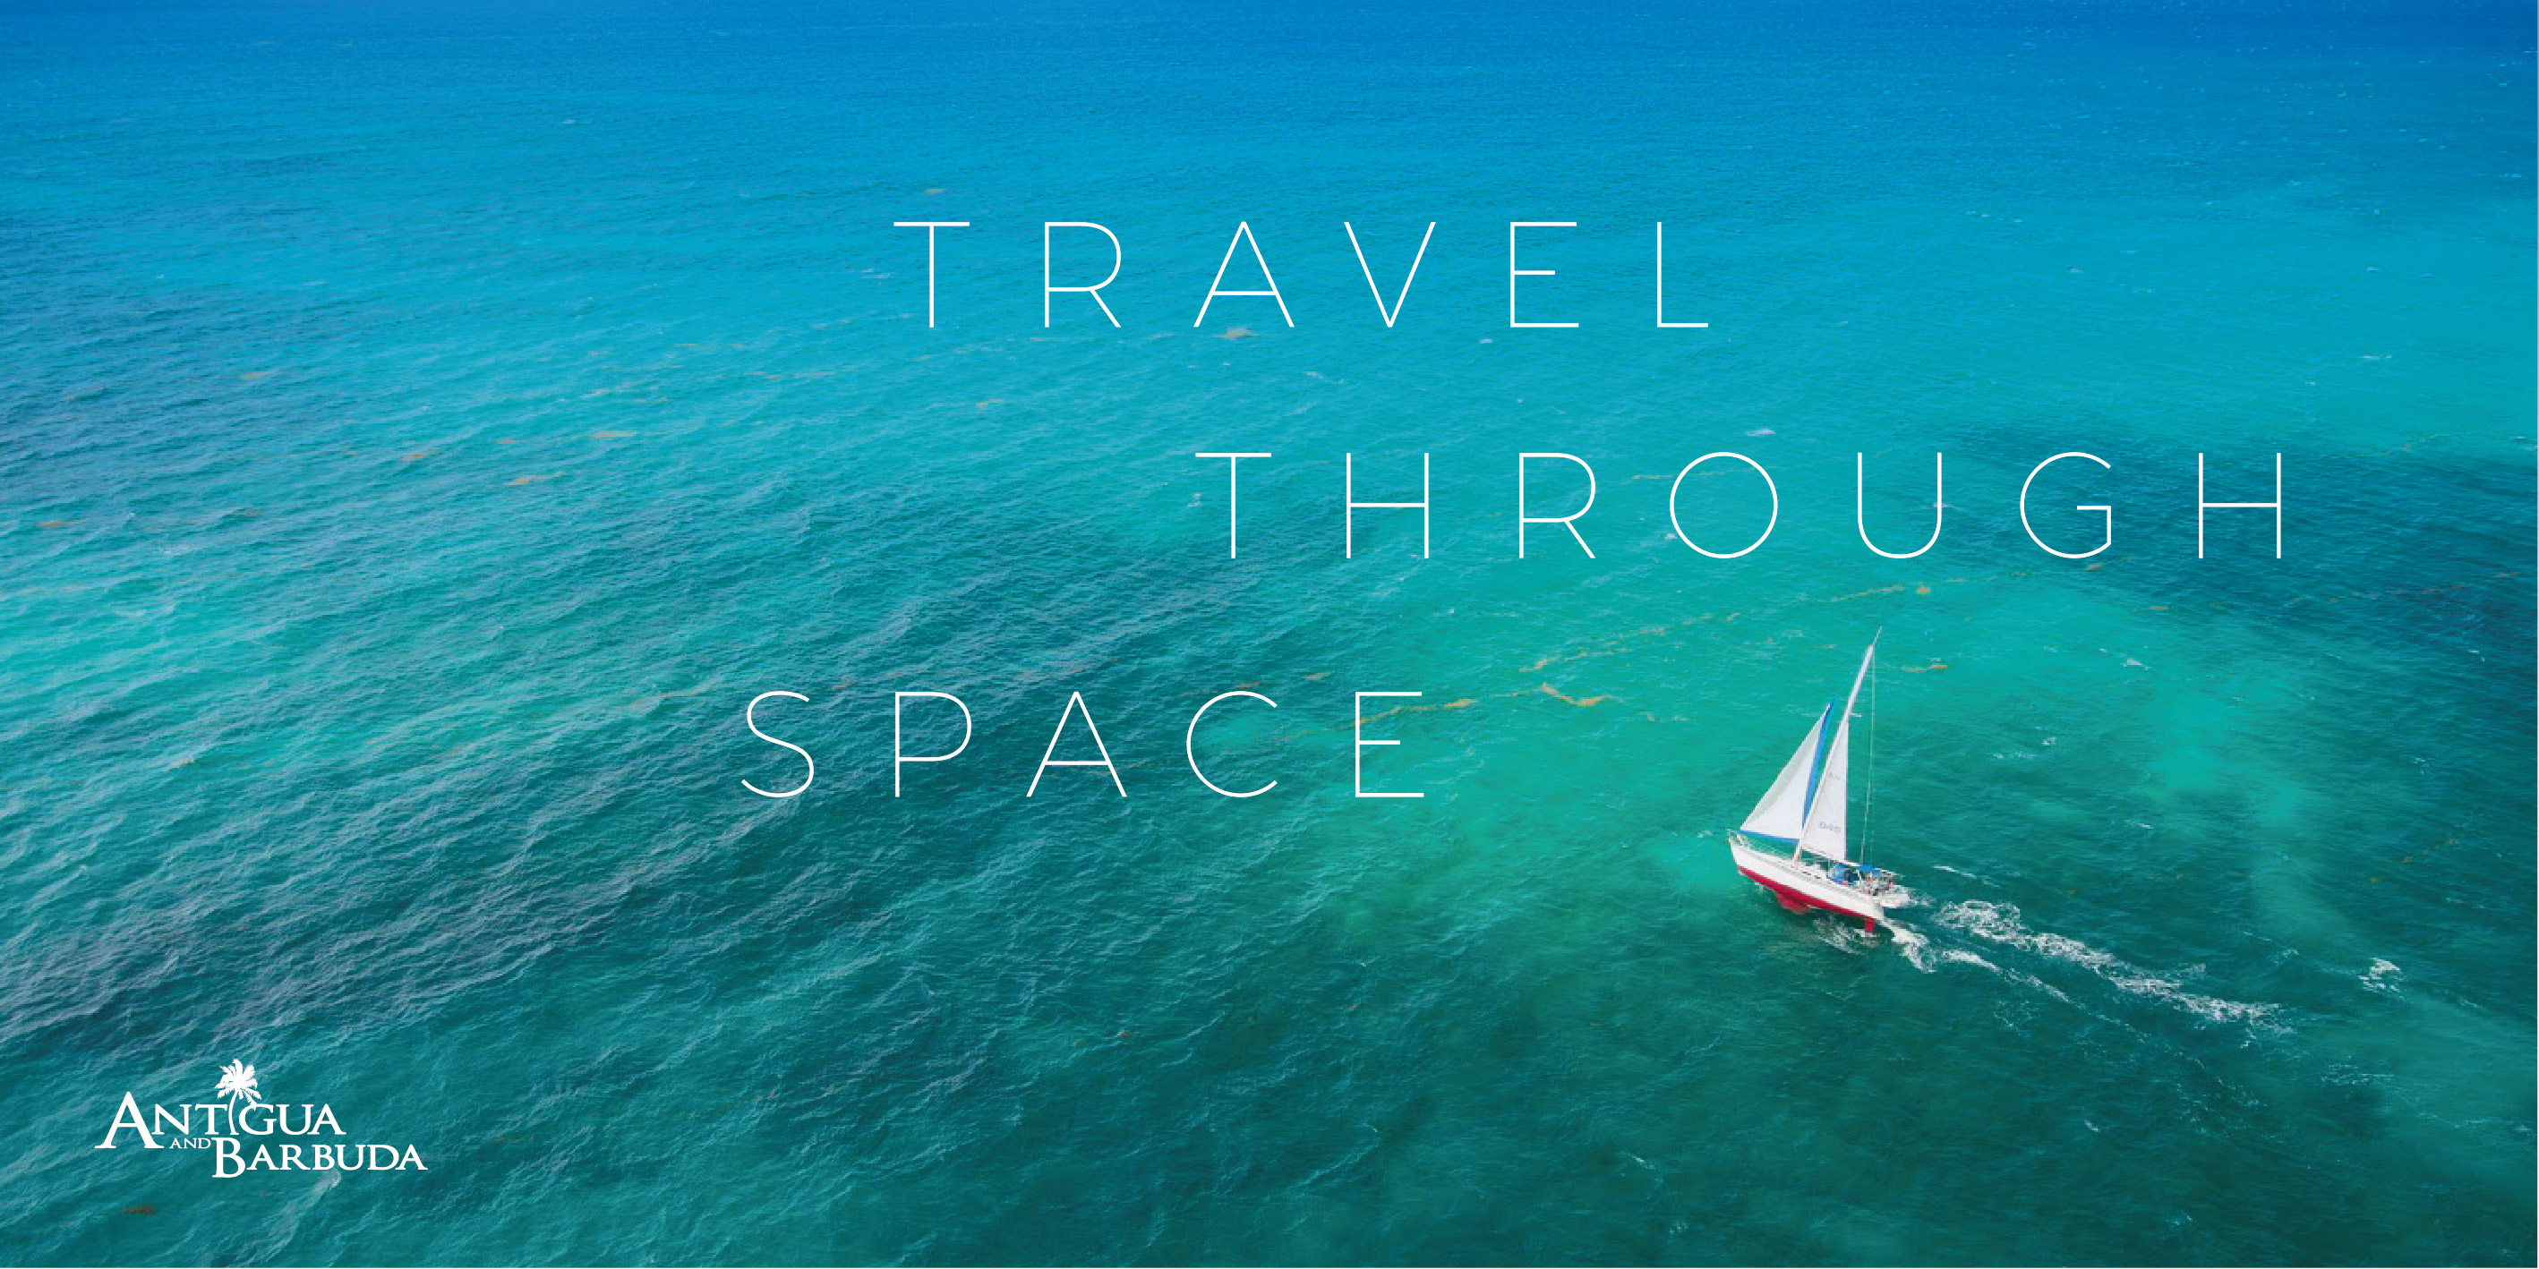

*The Antigua and Barbuda Tourism Authority’s ‘Your Space in the Sun’ campaign launched in June, invites persons to find all the space they need in Antigua and Barbuda. (Photo credits: The Antigua and Barbuda Tourism Authority)*

**ST. JOHN’S, ANTIGUA, (December 18, 2020) –**As 2020 comes to a close, Antigua and Barbuda is being recognized for the relentless work it has done to ensure the success of the tourism industry and maintain the safety of the destination for both visitors and residents alike. The ‘2021 Caribbean Travel Awards,’ led by the *Caribbean Journal*, have awarded Antigua and Barbuda’s Minister Charles ‘Max’ Fernandez as ‘Caribbean Tourism Minister of the Year,’ and named newest property, Hammock Cove, as ‘Small All-Inclusive of the Year,’ and flagship resort Curtain Bluff as ‘Caribbean All-Inclusive of the Year.’

Antigua and Barbuda was one of the first destinations to reopen for tourism, not only in the Caribbean, but the world and the leadership and informed guidance of the Honorable Fernandez, Minister of Tourism and Investment played an important part of him being named the ‘Caribbean Minister of the Year.’ The publication cited Minister Fernandez’s ‘calming hand’ as ‘one of the region’s exemplary tourism relaunches,’ while continuing to drive the hotel development industry as one of the fastest growing in the region.

The *Caribbean* Journal was founded in 2011 as the first pan-Caribbean newspaper, with cutting-edge analysis, unmatched original content, on-location video, the publication has changed the way the Caribbean gets its news, and is today, one of the leading publications in the Caribbean market.

In addition to being recognized in the ‘Caribbean Travel Awards,’ The Antigua and Barbuda Tourism Authority also recently received the Gold award in the annual *Travel Weekly Magellan Award* for the ‘Your Space in the Sun,’ digital campaign and the Platinum award in the *MARCOM Awards* for the same campaign.

For those wanting to experience the beautiful and safe destination firsthand, the Antigua and Barbuda Tourism Authority invites people to enter the ‘Your Space in the Sun’ sweepstakes on [www.visitantiguabarbuda.com](http://www.visitantiguabarbuda.com), to win the escape they deserve in 2021 to Antigua and Barbuda, staying at the luxurious, all-inclusive Royalton Antigua Resort and Spa.

###

**ABOUT ANTIGUA AND BARBUDA**

Antigua (pronounced An-tee'ga) and Barbuda (Bar-byew’da) is located in the heart of the Caribbean Sea. Voted the World Travel Awards 2015, 2016, 2017 *and 2018* *Caribbean’s Most Romantic Destination*, the twin-island paradise offers visitors two uniquely distinct experiences, ideal temperatures year-round, a rich history, vibrant culture, exhilarating excursions, award-winning resorts, mouth-watering cuisine and 365 stunning pink and white-sand beaches - one for every day of the year. The largest of the Leeward Islands, Antigua comprises 108-square miles with rich history and spectacular topography that provides a variety of popular sightseeing opportunities. Nelson’s Dockyard, the only remaining example of a Georgian fort a listed UNESCO World Heritage site, is perhaps the most renowned landmark. Antigua’s tourism events calendar includes the prestigious Antigua Sailing Week, Antigua Classic Yacht Regatta, and the annual Antigua Carnival; known as the Caribbean’s Greatest Summer Festival. Barbuda, Antigua’s smaller sister island, is the ultimate celebrity hideaway. The island lies 27 miles north-east of Antigua and is just a 15-minute plane ride away. Barbuda is known for its untouched 17 mile stretch of pink sand beach and as the home of the largest Frigate Bird Sanctuary in the Western Hemisphere.  Find information on Antigua & Barbuda at: [www.visitantiguabarbuda.com](http://www.visitantiguabarbuda.com) or follow us on **Twitter**. <http://twitter.com/antiguabarbuda>  **Facebook** [www.facebook.com/antiguabarbuda](http://www.facebook.com/antiguabarbuda); **Instagram**: [www.instagram.com/AntiguaandBarbuda](http://www.instagram.com/AntiguaandBarbuda)

**For media enquiries, please contact:**Maria Blackman  
Antigua and Barbuda Tourism Authority

T: 1 (268) 562 7600/464-7601  
E: [maria.blackman@visitaandb.com](mailto:maria.blackman@visitaandb.com)