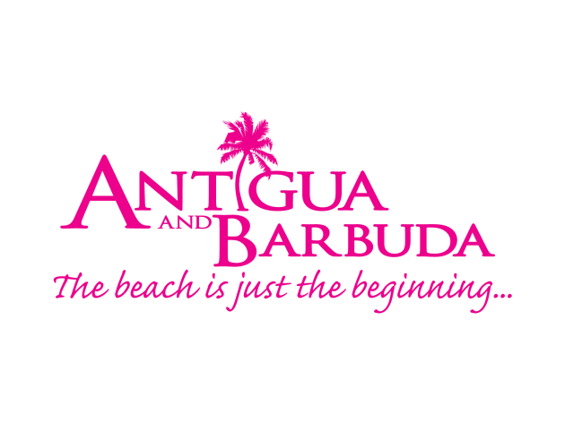

FOR IMMEDIATE RELEASE:

DEMAND FOR ANTIGUA AND BARBUDA HIGH AMONGST
US TRAVELLERS

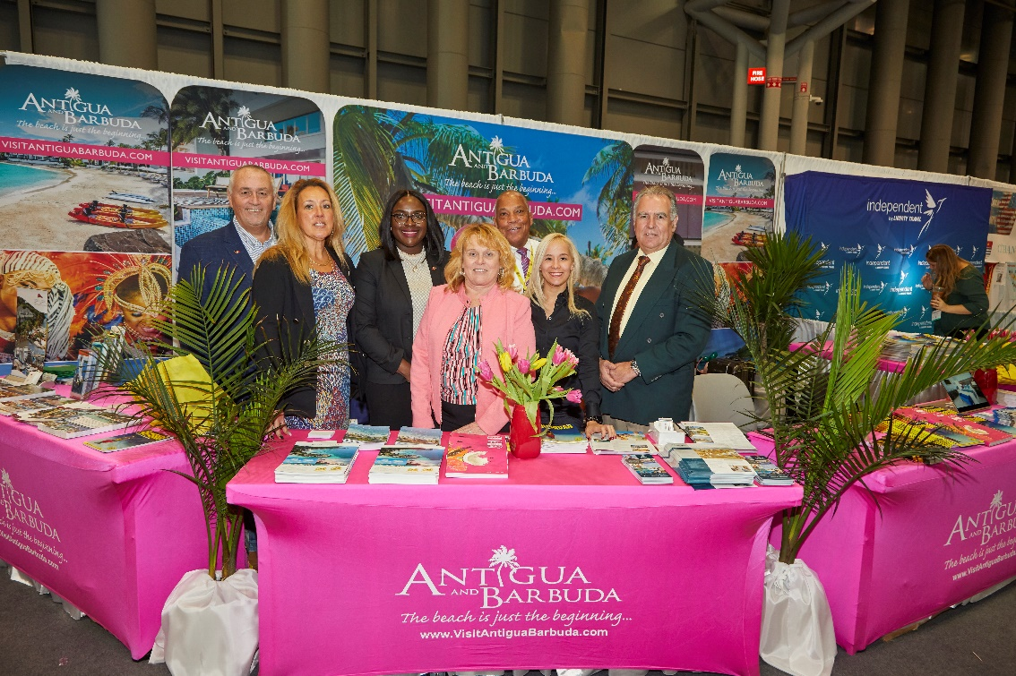
(Photo Caption: The Antigua and Barbuda Tourism Authority's US Team and Antigua hotel representatives were present at the 2020 New York Times Travel Show in New York City where they met with consumers, travel trade and members of the media)

ST. JOHN’S, ANTIGUA (February 10, 2020) - ABTA's US Director of Tourism Dean Fenton has noted that, Antigua and Barbuda is particularly resonating with the US traveller as the US Market continues to grow at a fast pace, having ended 2019, with +17% growth for the year, and forward bookings showing demand for the destination increasing amongst US Travellers into 2020.
Fenton made the comment, having participated at the largest travel trade and consumer show in North America, the New York Times Travel Show, held in late January.

Antigua and Barbuda was represented at the show by ABTA’s US Team who presented a comprehensive destination update to leading travel trade, media and consumers from the US, Canada and the Caribbean at the show.
The Antigua and Barbuda Tourism Authority also partnered with various hotel partners at the show, including Blue Waters, Elite Island Resorts, Carlisle Bay, South Point Hotel, Sugar Ridge Hotel, Royalton Antigua Resort and Spa, and the Starfish Hotel Properties.
“We are excited to partner with our hoteliers and on-island stakeholders to build on the success of 2019 and share first-hand with consumers and trade exactly why Antigua and Barbuda is on the ‘must visit’ list for 2020. I am confident we will see positive returns for this key US market,” said the US Director of Tourism.

ABOUT ANTIGUA AND BARBUDA
Antigua (pronounced An-tee'ga) and Barbuda (Bar-byew’da) is located in the heart of the Caribbean Sea. Voted the World Travel Awards 2015, 2016, 2017 and 2018 Caribbean’s Most Romantic Destination, the twin-island paradise offers visitors two uniquely distinct experiences, ideal temperatures year-round, a rich history, vibrant culture, exhilarating excursions, award-winning resorts, mouth-watering cuisine and 365 stunning pink and white-sand beaches - one for every day of the year. The largest of the Leeward Islands, Antigua comprises 108-square miles with rich history and spectacular topography that provides a variety of popular sightseeing opportunities. Nelson’s Dockyard, the only remaining example of a Georgian fort a listed UNESCO World Heritage site, is perhaps the most renowned landmark. Antigua’s tourism events calendar includes the prestigious Antigua Sailing Week, Antigua Classic Yacht Regatta, and the annual Antigua Carnival; known as the Caribbean’s Greatest Summer Festival. Barbuda, Antigua’s smaller sister island, is the ultimate celebrity hideaway. The island lies 27 miles north-east of Antigua and is just a 15-minute plane ride away. Barbuda is known for its untouched 17 mile stretch of pink sand beach and as the home of the largest Frigate Bird Sanctuary in the Western Hemisphere. Find information on Antigua & Barbuda at: www.visitantiguabarbuda.com or follow us on Twitter. http://twitter.com/antiguabarbuda Facebook www.facebook.com/antiguabarbuda; Instagram: www.instagram.com/AntiguaandBarbuda
For media enquiries, please contact:
Maria Blackman
Antigua and Barbuda Tourism Authority
T: 1 (268) 562 7600/464-7601
E: maria.blackman@visitaandb.com

