Lights, Camera, Action!
Antigua’s Romance, Gastronomy and Wellness Showcased on UK Television
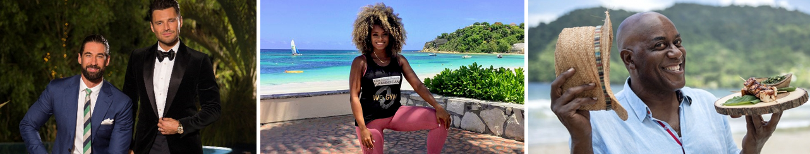

March 13 2019, (LONDON, UNITED KINGDOM): 2019 has seen Antigua take centre stage on UK terrestrial television with a host of celebrity presenters, reality television stars and much-loved chefs descending on the island for a bounty of broadcast opportunities that shine a light on the island’s most irresistible qualities. The television programmes have highlighted local and traditional cuisines, the incredible romance offerings for couples and the amazing health and wellness experiences at some of the island’s most beautiful hotels.
Showcasing the island’s mouth-watering gastronomy, Antigua played host to British celebrity chef Ainsley Harriott for a 10-part series on Caribbean cuisine for ITV. With the two Antigua episodes airing this March, Ainsley’s Caribbean Kitchen will take viewers on a delectable journey across the island, stopping off at local favourites Beach Limerz, Nicole’s Table and luxury resort Carlisle Bay.
The Bachelor, a popular reality television show that sees an eligible suitor on a quest for love, is back on the UK’s Channel 5 screens for its sixth series with the final two episodes airing on the beautiful island of Antigua. Hosted by UK and US reality star and presenter Mark Wright, Antigua is the idyllic backdrop for the show’s finale and the bachelor and his dates will have the chance to experience some of the island’s most exciting attractions; swimming with stingrays, partying at Shirley Heights and the unbeatable sunsets at Fort James Beach.
Earlier this year, Antigua was temporarily renamed as Inch Loss Island, as three contestants took part in a health and fitness challenge for the UK’s leading daytime television show, ITV’s This Morning. The mini-series saw British presenter, singer and fitness guru Fleur East guide a handful of This Morning viewers on their weight-loss journey in Antigua, with wellness experiences including kayaking across Mamora Bay, a zip-line ­challenge, float fit and aqua aerobics, and sunset yoga.

-Ends-
Notes to editors
Ainsley’s Caribbean Kitchen airs on ITV 1 at 11.30am with the Antigua episodes on screen on the 17th and 24th March 2019.
The Bachelor airs on Channel 5 at 10pm with the Antigua episodes airing for a two-hour special on the 14th March 2019.
ABOUT ANTIGUA AND BARBUDA
Antigua (pronounced An-tee'ga) and Barbuda (Bar-byew’da) is located in the heart of the Caribbean Sea. Voted the World Travel Awards Caribbean’s Most Romantic Destination, the twin-island paradise offers visitors two uniquely distinct experiences, ideal temperatures year-round, a rich history, vibrant culture, exhilarating excursions, award-winning resorts, mouth-watering cuisine and 365 stunning pink and white-sand beaches - one for every day of the year. The largest of the Leeward Islands, Antigua comprises 108-square miles with rich history and spectacular topography that provides a variety of popular sightseeing opportunities. Nelson’s Dockyard, the only remaining example of a Georgian fort a listed UNESCO World Heritage site, is perhaps the most renowned landmark. Antigua’s tourism events calendar includes the prestigious Antigua Sailing Week, Antigua Classic Yacht Regatta, and the annual Antigua Carnival; known as the Caribbean’s Greatest Summer Festival. Barbuda, Antigua’s smaller sister island, is the ultimate celebrity hideaway. The island lies 27 miles north-east of Antigua and is just a 15-minute plane ride away. Barbuda is known for its untouched 17 mile stretch of pink sand beach and as the home of the largest Frigate Bird Sanctuary in the Western Hemisphere. Find information on Antigua & Barbuda at: www.visitantiguabarbuda.com and follow us on:
Twitter: http://twitter.com/antiguabarbuda
Facebook: www.facebook.com/antiguabarbuda;

