FOR IMMEDIATE RELEASE:

JAMAICAN ROMAINE WELDS, ENDS QUEST TO VISIT ALL THE COUNTRIES OF THE WORLD IN ANTIGUA AND BARBUDA

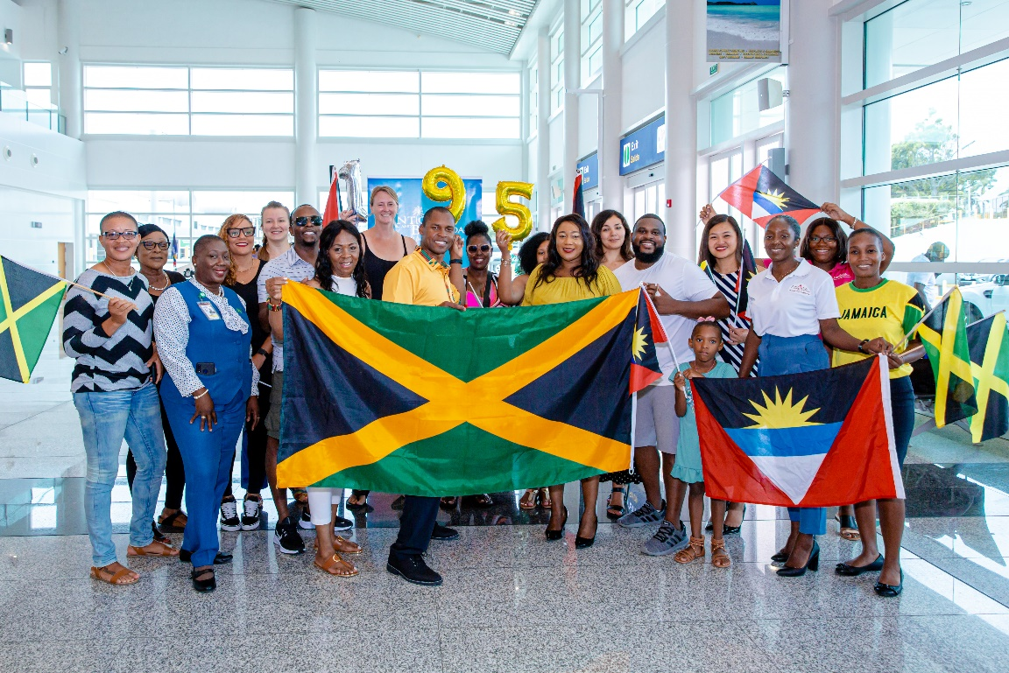
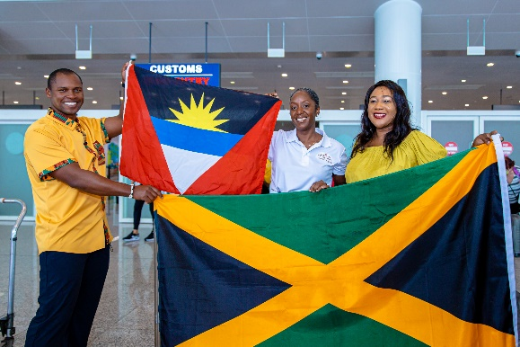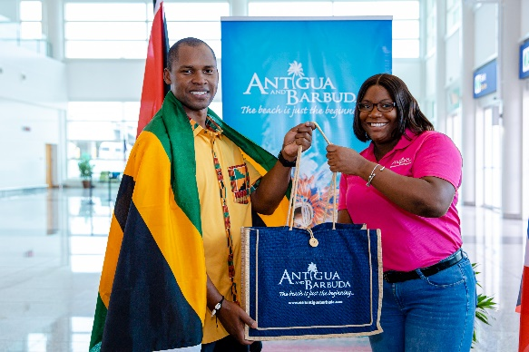
Photo Caption: Amongst the well-wishers who were present at the V.C. Bird International Airport to greet Romaine Welds, were (second row of photos) the Antigua and Barbuda Tourism Authority’s Marketing Communications Manager Maria Blackman, Honourary Consul for Jamaica in Antigua, Dr. Onika Campbell and Tourism Marketing Officer Kayla Christian.

ST. JOHN’S, ANTIGUA (September 20, 2022) – The Antigua and Barbuda Tourism Authority is celebrating with thirty-seven-year-old, world traveller Romaine Welds, who on his September 18th arrival into Antigua and Barbuda at the V.C. Bird International Airport, has completed his quest to visit all 195 countries in the world.

The Antigua and Barbuda Tourism Authority, The Antigua and Barbuda Airport Authority and The Jamaican Consulate in Antigua warmly welcomed Welds, alongside his family and travel friends who journeyed to Antigua to mark the momentous occasion with him.

Welds who is Jamaican-born and migrated to the United States of America in 2007, is the first Jamaican, and possibly the first person in the Caribbean to achieve this goal.

Marketing Communications Manager for the Antigua and Barbuda Tourism Authority, Maria Blackman said, “We’re thrilled to be sharing in this celebration with Romaine. How amazing is it to be able to travel and experience the wonders and cultures of the world. We invite you to explore our twin-island paradise and immerse yourself in our culture. We also look forward to welcoming all future world explorers.”

Honourary Consul for Jamaica in Antigua and Barbuda, Dr. Onika Campbell proudly said, “It is warming to welcome my fellow Jamaican and his team to Antigua and Barbuda. Antigua and Barbuda is home to many Jamaican nationals who for decades continue to enjoy the warmth and hospitality of the people.

"Your decision to complete your visit in Antigua and Barbuda speaks volumes of the historic, established and continuous bi-lateral relationship between Antigua and Barbuda and Jamaica", noted Dr. Campbell.

Welds said his travel adventures begun when he decided to visit bucket-list places he would see on National Geographic. From there he moved on to the ‘7 Wonders of the World’, then the BRICS (Brazil, Russia, India, China, and South Africa) countries and the list kept growing. In 2016 when he reached his then goal of visiting 100 countries by the age of 30, he decided to take on the world!

He reflected that, “As a student in Jamaica, I used to love geography. It was my favourite subject, but never in a million years did I imagine that I would end up visiting every country in the world. It has been a life changing experience. I’ve learned so much while travelling and meeting other inspiring globetrotters around the world and now finally, I have made it to the finish line, visiting 195 countries while working full time!”

On his reason for choosing Antigua and Barbuda as his final destination, Welds said, “I thought it would be great to complete this journey close to home where it all started. I settled mostly on Antigua because it seems like a mini hub in the Caribbean with lots of flight connections. As I wanted my friends and family to get flights easily to join me on this final journey, and also for the beautiful beaches – the choice fell on Antigua & Barbuda.”

Romaine will spend a week in Antigua, exploring the destination with friends.

You can follow Romaine Welds Travel Adventures on Instagram @Travelingtheworldwithromaine.

Romaine Welds currently lives in San Francisco, California where he works for a major American airline company as a ground agent which assists him in his travel pursuits. His next goal is to visit festivals and tribes around the world.

###
ABOUT THE ANTIGUA AND BARBUDA TOURISM AUTHORITY
The Antigua & Barbuda Tourism Authority is a statutory body dedicated to realizing the tourism potential of Antigua & Barbuda by promoting the twin island state as a unique, quality tourist destination with the overall objective of increasing visitor arrivals thereby providing sustainable economic growth. The Antigua and Barbuda Tourism Authority is headquartered in St. John’s Antigua, where regional marketing is directed. The Authority has three offices overseas in the United Kingdom, United States and Canada.

ABOUT ANTIGUA AND BARBUDA
Antigua (pronounced An-tee'ga) and Barbuda (Bar-byew’da) is located in the heart of the Caribbean Sea. The twin-island paradise offers visitors two uniquely distinct experiences, ideal temperatures year-round, a rich history, vibrant culture, exhilarating excursions, award-winning resorts, mouth-watering cuisine and 365 stunning pink and white-sand beaches - one for every day of the year. The largest of the English-speaking Leeward Islands, Antigua comprises 108-square miles with rich history and spectacular topography that provides a variety of popular sightseeing opportunities. Nelson’s Dockyard, the only remaining example of a Georgian fort a listed UNESCO World Heritage site, is perhaps the most renowned landmark. Antigua’s tourism events calendar includes the prestigious Antigua Sailing Week, Antigua Classic Yacht Regatta, and the annual Antigua Carnival; known as the Caribbean’s Greatest Summer Festival. Barbuda, Antigua’s smaller sister island, is the ultimate celebrity hideaway. The island lies 27 miles north-east of Antigua and is just a 15-minute plane ride away. Barbuda is known for its untouched 11-mile stretch of pink sand beach and as the home of the largest Frigate Bird Sanctuary in the Western Hemisphere. Find information on Antigua & Barbuda at: www.visitantiguabarbuda.com or follow us on Twitter: http://twitter.com/antiguabarbuda Facebook: www.facebook.com/antiguabarbuda; Instagram: www.instagram.com/AntiguaandBarbuda

For Antigua and Barbuda media enquiries, please contact:
Maria Blackman
Marketing Communications Manager
Antigua and Barbuda Tourism Authority
T: 1 (268) 562 7600/464-7601
E: maria.blackman@visitaandb.com
Antigua and Barbuda Images: aandbtourism.fotoseeker.com

