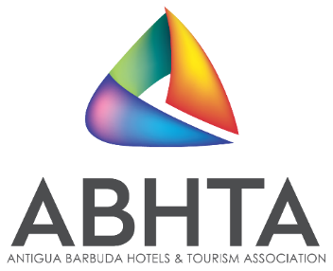
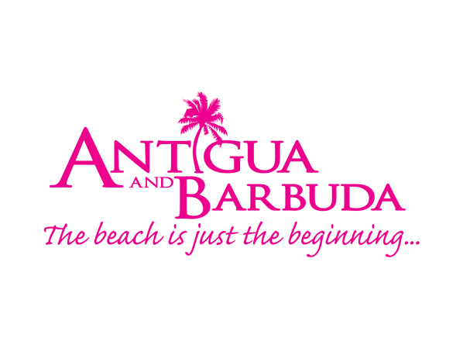
FOR IMMEDIATE RELEASE

“SUN SEA SAFE” BADGE LAUNCHED FOR
ANTIGUA & BARBUDA TOURISM SECTOR BUSINESSES
HEALTH AND SAFETY VIDEO FEATURING EMPLOYEES ALSO DEBUTING

ST. JOHN’S, Antigua and Barbuda (November 10, 2020) – The Antigua and Barbuda Ministry of Tourism, Antigua and Barbuda Tourism Authority (ABTA), and Antigua Barbuda Hotels and Tourism Association (ABHTA) has announced the tagline ‘Sun Sea Safe’ for the destination’s Covid-19 certification program. ‘Sun Sea Safe’ will feature prominently on an attractive new badge created by the Antigua and Barbuda Tourism Authority for tourism sector businesses that have completed the Health and Safety Programme and inspection by the Central Board of Health and the Ministry of Tourism.

The ‘Sun Sea Safe’ badge prominently displayed by resorts, retail outlets, restaurants and excursions will assure residents and visitors that their health and safety protocols meet the strict government guidelines. In addition to the new tagline, the ABHTA has also produced a “Sun Sea Safe” video featuring members staff showing how they keep everyone safe each day. The video will be available to stream on the ABHTA social media platforms, @antiguahotels and @antiguahoteljobs on Facebook and Instagram, as well as on the ABTA website at visitantiguabarbuda.com.

“Here in Antigua and Barbuda we are embracing the idea that the safety procedures our tourism sector has worked so diligently to put into place, will now be the standard for the future,” says Vernon A. Jeffers, Snr, Chairman of the ABHTA. “The ‘Sun Sea Safe’ tagline illustrates this beautifully and will become a familiar and expected symbol of the health and safety standards established for our guests and patrons.”

Antigua and Barbuda’s Minister of Tourism, The Hon. Charles Fernandez commented: “Sun Sea Safe is our open invitation to travellers to enjoy Antigua and Barbuda's warmth and hospitality, while importantly connecting with their need for safety. We believe that while wholly relevant today, this message will transcend the current pandemic connotation, and will in the future continue to differentiate our destination in a positive way.”

In addition to the new ‘Sun Sea Safe’ initiative, ABHTA members continue to put their own positive spin on the required guidelines. Galley Bay began welcoming guests back on October 14, and in addition to putting extensive enhanced health and safety protocols in place, the resort developed signage to remind everyone in a light-hearted way to obey all protocols. According to General Manger Alex de Brito their team wanted to make sure to keep the procedures top-of-mind for guests as they enjoyed their stay without causing protocol fatigue. Instead of telling guests to distance 2-meters, they are reminded that in Antigua social distance is 9½ coconuts apart. Colourful cartoon pineapples are featured handwashing and coconuts filled with refreshments wear face masks while reminding everyone to “be safe for yourself and others.”

As the destination continues their efforts to fully reopen for the Winter Season, 366 tourism businesses have already earned their “Sun Sea Safe” badges.
Tourism Businesses that have completed the Ministry of Tourism and Central Board of Health's inspections and that are eligible for the ‘Sun Sea Safe’ 2020 certification badge can contact the Ministry of Tourism on 468 - 4003 and the Antigua and Barbuda Tourism Authority on 562 - 7600. For more information businesses can also contact the office of the ABHTA abhta@antiguahotels.org or call 462 - 0374/4928.

ABOUT THE ABHTA
The ABHTA collectively represents the hospitality industry by educating, advocating and promoting to increase visitation and the economic benefits for Antigua and Barbuda. The primary focus is on the needs and best interests of the members of the Association. The membership of the Antigua & Barbuda Hotels & Tourism Association is open to all hotels, restaurants, airlines, and companies directly or indirectly involved in the tourism sector of Antigua and Barbuda. Joining the Association is a way of showing your support of the island’s tourism product and helping us to further develop our tourism industry.
###

ABOUT THE ANTIGUA AND BARBUDA TOURISM AUTHORITY
The Antigua & Barbuda Tourism Authority is a statutory body dedicated to realizing the tourism potential of Antigua & Barbuda by promoting the twin island state as a unique, quality tourist destination with the overall objective of increasing visitor arrivals thereby providing sustainable economic growth. The Antigua and Barbuda Tourism Authority is headquartered in St. John’s Antigua, where regional marketing is directed. The Authority has three offices overseas in the United Kingdom, United States and Canada.
ABOUT ANTIGUA AND BARBUDA
Antigua (pronounced An-tee'ga) and Barbuda (Bar-byew’da) is located in the heart of the Caribbean Sea. Voted the World Travel Awards 2015, 2016, 2017 and 2018 Caribbean’s Most Romantic Destination, the twin-island paradise offers visitors two uniquely distinct experiences, ideal temperatures year-round, a rich history, vibrant culture, exhilarating excursions, award-winning resorts, mouth-watering cuisine and 365 stunning pink and white-sand beaches - one for every day of the year. The largest of the Leeward Islands, Antigua comprises 108-square miles with rich history and spectacular topography that provides a variety of popular sightseeing opportunities. Nelson’s Dockyard, the only remaining example of a Georgian fort a listed UNESCO World Heritage site, is perhaps the most renowned landmark. Antigua’s tourism events calendar includes the prestigious Antigua Sailing Week, Antigua Classic Yacht Regatta, and the annual Antigua Carnival; known as the Caribbean’s Greatest Summer Festival. Barbuda, Antigua’s smaller sister island, is the ultimate celebrity hideaway. The island lies 27 miles north-east of Antigua and is just a 15-minute plane ride away. Barbuda is known for its untouched 17 mile stretch of pink sand beach and as the home of the largest Frigate Bird Sanctuary in the Western Hemisphere. Find information on Antigua & Barbuda at: www.visitantiguabarbuda.com or follow us on Twitter. http://twitter.com/antiguabarbuda Facebook www.facebook.com/antiguabarbuda; Instagram: www.instagram.com/AntiguaandBarbuda

For Antigua and Barbuda Hotels and Tourism Association Media Enquiries please contact:
E: abhta@antiguahotels.org
T: 462 - 0374/4928.

For Antigua and Barbuda Tourism Authority media enquiries, please contact:
Maria Blackman
Antigua and Barbuda Tourism Authority
T: 1 (268) 562 7600/464-7601
E: maria.blackman@visitaandb.com

