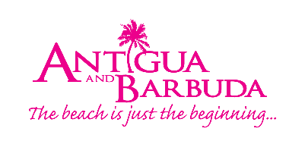
THINGS ARE GETTING BETTER AS FIRST CRUISE RETURNS TO ANTIGUA AND BARBUDA
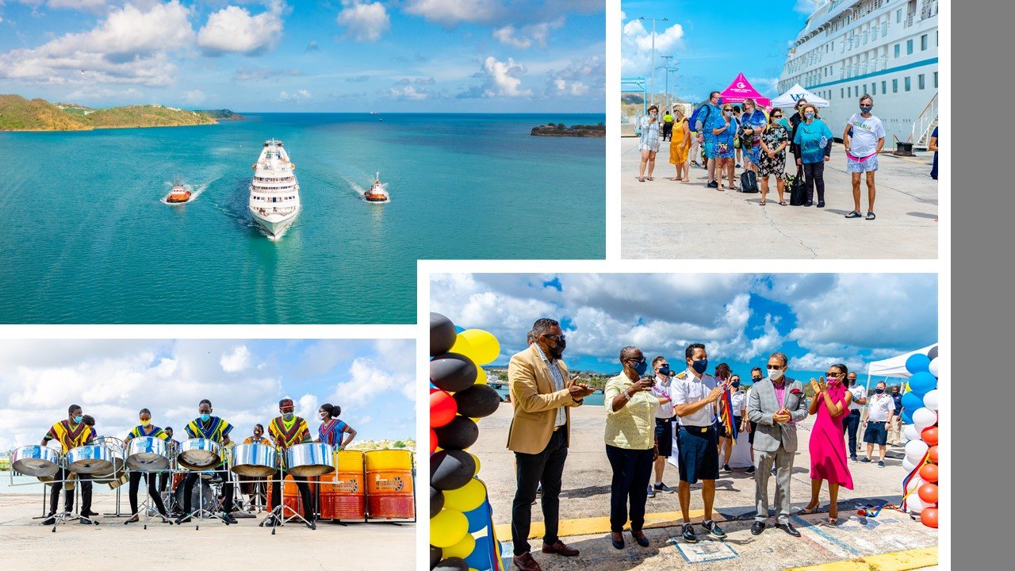
Photo Caption: A welcome sight, as Antigua and Barbuda celebrates the return of cruising (Photo Credits Antigua and Barbuda Tourism Authority)
ST. JOHN’S, ANTIGUA (July 15, 2021) – Tourism hopes are high in Antigua and Barbuda as the country welcomes the return of cruising signaling the rebound of the vibrant cruise tourism sector.
The mood was celebratory as Windstar Cruises’ Star Breeze, coasted into Antigua’s, St. John’s Harbour on July 15, greeted by a symbolic water canon salute, the booming of tugboat horns, and lively steelpan performances by the respected Hells Gate Steel Orchestra.
On hand to officially welcome Captain Ricardo Pinzon, and over two hundred passengers and crew onboard the luxury vessel, was Minister of Tourism, The Honourable Charles Fernandez, Minister of State in the Ministry of Tourism Senator, The Hon. Mary-Claire Hurst, CEO of the Antigua and Barbuda Tourism Authority Colin C. James, General Manager of the Antigua Cruise Port Dona Regis-Prosper, Chief Health Inspector Sharon Martin, alongside other health and tourism stakeholders.
“Today is truly an exciting day for Antigua and Barbuda’s cruise industry. It is one that we have been working hard towards with our Health Authorities and International Cruise lines to ensure that we restart in a safe and sustainable manner to the benefit of all stakeholders,” said Minister of Tourism, the Honourable Charles Fernandez. “It’s also one that has been looked forward to with anticipation by the scores of businesses and hundreds of our countrymen who depend on this industry for their livelihoods.”
Antigua’s cruise ship sector was poised for exponential growth just prior to the pandemic. This is the first revenue cruise that the country has received in over a year. It comes at a time when Antigua and Barbuda has more than 37,000 persons in its adult population vaccinated, and covid-19 cases are at an all time low, following the successful management of the health crisis.
A third of Antigua and Barbuda’s labour force is employed in the tourism industry. In preparation for the safe restart the cruise sector, Antigua and Barbuda tourism officials invested in training tourism workers, covid-19 protocol certified approximately four hundred tourism businesses, and improved port infrastructure to include the completion of a fifth berth. They have also held months of discussions with Antigua Cruise Port management, and the Ministry of Health designing robust health and safety protocols.
Dona Regis-Prosper, General Manager of Antigua Cruise Port said, “Nothing could have given me greater joy today than the sight of the Star Breeze pulling into the port! We are absolutely thrilled to welcome this fabulous yacht-style cruise ship and its passengers and crew to Antigua & Barbuda. In recent weeks, we have been in many discussions with the Windstar Cruises team and the government to determine how to make this trip, and voyages to come, as safe and successful as possible for everyone involved.

Regis-Prosper noted that, “Given the fact that the threat of COVID-19 is still very real, the cruise line has advised that as a cautionary measure, only passengers taking organized tours will be allowed to disembark in the first instance, however, we continue to work with the cruise line and local health authorities as these protocols evolve. We are grateful for the confidence that the Windstar Cruises team has demonstrated in our port and our destination by choosing Antigua & Barbuda as one of the exclusive destinations for this sailing”.
All crew and passengers on Windstar Cruises’ Star Breeze are fully vaccinated. Over sixty passengers disembarked the vessel to enjoy organized tours in Antigua and Barbuda.
Antigua and Barbuda is a luxurious world class destination with many beautiful white sandy beaches, culinary delicacies, unique excursions, and tour options for guests to enjoy.
###

ABOUT THE ANTIGUA AND BARBUDA TOURISM AUTHORITY
The Antigua & Barbuda Tourism Authority is a statutory body dedicated to realizing the tourism potential of Antigua & Barbuda by promoting the twin island state as a unique, quality tourist destination with the overall objective of increasing visitor arrivals thereby providing sustainable economic growth. The Antigua and Barbuda Tourism Authority is headquartered in St. John’s Antigua, where regional marketing is directed. The Authority has three offices overseas in the United Kingdom, United States and Canada.

ABOUT ANTIGUA AND BARBUDA
Antigua (pronounced An-tee'ga) and Barbuda (Bar-byew’da) is located in the heart of the Caribbean Sea. Voted the World Travel Awards 2015, 2016, 2017 and 2018 Caribbean’s Most Romantic Destination, the twin-island paradise offers visitors two uniquely distinct experiences, ideal temperatures year-round, a rich history, vibrant culture, exhilarating excursions, award-winning resorts, mouth-watering cuisine and 365 stunning pink and white-sand beaches - one for every day of the year. The largest of the Leeward Islands, Antigua comprises 108-square miles with rich history and spectacular topography that provides a variety of popular sightseeing opportunities. Nelson’s Dockyard, the only remaining example of a Georgian fort a listed UNESCO World Heritage site, is perhaps the most renowned landmark. Antigua’s tourism events calendar includes the prestigious Antigua Sailing Week, Antigua Classic Yacht Regatta, and the annual Antigua Carnival; known as the Caribbean’s Greatest Summer Festival. Barbuda, Antigua’s smaller sister island, is the ultimate celebrity hideaway. The island lies 27 miles north-east of Antigua and is just a 15-minute plane ride away. Barbuda is known for its untouched 17 mile stretch of pink sand beach and as the home of the largest Frigate Bird Sanctuary in the Western Hemisphere. Find information on Antigua & Barbuda at: www.visitantiguabarbuda.com or follow us on Twitter. http://twitter.com/antiguabarbuda Facebook www.facebook.com/antiguabarbuda; Instagram: www.instagram.com/AntiguaandBarbuda

For media enquiries, please contact:
Maria Blackman
Antigua and Barbuda Tourism Authority
T: 1 (268) 562 7600/464-7601
E: maria.blackman@visitaandb.com

