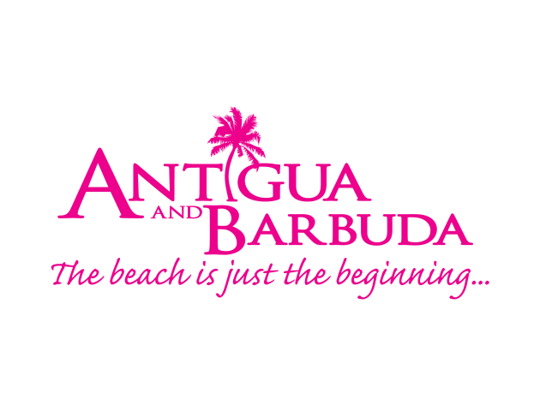

FOR IMMEDIATE RELEASE:

ANTIGUA AND BARBUDA REACHES 300,000th STAY-OVER VISITOR MILESTONE IN 2019

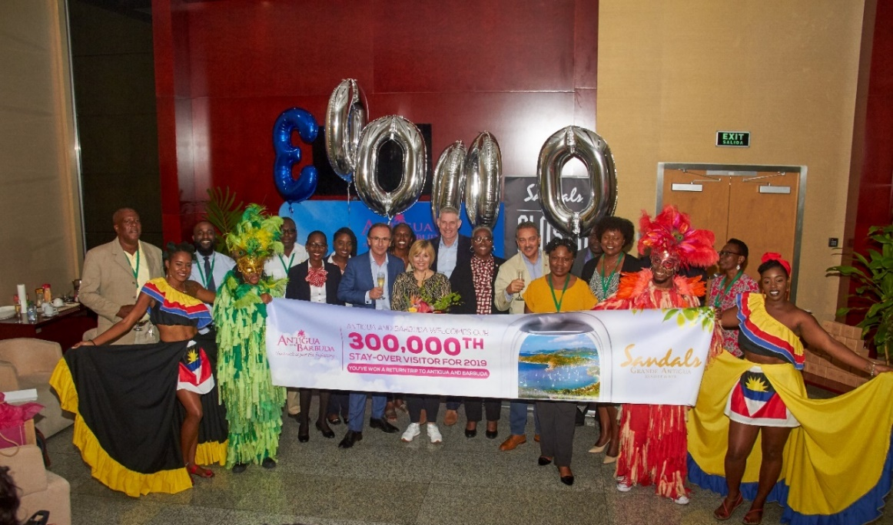
(Photo Caption: Antigua and Barbuda Minister of Tourism, The Hon. Charles Fernandez joins with tourism officials and stakeholders to welcome the arrival of the 300,000th visitor Laura Bowen (c) with a celebration on the eve of the new year.)
ST. JOHN’S, ANTIGUA (January 1, 2020) – Antigua and Barbuda Tourism Officials began ringing in the New Year early at the V.C. Bird International Airport, as visitors arriving into Antigua and Barbuda on Old Year’s Eve, helped to push Antigua and Barbuda’s total stay-over arrivals in 2019 to the 300,000th milestone.
It was a festive afternoon, as cultural masqueraders, and dancers in colourful costumes, begun celebrating by partying on the band stand and greeting passengers in an extravagant cultural display complete with the sounds of melodious steelpan music.
Below in the airport’s VIP Lounge, Antigua and Barbuda’s Minister of Tourism, The Hon. Charles Fernandez, Minister of State in the Ministry of Tourism, Sen. Mary-Clare Hurst, Chairman of the Antigua and Barbuda Tourism Authority, Lorraine Raeburn, and other airport and tourism officials awaited the announcement that the record-breaking 300,000th visitor mark had been reached.
Laura and Ian Bowen, became the 300,000th and the 300,001 visitors when they arrived on a Virgin Atlantic Flight into Antigua from the United Kingdom. As the couple stepped into the Arrivals Hall, tourism team members, and the cultural performers welcomed them and cheered congratulations.
In the VIP reception held for their arrival, the couple were presented with a free seven-night luxury hotel stay sponsored by Sandals Grande Antigua Resort and Spa along with return flights, a bouquet of tropical flowers and a gift basket filled with Antigua and Barbuda handmade treats and a bottle of the acclaimed 10-year old English Harbour Rum provided by the Antigua and Barbuda Tourism Authority.
“We have seen incredible year over year growth every month this year so far”, said Antigua and Barbuda’s Minister of Tourism, the Honourable Charles Fernandez during the reception.
“Almost every key market is seeing incredible growth – in particular the US, Caribbean, and the UK where our lovely couple hails from. These markets have all contributed to the double digit increase in stay-over air arrivals that we are celebrating this year,” Minister Fernandez remarked.
The Tourism Minister noted that, last month’s November figures showed the largest monthly double-digit increase ever, with November this year at +31% higher than November last year with 29,908 stay-over arrivals.
“At the end of November we had already exceeded our total arrivals reached in 2018. This represents a +14.9% increase year to date, and we were then only 25,000 shy of reaching the 300,000 visitor arrival milestone.”
In recognizing the 300,000 and 300,001 visitors, Minister Fernandez said: “This industry is about providing our visitors with a first class experience and so to our special guests of honour Mr. & Mrs. Bowen we say you could not have chosen a more romantic country for your holiday than Antigua and Barbuda and a more wonderful resort than the Internationally recognised Sandals Resort and Spa, which is the leading “couples only” resort on island.”
Sandals Grande Antigua Resort and Spa, General Manager, Matthew Cornall, who was also present at the reception said, “On behalf of our Chairman and Founder, Mr. Gordon ‘Butch’ Stewart, we remain committed to the continued promotion of Antigua as an ideal vacation destination and are happy to note that the island’s 300,000th stop-over visitor is among our valued returning guests. It is our pleasure to join with the local tourism authority to mark this incredible milestone and we look forward to greater achievements together, as we work to create new milestones for the destination.”
In 2015, The Government of Antigua and Barbuda, transformed the V.C. Bird International Airport, opening a modern terminal, with increased capacity, faster passenger processing times, and enhanced facilities and features to meet their strategic growth plan for tourism. Recognised as a leading Caribbean airport, the award-winning V.C. Bird International Airport, offers each visitor a world-class experience from the moment they disembark the aircraft.
The Tourism Minister, expressed thanks to those who work relentlessly and tirelessly to promote the destination, who share the story of why Antigua and Barbuda is the ‘must-visit’ destination and who provide the perfect travel experience for the many visitors to Antigua and Barbuda.
###

ABOUT ANTIGUA AND BARBUDA
Antigua (pronounced An-tee'ga) and Barbuda (Bar-byew’da) is located in the heart of the Caribbean Sea. Voted the World Travel Awards 2015, 2016, 2017, and 2018 Caribbean’s Most Romantic Destination, the twin-island paradise offers visitors two uniquely distinct experiences, ideal temperatures year-round, a rich history, vibrant culture, exhilarating excursions, award-winning resorts, mouth-watering cuisine and 365 stunning pink and white-sand beaches - one for every day of the year. The largest of the Leeward Islands, Antigua comprises 108-square miles with rich history and spectacular topography that provides a variety of popular sightseeing opportunities. Nelson’s Dockyard, the only remaining example of a Georgian fort a listed UNESCO World Heritage site, is perhaps the most renowned landmark. Antigua’s tourism events calendar includes the prestigious Antigua Sailing Week, Antigua Classic Yacht Regatta, and the annual Antigua Carnival; known as the Caribbean’s Greatest Summer Festival. Barbuda, Antigua’s smaller sister island, is the ultimate celebrity hideaway. The island lies 27 miles north-east of Antigua and is just a 15-minute plane ride away. Barbuda is known for its untouched 17 mile stretch of pink sand beach and as the home of the largest Frigate Bird Sanctuary in the Western Hemisphere. Find information on Antigua & Barbuda at: www.visitantiguabarbuda.com or follow us on Twitter. http://twitter.com/antiguabarbuda Facebook www.facebook.com/antiguabarbuda; Instagram: www.instagram.com/AntiguaandBarbuda

For media enquiries, please contact:
Maria Blackman
Antigua and Barbuda Tourism Authority
T: 1 (268) 562 7600/464-7601
E: maria.blackman@visitaandb.com

