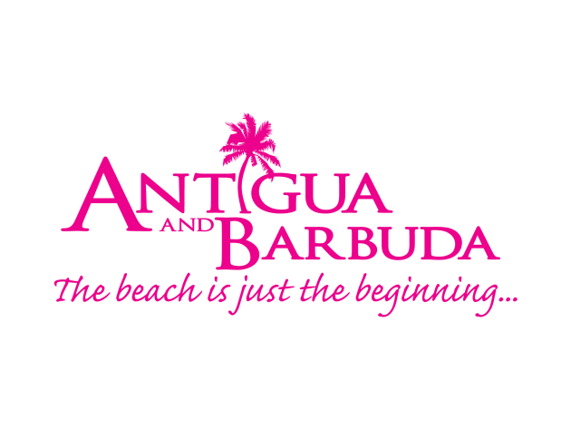

FOR IMMEDIATE RELEASE:

#WHATCOOLLOOKSLIKE SUMMER CAMPAIGN WINS BIG AT INDUSTRY MARKETING COMMUNICATIONS AWARDS
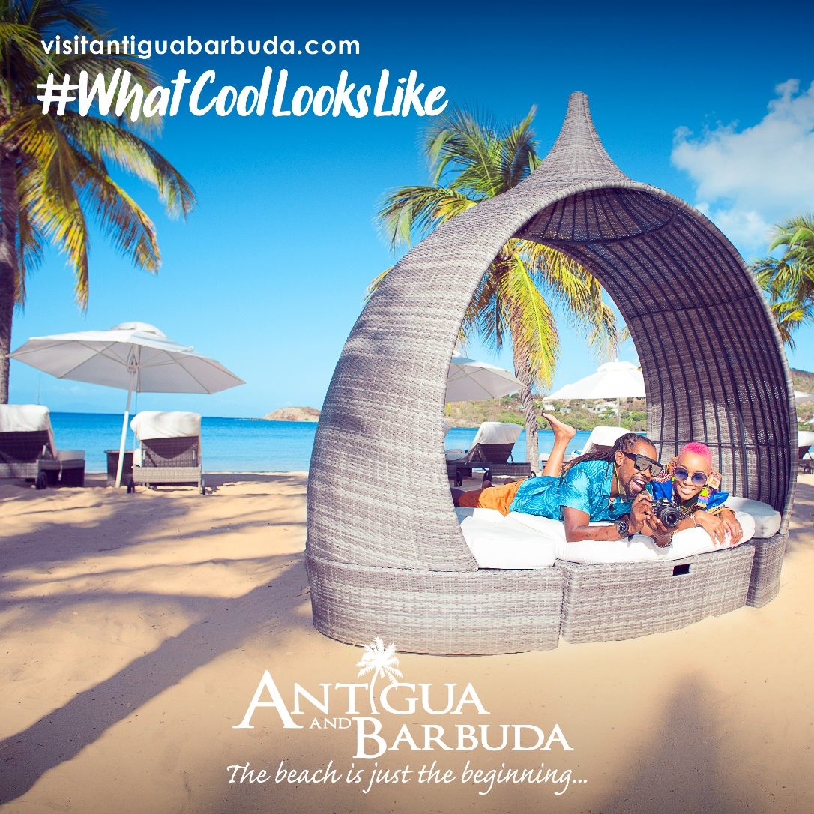
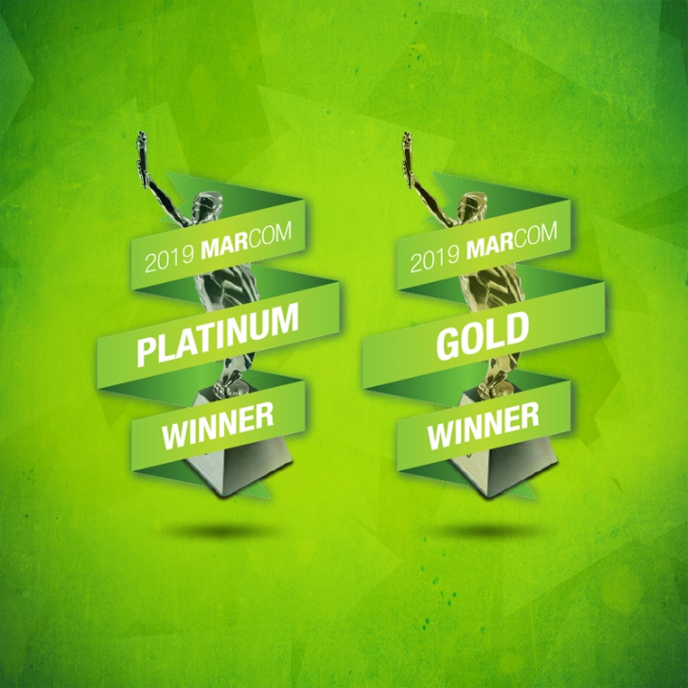

St. John’s, Antigua (Thursday, December 12, 2019) - The Antigua and Barbuda Tourism Authority's (ABTA) award-winning #WhatCoolLooksLike global summer 2019 campaign, has won another award.
This time it’s a MarCom platinum award, for best integrated marketing campaign, the highest accolade conferred by the MarCom Awards. The MarCom Awards honors excellence in marketing and communication while recognizing the creativity and hard work of industry professionals.
Meanwhile, ABTA’s #CoolisClean sub-campaign, focused on sensitizing the public on the importance of keeping Antigua and Barbuda clean has won gold in the digital video, animation category.
Over 6000 entries from corporate marketing and communications departments, advertising agencies, public relations firms, design shops, production companies and freelancers were submitted to this year’s award season. Entries receiving scores of 90-100 are Platinum Winners, while scores of 80-89 are Gold Winners and 70-79 are Honorable Mention Winners.
The winner’s circle included major campaigns from Calvin Klein CK One, Deloitte, Bank of America, Conde Nast, Hilton, All Nippon Airways, Harvard Business School and Weber Shandwick.
Antigua and Barbuda is the only Caribbean destination to have been awarded as MarCom Platinum and Gold Winners in the 2019 Awards.
The MarCom Awards is an international creative competition which recognizes outstanding achievement by marketing and communication professionals. Entries come from corporate marketing and communication departments, advertising agencies, public relations firms, design shops, production companies and freelancers.
The #WhatCoolLooksLike campaign also won a Silver Magellan Award for Best Destination Marketing Campaign from the Travel Weekly organization, one of the largest and most respectable travel trade organizations in the industry.

View the Award-Winning Campaigns here:
#WhatCoolLooksLike - Platinum Winner - https://enter.marcomawards.com/entry/whatcoollookslike-2/

#CoolisClean - Gold Winner - https://enter.marcomawards.com/entry/whatcoollookslike/

###

ABOUT ANTIGUA AND BARBUDA
Antigua (pronounced An-tee'ga) and Barbuda (Bar-byew’da) is located in the heart of the Caribbean Sea. Voted the World Travel Awards 2015, 2016, 2017 and 2018 Caribbean’s Most Romantic Destination, the twin-island paradise offers visitors two uniquely distinct experiences, ideal temperatures year-round, a rich history, vibrant culture, exhilarating excursions, award-winning resorts, mouth-watering cuisine and 365 stunning pink and white-sand beaches - one for every day of the year. The largest of the Leeward Islands, Antigua comprises 108-square miles with rich history and spectacular topography that provides a variety of popular sightseeing opportunities. Nelson’s Dockyard, the only remaining example of a Georgian fort a listed UNESCO World Heritage site, is perhaps the most renowned landmark. Antigua’s tourism events calendar includes the prestigious Antigua Sailing Week, Antigua Classic Yacht Regatta, and the annual Antigua Carnival; known as the Caribbean’s Greatest Summer Festival. Barbuda, Antigua’s smaller sister island, is the ultimate celebrity hideaway. The island lies 27 miles north-east of Antigua and is just a 15-minute plane ride away. Barbuda is known for its untouched 17 mile stretch of pink sand beach and as the home of the largest Frigate Bird Sanctuary in the Western Hemisphere. Find information on Antigua & Barbuda at: www.visitantiguabarbuda.com or follow us on Twitter. http://twitter.com/antiguabarbuda Facebook www.facebook.com/antiguabarbuda; Instagram: www.instagram.com/AntiguaandBarbuda

For media enquiries, please contact:
Maria Blackman
Antigua and Barbuda Tourism Authority
T: 1 (268) 562 7600/464-7601
E: maria.blackman@visitaandb.com

