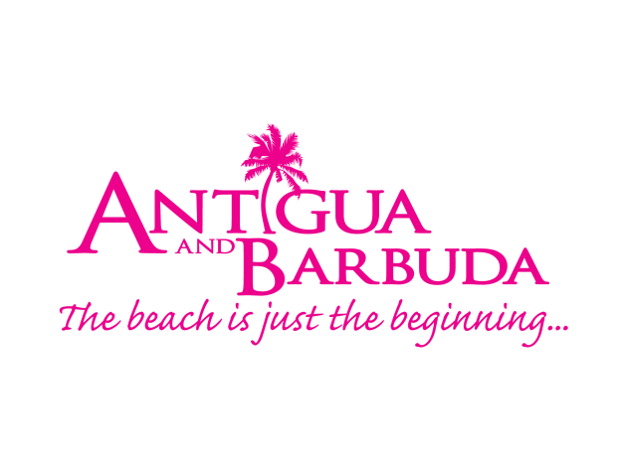

for immediate release:

wellness getaway experience brings US travellers to antigua for
#fABbODY RETREAT

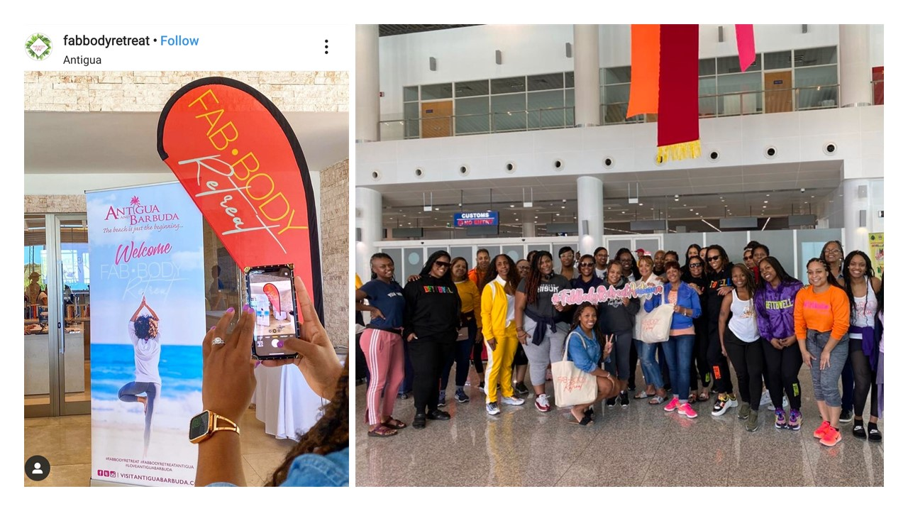
The Antigua and Barbuda Tourism Authority partnered with FabBody Retreat owner Deanna Robinson, to welcome fifty women to Antigua for the 3rd installment of the FabBody wellness retreat.

ST. JOHN’S, ANTIGUA (January 30, 2020) – In an exciting opportunity to showcase Antigua and Barbuda’s wellness attributes, the Antigua and Barbuda Tourism Authority has partnered with US based gym ‘Fab Body Factory by Deanna Robinson Fitness’, to welcome fifty women from across the United States to Antigua and Barbuda for the third installment of the annual FabBody Retreat taking place from January 29 – February 2, 2020.

The FabBody Retreat is a wellness retreat for women that offers the ultimate combination of fitness, wellness, and fun. It is an actioned-packed and empowering vacation, hosted by mega wellness influencer and health and fitness expert Deanna Robinson alongside trainers of her Fab Body Factory gym, a gym specializing in female fitness group exercise classes and personal training.

The hosting of the trip comes as the Antigua and Barbuda Tourism Authority continues to focus on the wellness tourism market and capitalizing on Antigua and Barbuda’s natural attributes to entice travelers seeking to incorporate wellness into their travels.

Health and Wellness Expert and Founder of the Fab Body Factory Gym and FabBody Retreat, Deanna Robinson said, “This is our first year coming to Antigua. We are super excited; we have fifty ladies and we are going to be doing all things wellness for the next four days. We have boat trips planned, workouts on the beach, yoga, empowerment seminars, everything wellness. And, we are just super excited to be here in Antigua.”

Robinson promises participants an actioned-packed and empowering vacation, with #fabBody workouts coordinated by Fab Body Factory gym fitness trainers, to include, Brittanee Brooks, Sihnuu Hetep, Rachel Miller, M'Balia Rucker, Amber Mays, Khanesha Mabin, and Hope Dews-Taylor.

Activities will include a hike to Fort Barrington, exercise workouts, yoga and meditation sessions on the beach and a day tour to Cade’s Reef for snorkeling and sun-bathing. A visit to the Five Islands Primary Schools for engagement with the students is also planned.

The FabBody Retreat group is being hosted at Royalton Antigua Resort & Spa.

###

ABOUT ANTIGUA AND BARBUDA
Antigua (pronounced An-tee'ga) and Barbuda (Bar-byew’da) is located in the heart of the Caribbean Sea. Voted the World Travel Awards 2015, 2016, 2017 and 2018 Caribbean’s Most Romantic Destination, the twin-island paradise offers visitors two uniquely distinct experiences, ideal temperatures year-round, a rich history, vibrant culture, exhilarating excursions, award-winning resorts, mouth-watering cuisine and 365 stunning pink and white-sand beaches - one for every day of the year. The largest of the Leeward Islands, Antigua comprises 108-square miles with rich history and spectacular topography that provides a variety of popular sightseeing opportunities. Nelson’s Dockyard, the only remaining example of a Georgian fort a listed UNESCO World Heritage site, is perhaps the most renowned landmark. Antigua’s tourism events calendar includes the prestigious Antigua Sailing Week, Antigua Classic Yacht Regatta, and the annual Antigua Carnival; known as the Caribbean’s Greatest Summer Festival. Barbuda, Antigua’s smaller sister island, is the ultimate celebrity hideaway. The island lies 27 miles north-east of Antigua and is just a 15-minute plane ride away. Barbuda is known for its untouched 17 mile stretch of pink sand beach and as the home of the largest Frigate Bird Sanctuary in the Western Hemisphere. Find information on Antigua & Barbuda at: www.visitantiguabarbuda.com or follow us on Twitter. http://twitter.com/antiguabarbuda Facebook www.facebook.com/antiguabarbuda; Instagram: www.instagram.com/AntiguaandBarbuda

For media enquiries, please contact:
Maria Blackman
Antigua and Barbuda Tourism Authority
T: 1 (268) 562 7600/464-7601
E: maria.blackman@visitaandb.com

