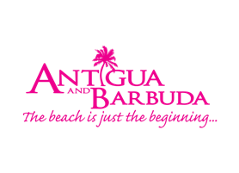

**ANTIGUA AND BARBUDA TOURISM AUTHORITY WINS PLATINUM AWARD FOR 'YOUR SPACE IN THE SUN' CAMPAIGN**

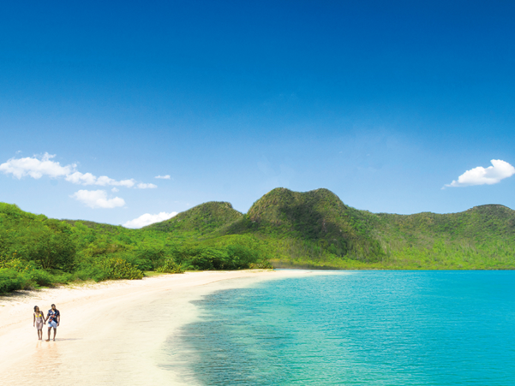

*The Antigua and Barbuda Tourism Authority’s ‘Your Space in the Sun’ campaign launched in June, invites persons to find all the space they need in Antigua and Barbuda. (Photo credits: The Antigua and Barbuda Tourism Authority)*

**ST. JOHN’S, ANTIGUA, (December 14, 2020) -**The Antigua and Barbuda Tourism Authority has received a second international marketing award for its ['Your Space in the Sun](http://www.visitantiguabarbuda.com)' digital marketing campaign, created as part of the destination marketing body's response to the Covid-19 pandemic.

Presented by the organisers of the international [MARCOM Awards](https://marcomawards.com/), in the category of ‘Digital Media | Social Media | Social Branding Campaign’, the Tourism Authority received the Platinum award, the highest-level award granted.

The ‘Your Space in the Sun’ campaign was designed to specifically speak to the new desires and needs of travelers. The campaign shows Antigua and Barbuda has the perfect antidote of space and invites people to broaden their horizons and enjoy all the space they need: space to move, space to think, space to be you.

The MARCOM Awards honours excellence in marketing and communications while recognising the creativity, hard work and generosity of industry professionals. Since its inception in 2004, MarCom has evolved into one of the largest, most-respected creative competitions in the world.

The Antigua and Barbuda Tourism Authority also recently received the Gold Travel Weekly Magellan Award for the same campaign.

As the 'Your Space In The Sun' campaign continues to roll-out, the Antigua and Barbuda Tourism Authority is now inviting persons to enter the ‘Your Space in the Sun’ sweepstakes on [www.visitantiguabarbuda.com](http://www.visitantiguabarbuda.com), to win the escape they deserve in 2021.

###

**ABOUT THE ANTIGUA AND BARBUDA TOURISM AUTHORITY**

The Antigua & Barbuda Tourism Authority is a statutory body dedicated to realizing the tourism potential of Antigua & Barbuda by promoting the twin island state as a unique, quality tourist destination with the overall objective of increasing visitor arrivals thereby providing sustainable economic growth. The Antigua and Barbuda Tourism Authority is headquartered in St. John’s Antigua, where regional marketing is directed. The Authority has three offices overseas in the United Kingdom, United States and Canada.

**ABOUT ANTIGUA AND BARBUDA**

Antigua (pronounced An-tee'ga) and Barbuda (Bar-byew’da) is located in the heart of the Caribbean Sea. Voted the World Travel Awards 2015, 2016, 2017 *and 2018* *Caribbean’s Most Romantic Destination*, the twin-island paradise offers visitors two uniquely distinct experiences, ideal temperatures year-round, a rich history, vibrant culture, exhilarating excursions, award-winning resorts, mouth-watering cuisine and 365 stunning pink and white-sand beaches - one for every day of the year. The largest of the Leeward Islands, Antigua comprises 108-square miles with rich history and spectacular topography that provides a variety of popular sightseeing opportunities. Nelson’s Dockyard, the only remaining example of a Georgian fort a listed UNESCO World Heritage site, is perhaps the most renowned landmark. Antigua’s tourism events calendar includes the prestigious Antigua Sailing Week, Antigua Classic Yacht Regatta, and the annual Antigua Carnival; known as the Caribbean’s Greatest Summer Festival. Barbuda, Antigua’s smaller sister island, is the ultimate celebrity hideaway. The island lies 27 miles north-east of Antigua and is just a 15-minute plane ride away. Barbuda is known for its untouched 17 mile stretch of pink sand beach and as the home of the largest Frigate Bird Sanctuary in the Western Hemisphere.  Find information on Antigua & Barbuda at: [www.visitantiguabarbuda.com](http://www.visitantiguabarbuda.com) or follow us on **Twitter**. <http://twitter.com/antiguabarbuda>  **Facebook** [www.facebook.com/antiguabarbuda](http://www.facebook.com/antiguabarbuda); **Instagram**: [www.instagram.com/AntiguaandBarbuda](http://www.instagram.com/AntiguaandBarbuda)

**For media enquiries, please contact:**Maria Blackman  
Antigua and Barbuda Tourism Authority

T: 1 (268) 562 7600/464-7601  
E: [maria.blackman@visitaandb.com](mailto:maria.blackman@visitaandb.com)