FOR IMMEDIATE RELEASE- ANTIGUA AND BARBUDA TOURISM AIR ARRIVALS SHOW BEST EVER PERFORMANCE FOR THE MONTH OF APRIL 2019

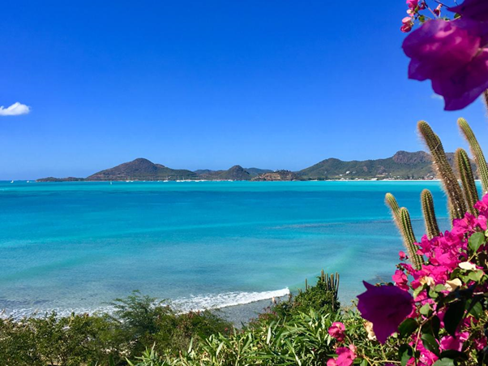

ST. JOHN’S, ANTIGUA (May 15, 2019) - Antigua and Barbuda has attracted a record number of visitors for April 2019, with 27,301 visitors arriving into the country during the month. This is according to the latest tourism statistics released from the Antigua and Barbuda Ministry of Tourism & Investment.
April 2019 saw an increase of 17.06%, with 3,979 more visitors travelling to Antigua, compared with April 2018 when 23,322 visitors vacationed in Antigua and Barbuda.
“A seventeen percent increase in arrivals is remarkable growth, and spells exciting news for Antigua and Barbuda”, said Minister of Tourism, the Honourable H. Charles “Max” Fernandez. We hope to carry forward this momentum through the crucial summer months of May – October with the launch of our global summer marketing campaign #WhatCoolLooksLike. This will all help to increase visitor arrivals and revenue to the destination, during this period.
The #WhatCoolLooksLike campaign currently being rolled out by the Antigua and Barbuda Tourism Authority, offers cool savings on flights and accommodation for persons booking vacations to Antigua and Barbuda, with opportunities for further savings on tours, excursions and restaurant dining, when they arrive in the country.
Antigua and Barbuda’s peak season generally extends well into April, with flagship activities taking place in the destination, such as the Antigua Classic Yacht Regatta, and the Antigua Sailing Week.
During the month of April, the US market lead the way with 11,709 US visitors, arriving into Antigua and Barbuda, recording a 23.43% increase. Antigua and Barbuda also saw increased arrivals from the United Kingdom, Europe and the Caribbean source markets, with increases of 9.92%, 32.75% and 14.81% respectively.
For the year to date, visitor air arrivals into Antigua and Barbuda are showing an increase of 9,327 or 8.59% visitors over the same period 2018. This equates to 117,920 visitors up to April 2019, compared to 108,593 for 2018.
Tourism Officials anticipate that the strong performance so far will continue during the summer, with the new opening of the luxurious Royalton Resort, and the hosting of events on the tourism calendar such as the ‘Play It Out” Concert, Antigua and Barbuda Sports fishing Tournament, The Optimist World Championships, and Antigua’s Carnival: The Caribbean’s Greatest Summer Festival.

