BELOW DECK TV SEASON 8 STUNS VIEWERS WITH GORGEOUS VISTAS OF ANTIGUA AND BARBUDA
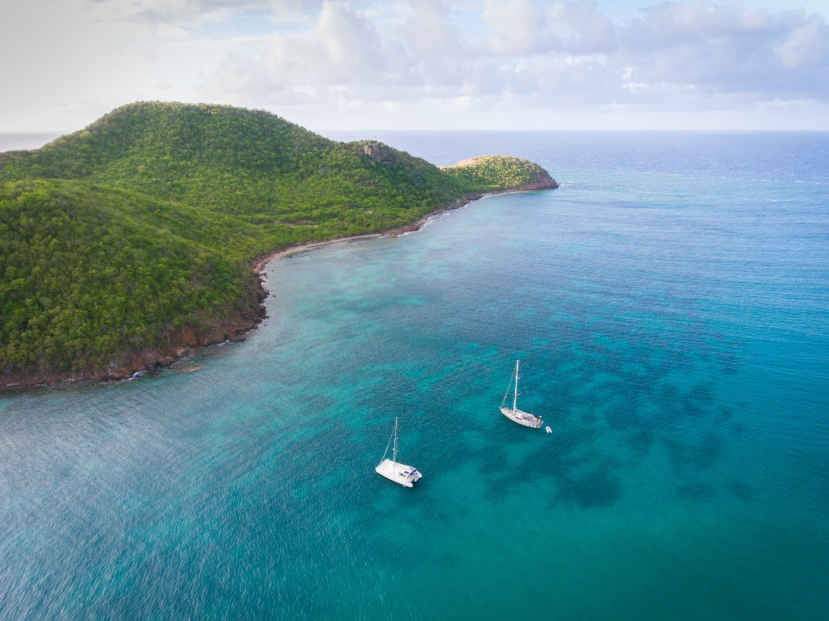
Yachts sailing off the coastline of Antigua. (Photo Credits: Tom Archer for the Antigua and Barbuda Tourism Authority)

(ST. JOHN’S, ANTIGUA) NOVEMBER 17, 2020 - It is always exciting to see visuals of Antigua and Barbuda on television. And, this November those with an interest in yachting will have numerous opportunities to see Antigua and Barbuda’s stunning coastal scenery on screen, as the twin-island destination shines as the backdrop for the entire Season 8 of the popular American reality television Bravo show, ‘Below Deck’.
Below Deck is known to be viewed across the globe by over 1 million persons per episode. The show chronicles the lives of the crew members who work and reside aboard a mega-yacht during charter season. The show’s Season 8 airing in November perfectly coincides with the start of Antigua and Barbuda’s yachting season.
With a November 2 premiere on the Bravo channel, episodes shown to date have put Antigua’s gorgeous south coast and the Jolly Harbour on display. Fans of the show have also been treated to sightings of English Harbour, the UNESCO World Heritage Site – Nelson’s Dockyard, popular restaurant Catherine’s Café as well as the Antigua Yacht Club. As the season unfolds, there will be a trip to Antigua’s sister island Barbuda, and the offshore island Green Island. News of covid-19 also features as filming for the show was done in early 2020.
Antigua and Barbuda’s Minister of Tourism, The Honourable Charles Fernandez said, “Antigua and Barbuda has lots of space on land and water for social distancing. The destination is open, and we are inviting visitors out on the water to explore Antigua’s 95 miles of indented coastlines and Barbuda’s secluded harbours.”
Antigua and Barbuda Tourism Officials and the Antigua and Barbuda Marine Association released in September yachting protocols for the yachting sector. The protocols can be viewed on www.visitantiguabarbuda.com
Below Deck Season 8, set in Antigua airs Mondays at 9 p.m. on Bravo TV. The November 2 premiere link can be viewed here

###
ABOUT THE ANTIGUA AND BARBUDA TOURISM AUTHORITY
The Antigua & Barbuda Tourism Authority is a statutory body dedicated to realizing the tourism potential of Antigua & Barbuda by promoting the twin island state as a unique, quality tourist destination with the overall objective of increasing visitor arrivals thereby providing sustainable economic growth. The Antigua and Barbuda Tourism Authority is headquartered in St. John’s Antigua, where regional marketing is directed. The Authority has three offices overseas in the United Kingdom, United States and Canada.
ABOUT ANTIGUA AND BARBUDA
Antigua (pronounced An-tee'ga) and Barbuda (Bar-byew’da) is located in the heart of the Caribbean Sea. Voted the World Travel Awards 2015, 2016, 2017 and 2018 Caribbean’s Most Romantic Destination, the twin-island paradise offers visitors two uniquely distinct experiences, ideal temperatures year-round, a rich history, vibrant culture, exhilarating excursions, award-winning resorts, mouth-watering cuisine and 365 stunning pink and white-sand beaches - one for every day of the year. The largest of the Leeward Islands, Antigua comprises 108-square miles with rich history and spectacular topography that provides a variety of popular sightseeing opportunities. Nelson’s Dockyard, the only remaining example of a Georgian fort a listed UNESCO World Heritage site, is perhaps the most renowned landmark. Antigua’s tourism events calendar includes the prestigious Antigua Sailing Week, Antigua Classic Yacht Regatta, and the annual Antigua Carnival; known as the Caribbean’s Greatest Summer Festival. Barbuda, Antigua’s smaller sister island, is the ultimate celebrity hideaway. The island lies 27 miles north-east of Antigua and is just a 15-minute plane ride away. Barbuda is known for its untouched 17 mile stretch of pink sand beach and as the home of the largest Frigate Bird Sanctuary in the Western Hemisphere. Find information on Antigua & Barbuda at: www.visitantiguabarbuda.com or follow us on Twitter. http://twitter.com/antiguabarbuda Facebook www.facebook.com/antiguabarbuda; Instagram: www.instagram.com/AntiguaandBarbuda

For Antigua and Barbuda media enquiries, please contact:
Maria Blackman
Antigua and Barbuda Tourism Authority
T: 1 (268) 562 7600/464-7601
E: maria.blackman@visitaandb.com

