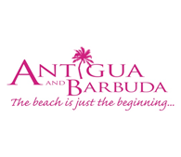

**ANTIGUA AND BARBUDA READIES ITSELF FOR THE BUSY FALL/WINTER SEASON**

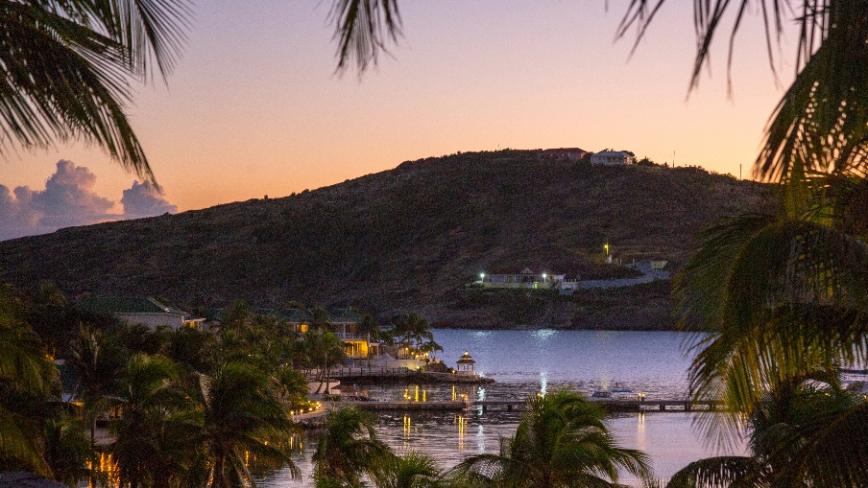

**Toronto – September 5, 2019 –** Antigua and Barbuda is getting ready to welcome a host of new visitors this upcoming winter season as some extraordinary new properties open their doors. The development of new rooms and properties in Antigua and Barbuda is a direct result of the rapid growth of the tourism industry. Though construction is ongoing, current accommodation capacity is expected to double with an estimated 2,535 rooms and units by 2021.

"Tourism has been experiencing a boom in Antigua & Barbuda and has therefore been very attractive for investors,” said Colin C. James, CEO, The Antigua and Barbuda Tourism Authority. “The growth in the industry has been fueled by a number of new luxury products, including the 294-suite Royalton Antigua Resort & Spa, which opened in May; Hodges Bay Resort & Spa, which debuted in December, and the planned debut of Hammock Cove Resort & Spa by Elite Island Resorts, Rosewood Half Moon Bay Antigua and Waldorf Astoria. The influx of these top luxury all-inclusive brands will help promote the destination."

**Hammock Cove Resort & Spa**

In December 2019, Antigua and Barbuda will introduce the brand-new Hammock Cove Resort & Spa by Elite Island Resorts. Antigua’s newest luxury resort is an adults-only, all-inclusive paradise offering 42 beautiful private villas. Introductory rates start as low as $422 per person per night.

**The Royalton Antigua Resort & Spa by Sunwing**

Opened in May 2019, The Royalton Antigua Resort & Spa by Sunwing is a stunning 294-room resort situated on the pristine white beach of picturesque Deep Bay with special all-in luxury amenities. From November 1, 2019 to October 31, 2020, guests who book at the leading upscale Caribbean resort chain will receive great savings with the Hang on To Summer Sale! In addition, families can take their travel budget even further with two kids stay free deals.

**The Hodges Bay Resort & Spa**

The Hodges Bay Resort & Spa is a charming hotel situated along beautiful crystal blue waters and resting between lush tropical vegetation. The contemporary style hotel, which opened its doors in December 2018, offers delectable dining, a first-class staff ready to meet your every need, easy access to the most visited tourist spots on the island of Antigua, incredible facilities and so much more! The eight-acre property is constantly offering great deals and new ideas to ensure the destination’s continued success.

**About Antigua and Barbuda**

Antigua (pronounced An-tee'ga) and Barbuda (Bar-byew’da) is located in the heart of the Caribbean Sea. Voted the World Travel Awards Caribbean’s Most Romantic Destination, the twin-island paradise offers visitors two uniquely distinct experiences, ideal temperatures year-round, a rich history, vibrant culture, exhilarating excursions, award-winning resorts, mouth-watering cuisine and 365 stunning pink and white-sand beaches - one for every day of the year. The largest of the Leeward Islands, Antigua comprises 108-square miles with rich history and spectacular topography that provides a variety of popular sightseeing opportunities. Barbuda, Antigua’s smaller sister island, is the ultimate celebrity hideaway. The island lies 27 miles north-east of Antigua and is just a 15-minute plane ride away. Barbuda is known for its untouched 17 mile stretch of pink sand beach and as the home of the largest Frigate Bird Sanctuary in the Western Hemisphere. Find information on Antigua & Barbuda at: www.visitantiguabarbuda.com and follow us on Twitter. http://twitter.com/antiguabarbuda Facebook www.facebook.com/antiguabarbuda; Instagram: [www.instagram.com/AntiguaandBarbuda](http://www.instagram.com/AntiguaandBarbuda)

**Media Contact:**

Jacob Del Zotto

Jesson + Company Communications Inc.

[jdelZotto@jessonco.com](mailto:jdelZotto@jessonco.com)

