'JUNE IS ROMANCE MONTH' PROMOTIONS TARGET REGIONAL TRAVELLERS

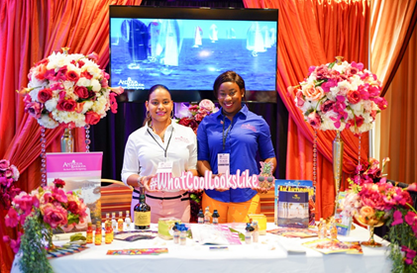
Photo Caption: The Antigua and Barbuda Tourism Authority Team in Port of Spain Trinidad where they attended the Wedding Convention Exhibition as part of the destination's ‘June is Romance’ month promotions.

ST. JOHN’S, ANTIGUA (JUNE 25, 2019) – Romance may be closer than you think! That's the message the Antigua and Barbuda Tourism Authority is sharing within the Caribbean region as they continue ‘June is Romance month' promotions, within their source markets.
Regional Marketing Consultant, Charmaine Spencer and Marketing Officer, Mauricia Frith, recently returned from Trinidad and Tobago, following participation in the Wedding Convention Exhibition, where they met with couples planning on getting married. The Wedding Convention Exhibition is the most respected wedding show in Trinidad and Tobago.
Trinidad and Tobago is a high performing market for the destination accounting for a major percentage of regional business.
Spencer, the Tourism Authority’s Marketing Consultant said, “We’ve noted that the Trinidad and Tobago market responds positively to the destination's romance promotions.”
Romance Month was the ideal time to tempt residents from Trinidad to visit the destination and extend offers to those persons directly interested in destination weddings and honeymoons. The Wedding Convention provided the perfect synergy for us to reach the weddings and honeymoon market”.
Additionally, the Antigua and Barbuda Tourism Authority team encouraged visitors to the show, searching for a summer getaway, to take advantage of the destination’s #WhatCoolLooksLike summer offers currently available at hotels, restaurants and tours in Antigua and Barbuda as well as with LIAT airline. Residents were also invited to journey to the destination to participate in Antigua’s Carnival: The Caribbean’s Greatest Summer Festival, which will run from July 25 – August 6, 2019 (www.antiguacarnival.com).

