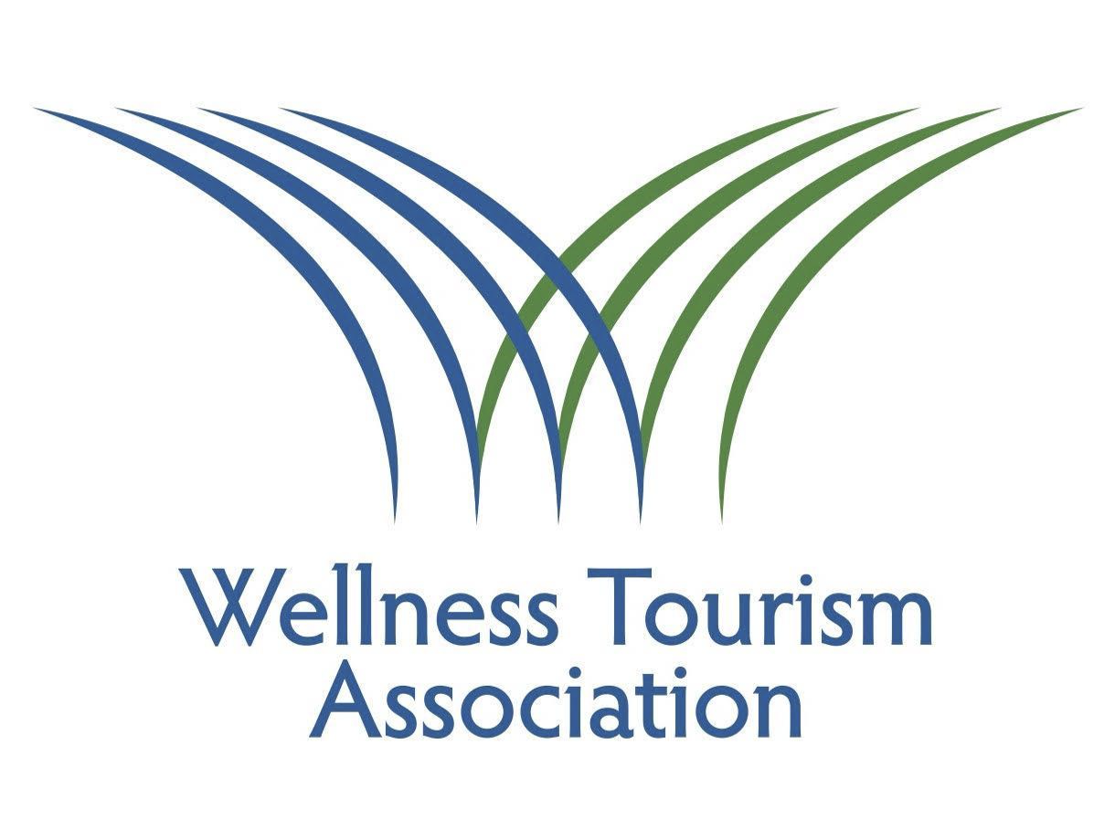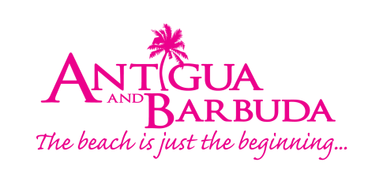

Contact:
Corey Finjer Bennett, Founder: Core Creative
corey@corecreativenyc.com; 516-353-0062

Click here for associated Leading Light Award media assets

WELLNESS TOURISM ASSOCIATION ANNOUNCES WINNERS OF INAUGURAL LEADING LIGHT AWARD

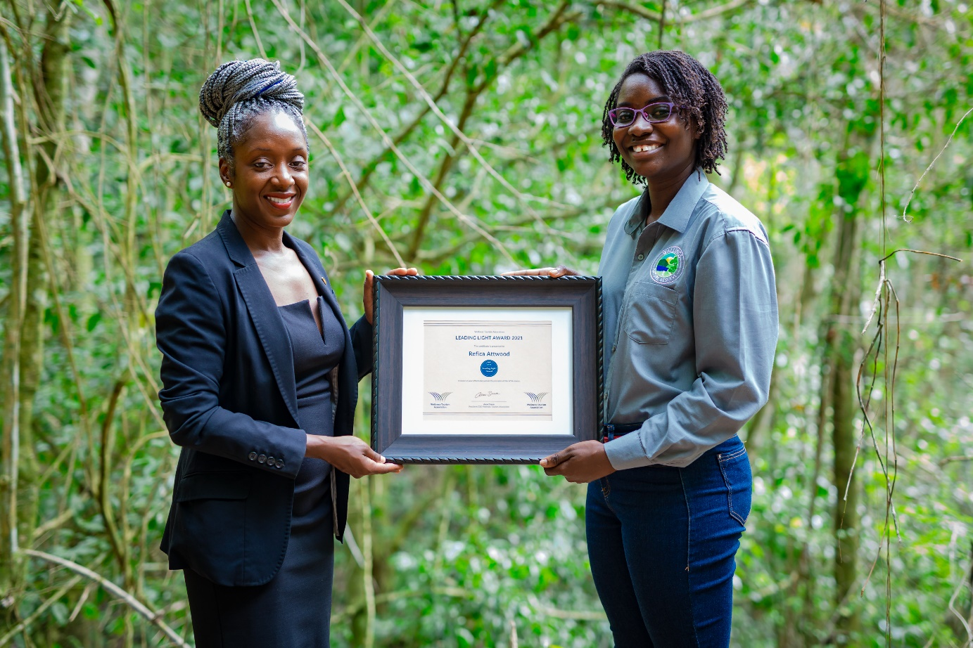
Photo Caption: Antigua and Barbuda Tourism Authority’s Marketing Communications Manager, Maria Blackman presents Wallings Nature Reserve Executive Director Refica Attwood with her Leading Light Award (Photo Courtesy, The Antigua and Barbuda Tourism Authority)

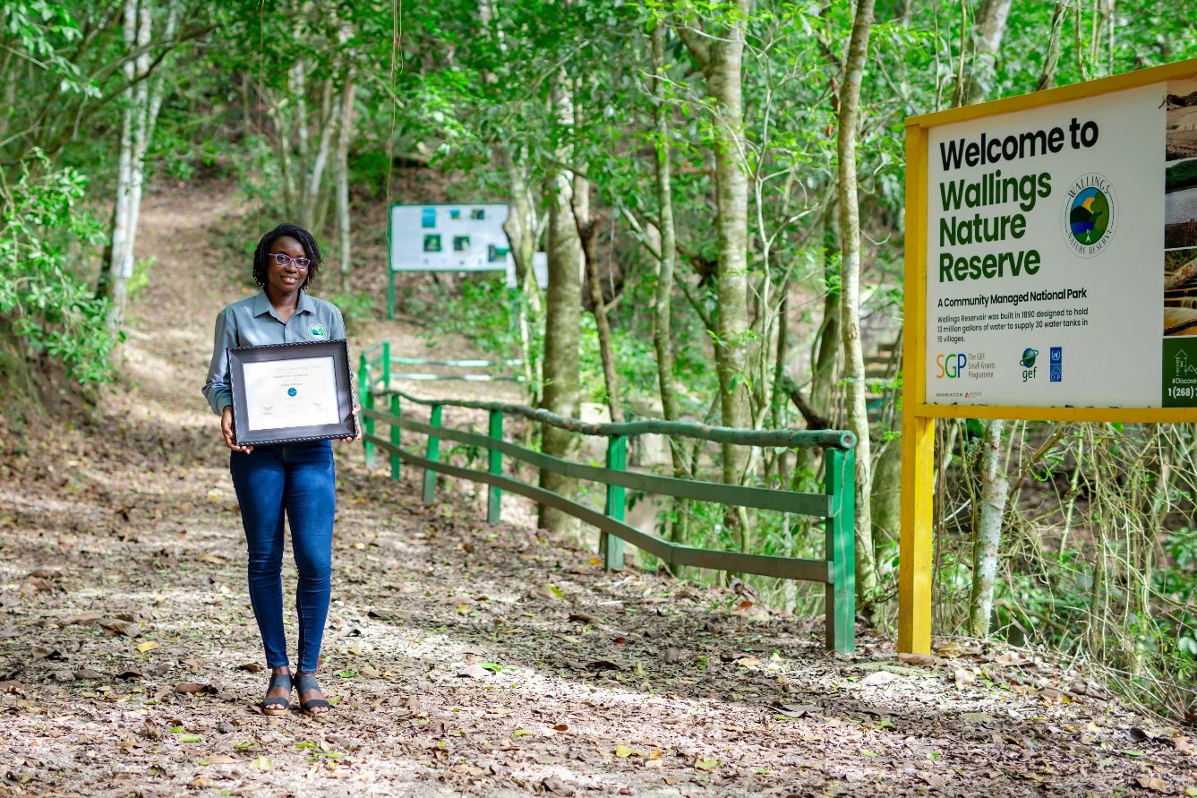
Photo Caption: Wallings Nature Reserve’s Executive Director Refica Attwood, is one of the two individuals who has been honoured with a Leading Light Award (Photo Courtesy, The Antigua and Barbuda Tourism Authority)

(Denver, CO; May 17, 2022) – The Wellness Tourism Association (WTA) has announced that two individuals have been selected to receive the organization’s first Leading Light Award. The award was launched earlier this year to honor companies or individuals who had successfully launched and implemented a wellness project/initiative that upholds and furthers the principles of the association's mission, "to shape and support sustainable wellness tourism for the global good.” The WTA Board of Directors reviewed the list of a dozen nominees and selected Ms. Refica Attwood, Founder and Executive Director of Wallings Nature Reserve in Antigua & Barbuda and Mr. I Nyoman Yastama, Spa & Wellness Director at Alba Wellness Valley by Fusion in Hue City, Vietnam.

Chair of the 2021 Leading Light Award Committee, John Nielsen, Board Member and General Manager of Fivelements Retreat in Bali, points out that “While the list of nominees was just 12 in this our inaugural year, the Board was unanimous in selecting these two individuals to be presented with the award.”

Ms. Refica Attwood
Known locally as “Antigua's Proudest Treehugger,” Refica Attwood is locally acclaimed for turning the neglected forest she loved and played in as a child into the country’s first community-managed national park, referred to as Wallings Nature Reserve. One of the Nature Reserves' current initiatives is the Reforestation of Signal Hill Project which will strengthen the island’s conservation efforts with the planting of 600 food-producing trees.
Anne Dimon, WTA President & CEO points out that “Ms. Attwood, is being honored by the WTA for her leadership in creating and continuing to manage a sustainable tourism product that can be looked upon as an inspiration to other communities, islands and countries around the world.” Attwood says, “I will always remember my father’s words that inspired me: ‘If you want to see a change you are going to have to take action.’ ”
She was nominated by Donyelle Bird-Browne on behalf of the Wellness Committee, Antigua & Barbuda Tourism Authority.
Maria Blackman, Marketing Communications Manager at the Antigua and Barbuda Tourism Authority and Wellness committee member said, “This award highlights the commitment and drive of Ms. Attwood and her team. We continue to see the emergence of Wallings Nature Reserve as a popular attraction for both residents and visitors, and through their work they continue to make a lasting investment into the future of Antigua and Barbuda.”

I Nyoman Yastama

I Nyoman Yastama is a 20-plus-year veteran of the hospitality industry and, currently, Spa & Wellness Director at Alba Wellness Valley by Fusion in Hue City, Vietnam. As the Spa & Wellness Director at Alba and a coordinator with World Wellness Weekend, Mr. Yastama is shining a light on the path to a wellness tourism culture in the province of Hue. He began working with the local tourism office and Hue University tourism program in 2021 to not only help raise the profile of wellness with the residents of the province, but to also open people’s minds to the concept of wellness travel. “Mr. Yastama is being honored for spreading wellness awareness and encouraging the local government to support the sector and further elevate the profile of the destination in order to attract the wellness-minded traveler for the benefit of all,” says Dimon. Mr. Yastama says, “Wellness is my passion and I want to see all qualifying businesses here in Hue band together with the support of the tourism board so that all locals benefit.”

He was nominated by Hylton Lipkin, General Manager of Alba Wellness Valley By Fusion
Nominations for the 2022 Leading Light Award will be accepted later this year.

More about the Leading Light Award

The Leading Light Award was launched by the WTA to honor businesses or individuals. The award was created to honor individuals and or companies/organizations that successfully launch and implement a wellness project/initiative that upholds the principles of the association's mission, "to shape and support sustainable wellness tourism for the global good.”

There was no cost to nominate or to be a nominee, and the award was open to both members and non-members. Since the WTA Board of Directors acted as the judging committee, all members of the board abstained from voting, and could not be nominated. Nominations closed on March 31st. Plans are to make it an award that is presented annually.

More about the Wellness Tourism Association (WTA)

A global association with Members and Partners from 20 plus countries, The Wellness Tourism Association is a registered not-for-profit incorporated in the U.S. and launched in 2018 with the mission to support and further the growth of the wellness tourism industry through networking, education, research and communication. Co-Founders are Accor Hotels, Canyon Ranch and Travel To Wellness with Founding Members Art of Living Retreat Center and the Monaco Government Tourist Office.

