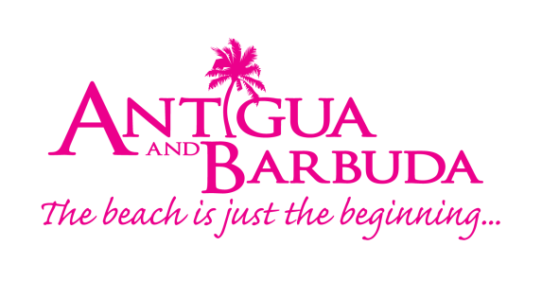
FOR IMMEDIATE RELEASE:
ANTIGUA AND BARBUDA TOURISM AUTHORITY RAMPS UP SALES CALLS IN CANADA 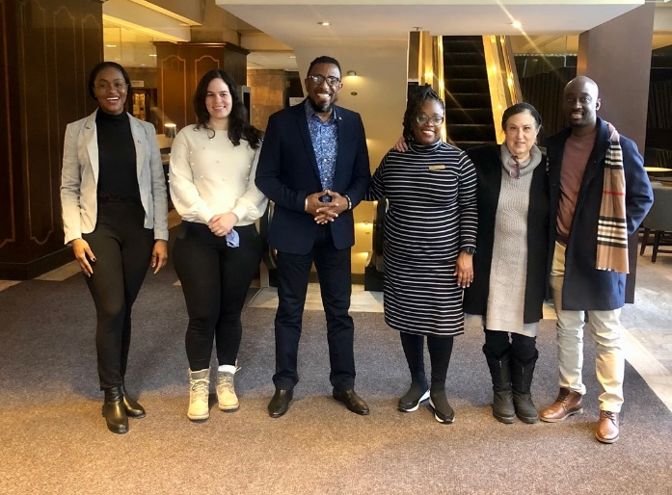
Photo 1: (Left to Right) Raynel Carroll – Antigua and Barbuda Tourism Authority (ABTA) Business Development Manager, Loraine Antonio - Sunwing Business Development Manager, Colin C. James – ABTA CEO, Tameka Wharton - ABTA Canada Director of Tourism Ag. , Celine Moskovitz - House of Travel Travel Consultant and Shamoi Richards - ABTA Canada Business Development Manager
Photo 2: The Antigua and Barbuda Tourism Authority Canadian Team and Colin C.James CEO of the Antigua and Barbuda Tourism Authority spot mobile advertising of Antigua and Barbuda in Montreal .

ST. JOHN’S, ANTIGUA (March 10, 2022) – The Antigua and Barbuda Tourism Authority (ABTA) is redoubling efforts to stimulate travel between Canada and the twin-island destination of Antigua and Barbuda.
This comes as the ABTA Chief Executive Officer, Colin C. James joined ABTA Canada Director of Tourism (Ag) Tameka Wharton and the Canadian sales team, on a marathon of important meetings with key airline executives and partners within the French district of Montreal Quebec, this week.
Key on the agenda for the ABTA CEO during his visits, was reigniting the conversation on the need for direct airlift out of the Montreal region. Trade partners were also updated, on the destination’s successful management of the covid-19 pandemic, the demand for Antigua and Barbuda amongst consumers, and new tourism developments.

CEO of ABTA, Colin C. James remarked “We are working assiduously to rebuild our Canadian airlift and Canadian business particularly out of Montreal. We are looking towards regaining direct flights from Montreal to Antigua in the near future.”

The two-day blitz yielded positive results as it was the first face-to-face meeting from a Caribbean destination since the pandemic for many of the agencies who were visited.

Tameka Wharton, Director of Tourism (Ag) said, “We are focused on building stronger relationships with our trade and travel agent partners, so opted for face-to-face visits over an online meeting as a means of showing our commitment to supporting our partners, as well as to make sure they are effectively equipped with the most accurate information needed to sell the destination.”

###

For Antigua and Barbuda media enquiries, please contact:
Maria Blackman
Antigua and Barbuda Tourism Authority
T: 1 (268) 562 7600/464-7601
E: maria.blackman@visitaandb.com

ABOUT THE ANTIGUA AND BARBUDA TOURISM AUTHORITY
The Antigua & Barbuda Tourism Authority is a statutory body dedicated to realizing the tourism potential of Antigua & Barbuda by promoting the twin island state as a unique, quality tourist destination with the overall objective of increasing visitor arrivals thereby providing sustainable economic growth. The Antigua and Barbuda Tourism Authority is headquartered in St. John’s Antigua, where regional marketing is directed. The Authority has three offices overseas in the United Kingdom, United States and Canada.

ABOUT ANTIGUA AND BARBUDA
Antigua (pronounced An-tee'ga) and Barbuda (Bar-byew’da) is located in the heart of the Caribbean Sea. Voted the World Travel Awards 2015, 2016, 2017 and 2018 Caribbean’s Most Romantic Destination, the twin-island paradise offers visitors two uniquely distinct experiences, ideal temperatures year-round, a rich history, vibrant culture, exhilarating excursions, award-winning resorts, mouth-watering cuisine and 365 stunning pink and white-sand beaches - one for every day of the year. The largest of the Leeward Islands, Antigua comprises 108-square miles with rich history and spectacular topography that provides a variety of popular sightseeing opportunities. Nelson’s Dockyard, the only remaining example of a Georgian fort a listed UNESCO World Heritage site, is perhaps the most renowned landmark. Antigua’s tourism events calendar includes the prestigious Antigua Sailing Week, Antigua Classic Yacht Regatta, and the annual Antigua Carnival; known as the Caribbean’s Greatest Summer Festival. Barbuda, Antigua’s smaller sister island, is the ultimate celebrity hideaway. The island lies 27 miles north-east of Antigua and is just a 15-minute plane ride away. Barbuda is known for its untouched 17 mile stretch of pink sand beach and as the home of the largest Frigate Bird Sanctuary in the Western Hemisphere. Find information on Antigua & Barbuda at: www.visitantiguabarbuda.com or follow us on Twitter. http://twitter.com/antiguabarbuda Facebook www.facebook.com/antiguabarbuda;
Instagram: www.instagram.com/AntiguaandBarbuda

