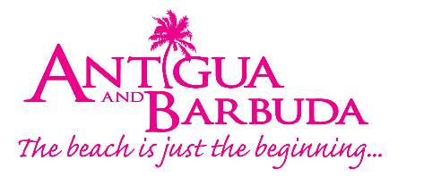

FOR IMMEDIATE RELEASE:

ANTIGUA AND BARBUDA TOURISM AUTHORITY STRATEGIZES WITH NEWLY SELECTED US MARKET TRAVEL ADVISORY BOARD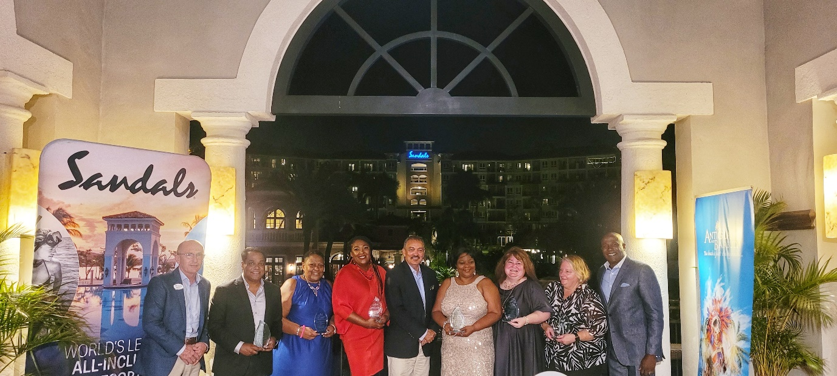
Photo Caption: Antigua and Barbuda’s Minister of Tourism, The Honourable Charles Fernandez (c) greeted six of the nine US Travel Trade professionals who will sit on the ABTA's US Market Travel Advisory Board at a dinner attended by Sandals General Manager Matthew Cornall (far left) and US Director of Tourism Dean Fenton (far right). (Photo Credits, The Antigua and Barbuda Tourism Authority)

ST. JOHN’S, ANTIGUA (August 9, 2022) – The Antigua and Barbuda Tourism Authority (ABTA) has selected a “dynamic” and “remarkable” group of travel trade professionals within the United States to sit on a new ABTA (USA) Travel Advisory Board for the period September 2022/September 2023.

The board members, owners of travel businesses within the mid-west, south-east, east coast and west coast of the USA have been selected because of their strong relationship with the Antigua and Barbuda Tourism Authority’s US Office, the passion they have for the destination, and the important role they play in the travel industry.

The travel professionals have agreed to offer their assistance and guidance to the ABTA for a one-year period, as the Authority seeks to exponentially increase arrivals from the US market.

Antigua and Barbuda Minister of Tourism, The Hon. Charles Fernandez, speaking at a dinner held at Sandals Grande Antigua Resort to recognize the newly selected board members said, “I feel privileged and honoured to be in your company this evening because I know of your commitment - and your mission - to help our tourism product grow.”

The Minister thanked the group for their unwavering support particularly within the recent years and for their partnership. “We benefit from your knowledge and expertise, so I would also like to congratulate those of you who have had careers spanning more than 30 years in the travel industry and who are proud owners and managers in in your respective field”, said the tourism minister.

Commenting on the week, US Director of Tourism Dean Fenton said, “The last few days have been very productive. The group has been engaged in strategic think tank sessions, producing big ideas that will help Antigua and Barbuda stand-out and drive more business to the destination from the US.”

The trade partners spent five days in Antigua, familiarizing themselves with the newest destination updates, and brainstorming.

Chair of the Advisory Board Brenda O’Neale said, “The real purpose and mission of the Board is to create true value for the destination while we look forward, not backward, and present ideas that will allow the advanced uniqueness of Antigua and Barbuda to shine through. I am especially proud to be a part of a team that cares deeply about Antigua and Barbuda’s tourism and the travel industry at large.”

The 2022/2023 Board members are: Brenda O’Neale - With This Ring Destination Weddings and Honeymoons, Debra Brown - SmartBird World Travel, Susan Berman – Berman Travel, Sanya L. Weston – Your Premier Travel Service Group, Terry Strauss – Dedham Travel, Niki Rakowitz – Care Travel, Edouard Jean – Massive Travels, Tom Varghese – Travel Tom and Donna Borrelli – Hamden Travel.

###
ABOUT THE ANTIGUA AND BARBUDA TOURISM AUTHORITY
The Antigua & Barbuda Tourism Authority is a statutory body dedicated to realizing the tourism potential of Antigua & Barbuda by promoting the twin island state as a unique, quality tourist destination with the overall objective of increasing visitor arrivals thereby providing sustainable economic growth. The Antigua and Barbuda Tourism Authority is headquartered in St. John’s Antigua, where regional marketing is directed. The Authority has three offices overseas in the United Kingdom, United States and Canada.
ABOUT ANTIGUA AND BARBUDA
Antigua (pronounced An-tee'ga) and Barbuda (Bar-byew’da) is located in the heart of the Caribbean Sea. The twin-island paradise offers visitors two uniquely distinct experiences, ideal temperatures year-round, a rich history, vibrant culture, exhilarating excursions, award-winning resorts, mouth-watering cuisine and 365 stunning pink and white-sand beaches - one for every day of the year. The largest of the English-speaking Leeward Islands, Antigua comprises 108-square miles with rich history and spectacular topography that provides a variety of popular sightseeing opportunities. Nelson’s Dockyard, the only remaining example of a Georgian fort a listed UNESCO World Heritage site, is perhaps the most renowned landmark. Antigua’s tourism events calendar includes the prestigious Antigua Sailing Week, Antigua Classic Yacht Regatta, and the annual Antigua Carnival; known as the Caribbean’s Greatest Summer Festival. Barbuda, Antigua’s smaller sister island, is the ultimate celebrity hideaway. The island lies 27 miles north-east of Antigua and is just a 15-minute plane ride away. Barbuda is known for its untouched 11-mile stretch of pink sand beach and as the home of the largest Frigate Bird Sanctuary in the Western Hemisphere. Find information on Antigua & Barbuda at: www.visitantiguabarbuda.com or follow us on Twitter: http://twitter.com/antiguabarbuda Facebook: www.facebook.com/antiguabarbuda; Instagram: www.instagram.com/AntiguaandBarbuda

For Antigua and Barbuda media enquiries, please contact:
Maria Blackman
Marketing Communications Manager
Antigua and Barbuda Tourism Authority
T: 1 (268) 562 7600/464-7601
E: maria.blackman@visitaandb.com
Antigua and Barbuda Images: aandbtourism.fotoseeker.com

