FOR IMMEDIATE RELEASE:

ANTIGUA AND BARBUDA LAUNCHES SPECIAL ‘LOVE LANE’ FOR ROMANCE MONTH IN JUNE
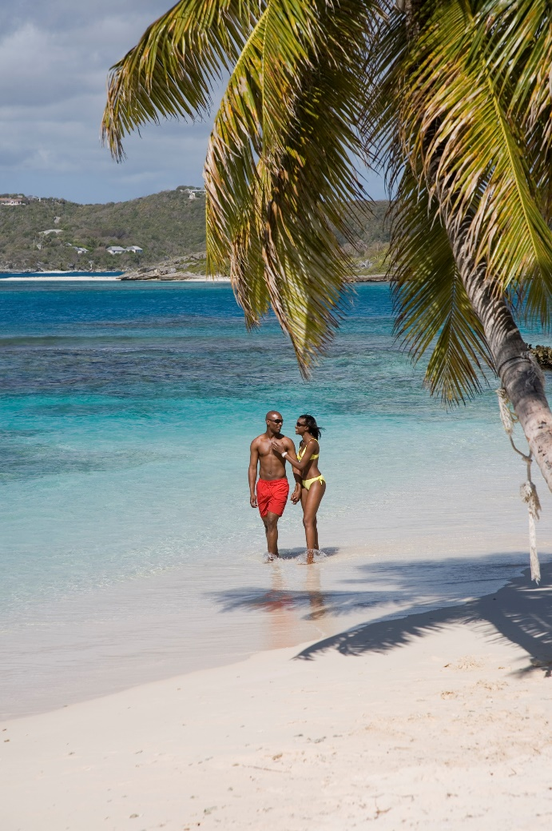
Photo Caption: During Antigua and Barbuda’s Romance Month in June, couples arriving in Antigua for a romantic getaway will be whisked through the ‘Love Lane’.
(Photo Courtesy: The Antigua and Barbuda Tourism Authority)

ST. JOHN’S, ANTIGUA (May 18, 2022) - The Antigua and Barbuda Tourism Authority in partnership with the Antigua and Barbuda Airport Authority has launched a ‘Love Lane’ fast track service for couples travelling to the destination during Antigua and Barbuda’s Romance Month in June.

Couples entering the ‘Love Lane’ on arrival at the award-winning V.C. Bird International Airport from June 1 – June 30, will be fast-tracked through immigration via a special couples-only lane for the month of June celebrations.

The ‘Love Lane’ experience will be open to couples traveling to Antigua and Barbuda to get married, to celebrate their honeymoon or to enjoy a romantic escape. Couples are encouraged to pre-register prior to travel via the registration link that can be found here.
Couples who pre-register for the complimentary service will receive a confirmation email containing a digital E-Card which they must present upon arrival, in order to receive the fast-track service.

“We want all couples visiting Antigua and Barbuda to feel the love starting from the moment they arrive in the country. Romance month has been a fixture on the marketing calendar for over 10 years and now that we are moving beyond the pandemic and couples can now begin to plan their special occasions again, we want them to think of enchanting Antigua and Barbuda”, says Shermain Jeremy, Special Projects and Events Marketing Manager within the Antigua and Barbuda Tourism Authority.

Chief Executive Officer of the Antigua and Barbuda Airport Authority Euletta Francis says, “We are once again delighted to be partnering with the Antigua and Barbuda Tourism Authority in yet another initiative that promises to enrich the experience of visitors arriving at the V.C Bird International Airport.”

Romance Month is celebrated for the entire month of June each year and seeks to position Antigua and Barbuda as the premiere romance destination in the world. This year’s celebration will see the return of special promotions such as the celebrity destination wedding and a global romance webinar for all trade partners across the major source markets.

For more information on romantic escapes to Antigua and Barbuda, visit: www.visitantiguabarbuda.com
###
ABOUT THE ANTIGUA AND BARBUDA TOURISM AUTHORITY
The Antigua & Barbuda Tourism Authority is a statutory body dedicated to realizing the tourism potential of Antigua & Barbuda by promoting the twin island state as a unique, quality tourist destination with the overall objective of increasing visitor arrivals thereby providing sustainable economic growth. The Antigua and Barbuda Tourism Authority is headquartered in St. John’s Antigua, where regional marketing is directed. The Authority has three offices overseas in the United Kingdom, United States and Canada.
ABOUT ANTIGUA AND BARBUDA
Antigua (pronounced An-tee'ga) and Barbuda (Bar-byew’da) is located in the heart of the Caribbean Sea. The twin-island paradise offers visitors two uniquely distinct experiences, ideal temperatures year-round, a rich history, vibrant culture, exhilarating excursions, award-winning resorts, mouth-watering cuisine and 365 stunning pink and white-sand beaches - one for every day of the year. The largest of the English-speaking Leeward Islands, Antigua comprises 108-square miles with rich history and spectacular topography that provides a variety of popular sightseeing opportunities. Nelson’s Dockyard, the only remaining example of a Georgian fort a listed UNESCO World Heritage site, is perhaps the most renowned landmark. Antigua’s tourism events calendar includes the prestigious Antigua Sailing Week, Antigua Classic Yacht Regatta, and the annual Antigua Carnival; known as the Caribbean’s Greatest Summer Festival. Barbuda, Antigua’s smaller sister island, is the ultimate celebrity hideaway. The island lies 27 miles north-east of Antigua and is just a 15-minute plane ride away. Barbuda is known for its untouched 11-mile stretch of pink sand beach and as the home of the largest Frigate Bird Sanctuary in the Western Hemisphere. Find information on Antigua & Barbuda at: www.visitantiguabarbuda.com or follow us on Twitter: http://twitter.com/antiguabarbuda Facebook: www.facebook.com/antiguabarbuda; Instagram: www.instagram.com/AntiguaandBarbuda

For Antigua and Barbuda media enquiries, please contact:
Maria Blackman
Marketing Communications Manager
Antigua and Barbuda Tourism Authority
T: 1 (268) 562 7600/464-7601
E: maria.blackman@visitaandb.com

Antigua and Barbuda Images: aandbtourism.fotoseeker.com

