FOR IMMEDIATE RELEASE:

ANTIGUA AND BARBUDA TOURISM AUTHORITY LAUNCHES MULTI-MEDIA ADVERTISING CAMPAIGN IN UK
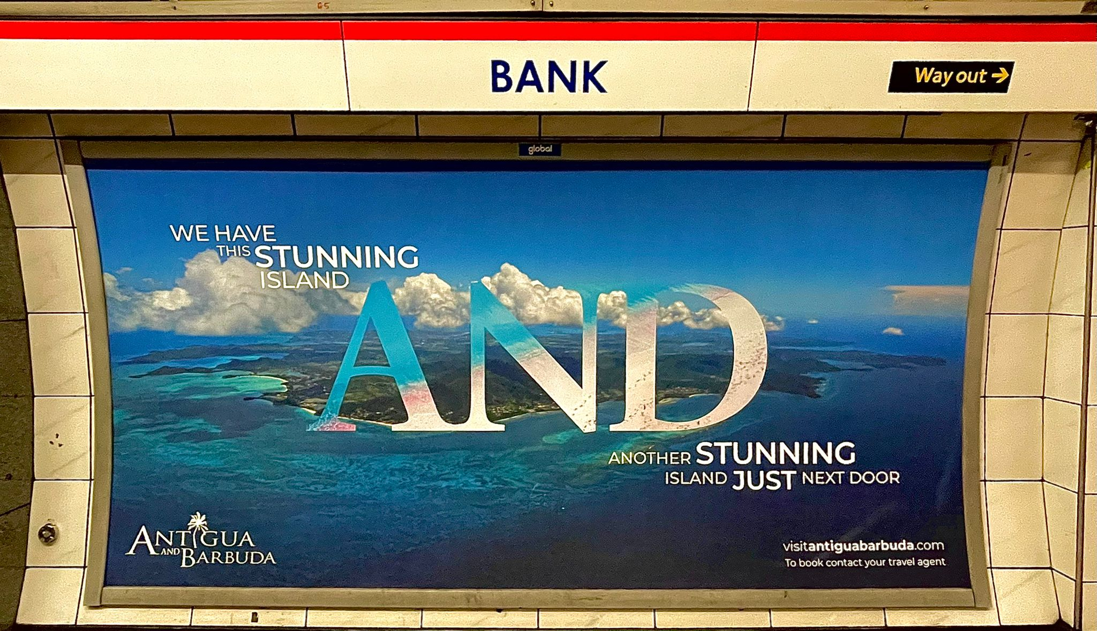
Photo Caption: Antigua and Barbuda is being advertised at Bank, and several other underground stations in London (Photo courtesy, The Antigua and Barbuda Tourism Authority)

LONDON, September 5 2022: The Antigua and Barbuda Tourism Authority has launched its out of home advertising campaign in the United Kingdom across multiple media outlets to include radio, print and the London underground. The twin island nation is looking to capture consumer hearts and minds with this campaign, ahead of the popular winter sun period and 2023.
The new campaign features advertising displays that will promote Antigua and Barbuda at a number of prominent London tube stations including King’s Cross St Pancras, Liverpool Street, Bond Street, Bank, Green Park and Waterloo. These advertisements will be shown for two weeks from August 29.
As well as this, there is an eight-week radio advertising campaign running across commercial radio stations broadcasting in the Greater London area, including Heart, Capital FM and multiple Podcasts, plus an advertorial feature in the September 11 print edition of The Times. The Antigua and Barbuda Tourism Authority is also sponsoring the Island Mas at Notting Hill Carnival.
To support the advertising, the UK team’s recently launched travel trade booking initiative underway in conjunction with Elite Island Resorts. The incentive offers UK travel agents to win a place on a mega fam trip for bookings made until end of October.
Cherrie Osborne, UK & Europe Director of Tourism for the Antigua and Barbuda Tourism Authority said “We are delighted to share details of our most recent advertising campaign which we hope will stimulate some last-minute late summer/autumn bookings as well as gear the destination up for winter and 2023.
Antigua and Barbuda have remained visible to the consumer this year and we are excited that we are able to continue this momentum by keeping the brand visible to those living and visiting London, whether using the underground or listening to the radio, and will reach audiences across the UK through our print media partnerships planned.”
This year, the Antigua and Barbuda Tourism Authority, also sponsored carnival group Island Mas UK during the Notting Hill carnival.
###

ABOUT THE ANTIGUA AND BARBUDA TOURISM AUTHORITY
The Antigua & Barbuda Tourism Authority is a statutory body dedicated to realizing the tourism potential of Antigua & Barbuda by promoting the twin island state as a unique, quality tourist destination with the overall objective of increasing visitor arrivals thereby providing sustainable economic growth. The Antigua and Barbuda Tourism Authority is headquartered in St. John’s Antigua, where regional marketing is directed. The Authority has three offices overseas in the United Kingdom, United States and Canada.

ABOUT ANTIGUA AND BARBUDA
Antigua (pronounced An-tee'ga) and Barbuda (Bar-byew’da) is located in the heart of the Caribbean Sea. The twin-island paradise offers visitors two uniquely distinct experiences, ideal temperatures year-round, a rich history, vibrant culture, exhilarating excursions, award-winning resorts, mouth-watering cuisine and 365 stunning pink and white-sand beaches - one for every day of the year. The largest of the English-speaking Leeward Islands, Antigua comprises 108-square miles with rich history and spectacular topography that provides a variety of popular sightseeing opportunities. Nelson’s Dockyard, the only remaining example of a Georgian fort a listed UNESCO World Heritage site, is perhaps the most renowned landmark. Antigua’s tourism events calendar includes the prestigious Antigua Sailing Week, Antigua Classic Yacht Regatta, and the annual Antigua Carnival; known as the Caribbean’s Greatest Summer Festival. Barbuda, Antigua’s smaller sister island, is the ultimate celebrity hideaway. The island lies 27 miles north-east of Antigua and is just a 15-minute plane ride away. Barbuda is known for its untouched 11-mile stretch of pink sand beach and as the home of the largest Frigate Bird Sanctuary in the Western Hemisphere.

Find information on Antigua & Barbuda at: www.visitantiguabarbuda.com or follow us on Twitter: http://twitter.com/antiguabarbuda Facebook: www.facebook.com/antiguabarbuda; Instagram: www.instagram.com/AntiguaandBarbuda

