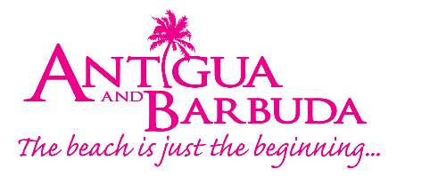
FOR IMMEDIATE RELEASE:

ANTIGUA AND BARBUDA RUNS US TV PRIMETIME CAMPAIGN
FEATURING REGGAE AMBASSADOR CAUSION

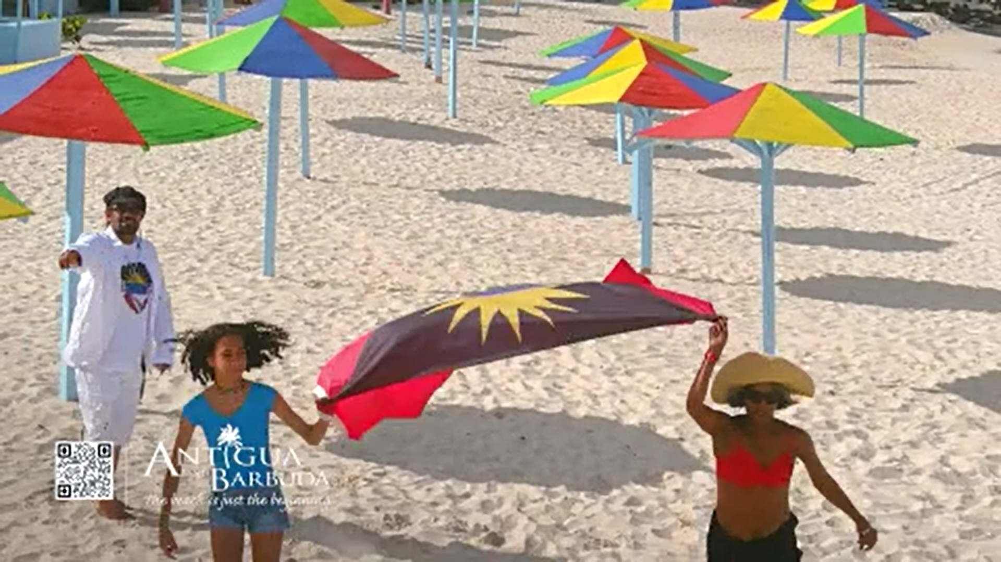

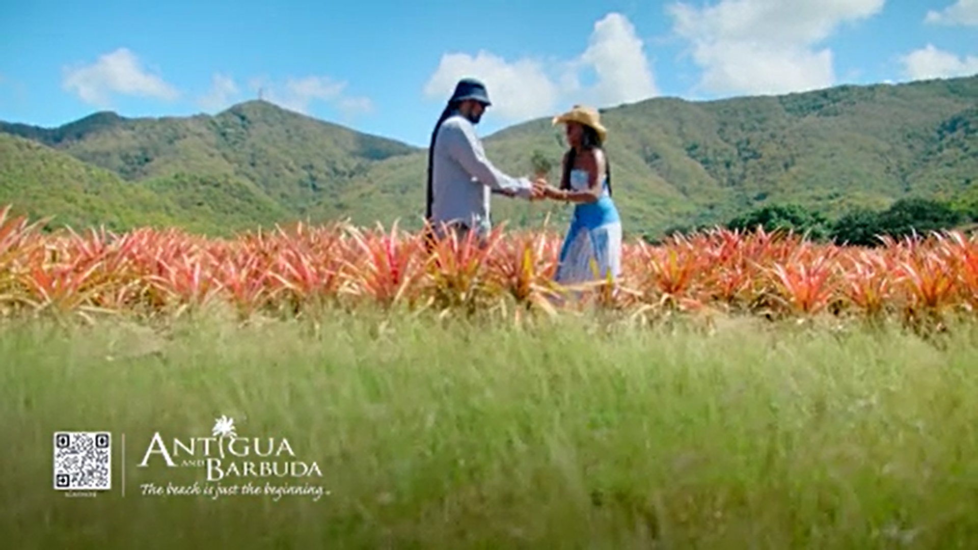

ST. JOHN’S, ANTIGUA (August 18, 2022) - The Antigua and Barbuda Tourism Authority’s latest advertising campaign out of the US Market has been creating a stir as Antigua and Barbuda’s Reggae Ambassador Gregory ‘Causion’ Bailey croons across US television screens and issues an invitation to CBS TV audiences to “bathe in the sun” in Antigua and Barbuda, known for having an astonishing 365 beaches.

The television advertising campaign which begun on August 9 features fifteen second and thirty second clips of Causion’s summer hit music video ‘Antigua Me Come From’ played on CBS TV programmes. A call-to-action encourages viewers of the advert to contact their travel advisor to book an Antigua and Barbuda vacation.

The campaign will run through to the Labor Day weekend (up to September 5) for a total of four weeks, creating over 100 airings and delivering over 10 million New York DMA (designated marketing area) ad impressions.

Programming will include daily CBS morning and evening (11pm) newscasts, CBS Sunday Morning, and Face the Nation (9-11am), Late Night with Stephen Colbert, Entertainment Tonight and CBS Primetime!

A ten second A&B snipe (logo with picture, no audio) will also appear in the bottom right corner during Entertainment Tonight (ET), the leading source of all things entertainment and pop culture.

Causion’s ‘Antigua Me Come From’ video, launched in May 2022 to inspire summer travel, features some of Antigua and Barbuda’s scenic locations, popular resorts, and hospitable people.

ABTA US Director of Tourism Dean Fenton said, “The song really resonated well with our target audience during the early summer months and was the perfect anthem for our brand. Summer is still going strong in Antigua and Barbuda and we are excited to see what this television opportunity does for the destination as far as increasing brand awareness, driving last-minute summer bookings, and getting persons thinking about upcoming winter breaks.”

The CBS audience is considered a strong target for the destination. Viewers plan to take an all-inclusive resort, spa, and beach vacation in the next 12 months, have spent $10,000 or more on vacations during the past 12 months and have an annual household income exceeding $250,000.

Persons can tune into these key CBS Programmes to catch the Antigua and Barbuda advert this Thursday evening and Friday:

Thursday, Aug 18
- 7:28pm – Entertainment Tonight
- 8:45pm – CBS Primetime’s “Ghosts”
- 11:21pm – CBS 11pm News
Friday, Aug 19
- 5:28am – CBS Morning News
- 8:48am – CBS Morning News
- 1:29pm – Young and the Restless
- 7:28pm – Entertainment Tonight
- 9:45pm: CBS Primetime’s “Blue Bloods”
###
ABOUT THE ANTIGUA AND BARBUDA TOURISM AUTHORITY
The Antigua & Barbuda Tourism Authority is a statutory body dedicated to realizing the tourism potential of Antigua & Barbuda by promoting the twin island state as a unique, quality tourist destination with the overall objective of increasing visitor arrivals thereby providing sustainable economic growth. The Antigua and Barbuda Tourism Authority is headquartered in St. John’s Antigua, where regional marketing is directed. The Authority has three offices overseas in the United Kingdom, United States and Canada.
ABOUT ANTIGUA AND BARBUDA
Antigua (pronounced An-tee'ga) and Barbuda (Bar-byew’da) is located in the heart of the Caribbean Sea. The twin-island paradise offers visitors two uniquely distinct experiences, ideal temperatures year-round, a rich history, vibrant culture, exhilarating excursions, award-winning resorts, mouth-watering cuisine and 365 stunning pink and white-sand beaches - one for every day of the year. The largest of the English-speaking Leeward Islands, Antigua comprises 108-square miles with rich history and spectacular topography that provides a variety of popular sightseeing opportunities. Nelson’s Dockyard, the only remaining example of a Georgian fort a listed UNESCO World Heritage site, is perhaps the most renowned landmark. Antigua’s tourism events calendar includes the prestigious Antigua Sailing Week, Antigua Classic Yacht Regatta, and the annual Antigua Carnival; known as the Caribbean’s Greatest Summer Festival. Barbuda, Antigua’s smaller sister island, is the ultimate celebrity hideaway. The island lies 27 miles north-east of Antigua and is just a 15-minute plane ride away. Barbuda is known for its untouched 11-mile stretch of pink sand beach and as the home of the largest Frigate Bird Sanctuary in the Western Hemisphere. Find information on Antigua & Barbuda at: www.visitantiguabarbuda.com or follow us on Twitter: http://twitter.com/antiguabarbuda Facebook: www.facebook.com/antiguabarbuda; Instagram: www.instagram.com/AntiguaandBarbuda

For Antigua and Barbuda media enquiries, please contact:
Maria Blackman
Marketing Communications Manager
Antigua and Barbuda Tourism Authority
T: 1 (268) 562 7600/464-7601
E: maria.blackman@visitaandb.com
Antigua and Barbuda Images: aandbtourism.fotoseeker.com

