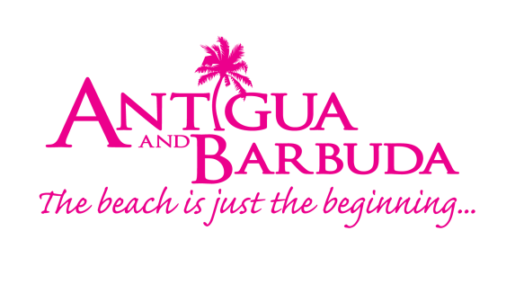
PRESS RELEASE:

Antigua and Barbuda tourism authority Brings antigua and barbuda culture to the 2022 ACTA Golf Tournament in canada

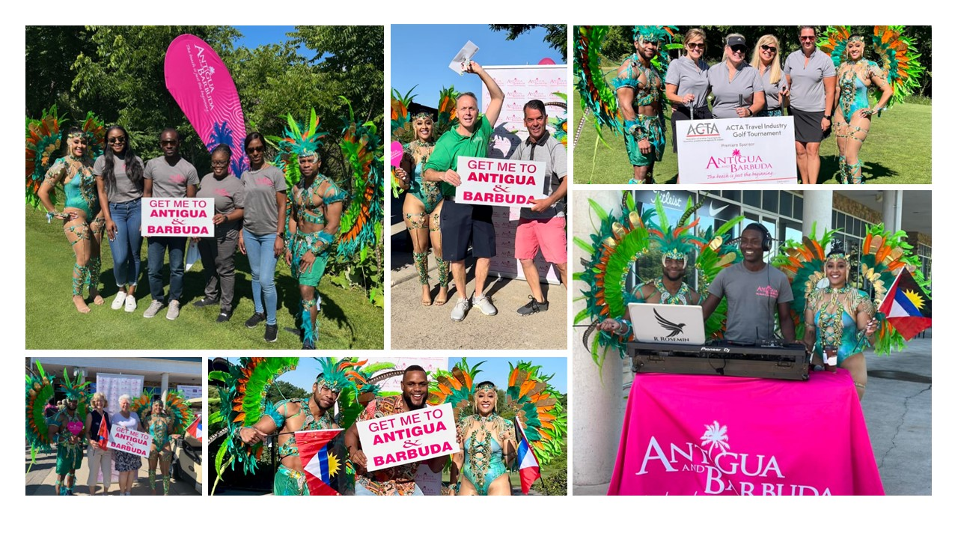
Photo Caption: The Antigua and Barbuda Tourism Authority’s team in Canada, brought smiles, warmth and the culture of Antigua and Barbuda to the ACTA’s Golf Tournament, last week (Photos courtesy, The Antigua and Barbuda Tourism Authority)

TORONTO, CANADA (July 19, 2022) – The Antigua and Barbuda Tourism Authority’s Canadian Office partnered with the Association of Canadian Travel Agencies (ACTA) on last Thursday’s much-anticipated return of the Association of Canadian Travel Agencies (ACTA) Ontario Golf Tournament. The 2022 incarnation of this travel industry tradition is the first since the pandemic began. As the Premier Destination Sponsor of the event, tourism executives created an Antigua and Barbuda vacation atmosphere and introduced audiences to the twin-island’s music and carnival festivities during the event.

“We were delighted to bring a little bit of Antigua and Barbuda to the course as destination sponsors, highlighting our partners the luxurious 5-star Blue Waters Resort & Spa and our 18-hole championship golf course Cedar Valley in Antigua. My greatest delight was welcoming our many Canadian industry friends and partners in attendance as they enjoyed themselves; dancing their way over to us to the sweet sounds of our local music and sampling our authentic sweets during their breaks,” said Tameka Wharton, Canada Director of Tourism (Ag) at the Antigua and Barbuda Tourism Authority. “This was a great opportunity to genuinely reconnect in person after two years apart."

The tournament, which took place at the Royal Ontario Golf Club in Milton had over 72 golfers for 18 holes of casual competition, and over 200 for the dinner event from all sectors of the Canadian travel industry.

The Antigua and Barbuda Tourism Authority delighted those in attendance with sponsored attractions like a live DJ at the check-in table and photo opportunities with two performers in colourful carnival masquerade costumes both at check-in and later at their sponsored hole. Golfers were able to sample Antiguan specialties like saltfish fritters, local lemonade and ginger beer.

After dinner, prizes were awarded with multiple winners of complimentary rounds of golf at the Cedar Valley Golf Course in Antigua & Barbuda. A Grand Prize was awarded which included a wonderful, complimentary 3 night stay at the 5-star Blue Water Resort & Spa, 2 rounds of golf at Antigua’s Cedar Valley Golf Course, 2 Executive Lounge passes, Port Health Clearance, 7-day Valet parking at Park N’ Fly, and 2 Air Canada economy class flights to Antigua.

A yearly tradition since 1988, the ACTA Ontario Golf Tournament unites Canadian travel industry representatives, suppliers, and agents drawn from ACTA’S 12,000 members for a day of lighthearted fun. Beyond the joy of competition, the tournament is also one of the foremost networking and fundraising events within the Canadian travel industry. Air Canada and Manulife joined the Antigua and Barbuda Tourism Authority in sponsoring this year’s event.

To learn more about ACTA and its upcoming industry events, visit www.acta.ca/.

Start planning your getaway to Antigua and Barbuda at www.visitantiguabarbuda.com.
###

ABOUT THE ANTIGUA AND BARBUDA TOURISM AUTHORITY
The Antigua & Barbuda Tourism Authority is a statutory body dedicated to realizing the tourism potential of Antigua & Barbuda by promoting the twin island state as a unique, quality tourist destination with the overall objective of increasing visitor arrivals thereby providing sustainable economic growth. The Antigua and Barbuda Tourism Authority is headquartered in St. John’s Antigua, where regional marketing is directed. The Authority has three offices overseas in the United Kingdom, United States and Canada.

ABOUT ANTIGUA AND BARBUDA
Antigua (pronounced An-tee'ga) and Barbuda (Bar-byew’da) is located in the heart of the Caribbean Sea. Voted the World Travel Awards 2015, 2016, 2017 and 2018 Caribbean’s Most Romantic Destination, the twin-island paradise offers visitors two uniquely distinct experiences, ideal temperatures year-round, a rich history, vibrant culture, exhilarating excursions, award-winning resorts, mouth-watering cuisine and 365 stunning pink and white-sand beaches - one for every day of the year. The largest of the Leeward Islands, Antigua comprises 108-square miles with rich history and spectacular topography that provides a variety of popular sightseeing opportunities. Nelson’s Dockyard, the only remaining example of a Georgian fort a listed UNESCO World Heritage site, is perhaps the most renowned landmark. Antigua’s tourism events calendar includes the prestigious Antigua Sailing Week, Antigua Classic Yacht Regatta, and the annual Antigua Carnival; known as the Caribbean’s Greatest Summer Festival. Barbuda, Antigua’s smaller sister island, is the ultimate celebrity hideaway. The island lies 27 miles north-east of Antigua and is just a 15-minute plane ride away. Barbuda is known for its untouched 17 mile stretch of pink sand beach and as the home of the largest Frigate Bird Sanctuary in the Western Hemisphere. Find information on Antigua & Barbuda at: www.visitantiguabarbuda.com or follow us on
Twitter: http://twitter.com/antiguabarbuda
Facebook: www.facebook.com/antiguabarbuda
Instagram: www.instagram.com/AntiguaandBarbuda

For Antigua and Barbuda media enquiries, please contact:
Maria Blackman
Marketing Communications Manager
Antigua and Barbuda Tourism Authority
T: 1 (268) 562 7600/464-7601
E: maria.blackman@visitaandb.com

Antigua and Barbuda Images: aandbtourism.fotoseeker.com

