FOR IMMEDIATE RELEASE:

ANTIGUA AND BARBUDA NOMINATED AS LEADING DESTINATION IN WORLD TRAVEL AWARDS

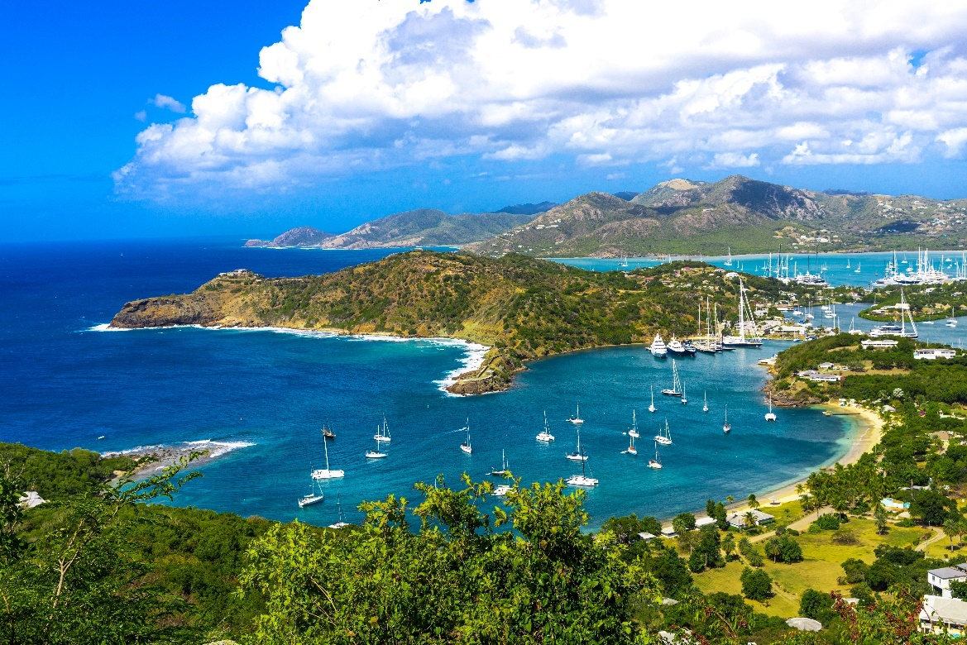

Antigua and Barbuda gains twenty nominations in the 2022 World Travel Awards (Photo credit: Antigua and Barbuda Tourism Authority)

ST. JOHN’S, ANTIGUA (APRIL 14, 2022) - The twin-island paradise of Antigua and Barbuda has received twenty nominations in the 2022 World Travel Awards. The prestigious World Travel Awards, now in its 29th year celebrates excellence in all areas of the global travel and tourism industry.

Antigua and Barbuda has been recognized as a leading destination with nominations across various categories to include: Caribbean’s Leading Beach Destination, Caribbean’s Most Romantic Destination and Caribbean’s Leading Honeymoon Destination.

With scenic locales and romantics experiences, the destination has previously celebrated award wins for the Caribbean’s Most Romantic Destination in 2015, 2016, 2017 and 2018.

In 2022, the Antigua and Barbuda Tourism Authority (ABTA) introduced a new romance Campaign ‘Love & Wanderlust’ which falls under the Romance Pillar of the ABTA’s marketing programme. The campaign is intended to position the destination as the leading choice for couples.

Known for possessing an abundance of gorgeous, sandy beaches with turquoise waters, the beach personality test launched by the Antigua and Barbuda Tourism Authority this year, also allows users to find their perfect beach in Antigua and Barbuda.

The Antigua and Barbuda Tourism Authority, the statutory body responsible for destination marketing has also received a nomination for Caribbean’s Leading Tourist Board.

Minister of Tourism and Investment, The Hon. Charles ‘Max’ Fernandez remarked, “These nominations are a testament to the level of work and commitment displayed by the Tourism Authority and the Ministry of Tourism in our relentless effort to maintain Antigua and Barbuda as a premier destination, moreso coming out of a near two-year pandemic. With continued strategic marketing, I foresee many more nominations and awards coming our way as we expand and explore the vastness of the tourism industry which is so vital to our economy.”

Several of Antigua and Barbuda’s hospitality and tourism service providers have also been nominated for the 2022 Caribbean awards. Those award nominations are within the categories of: Caribbean’s Leading Boutique Hotel, Caribbean’s Leading Resort, Caribbean’s Leading Destination Management Company, Caribbean’s Leading Airport, Caribbean’s Leading Airport Lounge, Caribbean’s Leading Tour Operators, Caribbean’s Leading Adventure Tourist Attraction, Caribbean’s Leading All-inclusive Family Resort, Caribbean’s Leading Green Resort, Caribbean’s Leading Luxury All Suite Resorts, Caribbean’s Leading Luxury All-Inclusive Resorts, Caribbean’s Leading Luxury Resort, Caribbean’s Leading Resort, Caribbean’s Leading Villa Resort and Caribbean’s Most Romantic Resort.

The Antigua and Barbuda Tourism Authority invites the general public to vote for Antigua and Barbuda in the 29th World Travel Awards. Voting for the twin-isle nation can be done on worldtravelawards.com at the link
www.worldtravelawards.com/nominees/2022/caribbean. Voting ends on May 3 2022.

This year’s World Travel Awards Caribbean & North America Gala Ceremony will be hosted in Jamaica on June 14, 2022.

###

For Antigua and Barbuda media enquiries, please contact:
Maria Blackman
Antigua and Barbuda Tourism Authority
T: 1 (268) 562 7600/464-7601
E: maria.blackman@visitaandb.com

ABOUT ANTIGUA AND BARBUDA:
Antigua (pronounced An-tee'ga) and Barbuda (Bar-byew’da) is located in the heart of the Caribbean Sea. The twin-island paradise offers visitors two uniquely distinct experiences, ideal temperatures year-round, a rich history, vibrant culture, exhilarating excursions, award-winning resorts, mouth-watering cuisine and 365 stunning pink and white-sand beaches - one for every day of the year. The largest of the English-speaking Leeward Islands, Antigua comprises 108-square miles with rich history and spectacular topography that provides a variety of popular sightseeing opportunities. Nelson’s Dockyard, the only remaining example of a Georgian fort a listed UNESCO World Heritage site, is perhaps the most renowned landmark. Antigua’s tourism events calendar includes the prestigious Antigua Sailing Week, Antigua Classic Yacht Regatta, and the annual Antigua Carnival; known as the Caribbean’s Greatest Summer Festival. Barbuda, Antigua’s smaller sister island, is the ultimate celebrity hideaway. The island lies 27 miles north-east of Antigua and is just a 15-minute plane ride away. Barbuda is known for its untouched 11-mile stretch of pink sand beach and as the home of the largest Frigate Bird Sanctuary in the Western Hemisphere. Find information on Antigua & Barbuda at: www.visitantiguabarbuda.com

