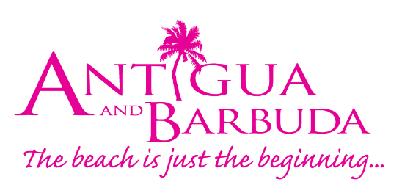

FOR IMMEDIATE RELEASE:
ANTIGUA AND BARBUDA PAVILION DOORS OPEN AT EXPO DUBAI 2020
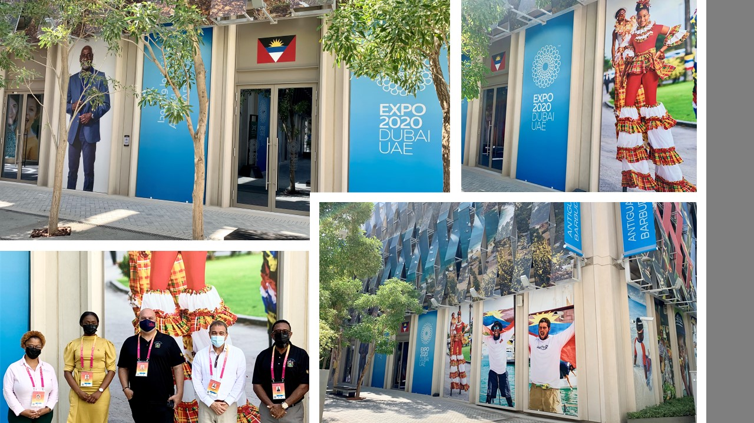
Photo Caption: Antigua and Barbuda’s pavilion doors at Expo Dubai 2020 are now officially opened. Pictured L-R are Senior Sustainable Tourism Officer from the Ministry of Tourism Vashti Ramsey, Marketing Executive from the Antigua and Barbuda Tourism Authority, Raynel Carroll, Non-Resident Ambassador of Antigua and Barbuda to the UAE H.E. Ambassador Gilbert Boustany, Minister of Tourism and Investment, The Honourable Charles Fernandez and CEO of the Antigua and Barbuda Tourism Authority Colin C. James.

ST. JOHN’S, ANTIGUA (Friday October 1, 2021) – The twin-island paradise of Antigua and Barbuda is on show at the world expo ‘Expo Dubai 2020’ being held in Dubai under the theme ‘Connecting Minds, Creating the Future’.
Antigua and Barbuda’s pavilion located in the ‘Mobility’ section of the expo; displays the remarkable strides the Caribbean nation has made in its socio-economic development over the years.

Officially opening, the doors to the Antigua and Barbuda pavilion on Friday October 1 were, Minister of Tourism and Investment, The Honourable Charles Fernandez, CEO of the Antigua and Barbuda Tourism Authority Colin C. James, Non-Resident Ambassador of Antigua and Barbuda to the UAE H.E. Ambassador Gilbert Boustany, Senior Sustainable Tourism Officer from the Ministry of Tourism Vashti Ramsey and Marketing Executive from the Antigua and Barbuda Tourism Authority, Raynel Carroll.

Speaking at the opening, Minister of Tourism and Investment the Honourable Charles Fernandez said: "Antigua and Barbuda's participation at Expo Dubai 2020 is a momentous occasion and marks another milestone for our country on an international stage. It is an honour to be a part of history, as we showcase the progress of the nation, and the very best Antigua and Barbuda has to offer; from luxury vacations to first class business and investment opportunities. Not only that, but Expo Dubai 2020 is the perfect backdrop for the sharing of ideas and culture; particularly our move towards green energy and of course, our world-class talent which will also be on display.”

Chief Executive Officer of the Antigua and Barbuda Tourism Authority Colin C. James said the team will take advantage of opportunities available in Dubai.

“Expo Dubai 2020 will serve as an international platform for us to raise awareness of Antigua and Barbuda as a tourism destination, to draw attention to our sound financial banking sector, ship registry offerings, and Citizenship by Investment programme”. He added that specific to airlift, there are plans to, “re-engage Emirates Airline about starting direct service.”
Visitors to the Antigua and Barbuda pavilion will learn to play the traditional game of warri, be entertained with cultural storytelling, browse and purchase masterpieces of local artisans and experience the pulsating rhythms of Antigua and Barbuda’s vibrant music.

The destination’s marine attributes are also on display with highlights of the UNESCO World Heritage Site: Nelson’s Dockyard and related archeological sites, alongside attractive sailing, yachting and watersport conditions. The Antigua and Barbuda Department of Marine Services and Merchant Shipping (ADOMS) will also have representation over the next six months, highlighting the country's maritime and shipping opportunities.

Additionally, Antigua and Barbuda’s sporting greats both past and present are being featured, with athletes highlighted in the pavilion design. A special appearance by National Hero and Sporting Legend, Sir Vivian Richards KNH, OBE has been planned for Expo Dubai 2020.

Sister-island Barbuda is being highlighted as the ‘Untouched Eco-paradise’, while the destination’s latest sustainable initiatives and moves towards green energy will be discussed.

The Citizenship by Investment Unit (CIU) will also be present to encourage foreign direct investment. The CIU is scheduled to host the country's first Business Briefing.

The Antigua and Barbuda delegation will look forward to hosting for expo attendees the ‘Antigua and Barbuda's National Day’, a rich cultural and historic presentation to commemorate Antigua and Barbuda’s 40th Anniversary of Independence on November 1, 2021. Attendees can expect performances by top Antigua and Barbuda performers to include the "Soca Diva" Claudette "CP" Peters, OH and renowned steel pannist Khan Cordice, alongside other cultural talent.

Being held from 1 October 2021 - 31 March 2022, Expo Dubai 2020, joins businesses from around the world to create new opportunities, attract investment, forge business agreements, and promote international cooperation and growth. The purpose-built, 4.8-square-kilometre exhibition grounds highlight Opportunity, Mobility and Sustainability as interconnected drivers of progress.
###
ABOUT ANTIGUA AND BARBUDA
Antigua (pronounced An-tee'ga) and Barbuda (Bar-byew’da) is located in the heart of the Caribbean Sea. Voted the World Travel Awards 2015, 2016, 2017 and 2018 Caribbean’s Most Romantic Destination, the twin-island paradise offers visitors two uniquely distinct experiences, ideal temperatures year-round, a rich history, vibrant culture, exhilarating excursions, award-winning resorts, mouth-watering cuisine and 365 stunning pink and white-sand beaches - one for every day of the year. The largest of the Leeward Islands, Antigua comprises 108-square miles with rich history and spectacular topography that provides a variety of popular sightseeing opportunities. Nelson’s Dockyard, the only remaining example of a Georgian fort a listed UNESCO World Heritage site, is perhaps the most renowned landmark. Antigua’s tourism events calendar includes the prestigious Antigua Sailing Week, Antigua Classic Yacht Regatta, and the annual Antigua Carnival; known as the Caribbean’s Greatest Summer Festival. Barbuda, Antigua’s smaller sister island, is the ultimate celebrity hideaway. The island lies 27 miles north-east of Antigua and is just a 15-minute plane ride away. Barbuda is known for its untouched 17 mile stretch of pink sand beach and as the home of the largest Frigate Bird Sanctuary in the Western Hemisphere. Find information on Antigua & Barbuda at: www.visitantiguabarbuda.com or follow us on Twitter. http://twitter.com/antiguabarbuda Facebook www.facebook.com/antiguabarbuda; Instagram: www.instagram.com/AntiguaandBarbuda

For media enquiries, please contact:
Maria Blackman
Antigua and Barbuda Tourism Authority
T: 1 (268) 562 7600/464-7601
E: maria.blackman@visitaandb.com

