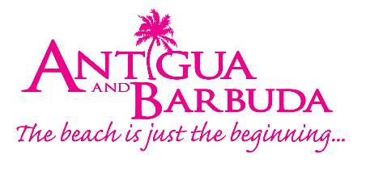

FOR IMMEDIATE RELEASE:

EIGHTY BARBUDA TOURISM PROFESSIONALS AWARDED
D.E.E.R CERTIFICATES OF SERVICE EXCELLENCE
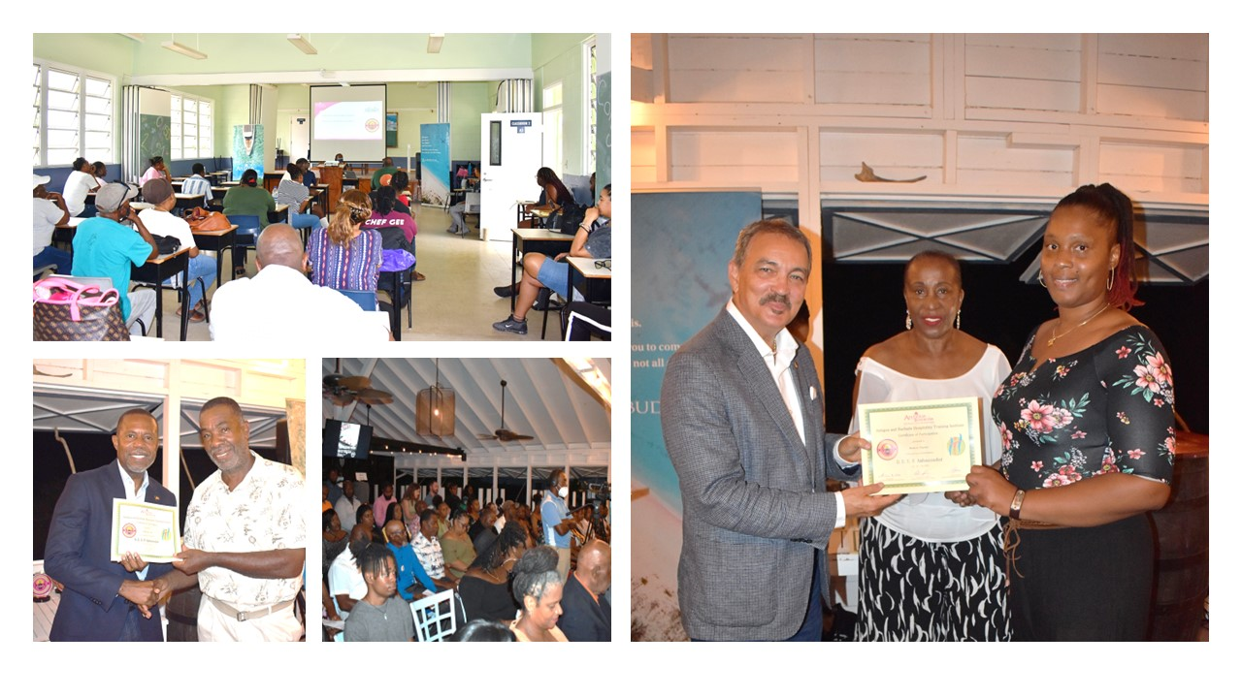
Photo Caption: A cross-section of tourism stakeholders in Barbuda took advantage of the intensive two-day customer service certification course. (Photo Credits, The Antigua and Barbuda Tourism Authority)

CODRINGTON, BARBUDA (July 21, 2022) – Eighty tourism professionals in Barbuda have earned Barbuda’s D.E.E.R Certification having demonstrated their knowledge, skills, ability, and competencies to deliver quality customer experiences, in completing the Antigua and Barbuda Tourism Authority’s service excellence D.E.E.R Ambassador programme designed exclusively for Barbuda.

The D.E.E.R (Delivering Exceptional Experiences Repeatedly’) (Deliver Excellence Everyone Responsibility) Programme launched early in July, by the Antigua and Barbuda Tourism Authority (ABTA) in collaboration with the Barbuda Council, offers customer service certification issued by the Antigua and Barbuda Hospitality Training Institute.

A cross-section of tourism stakeholders in Barbuda ranging from taxi drivers, council employees, entrepreneurs, restauranteurs, hotel employees, tourism officials and police officers took advantage of the intensive three-day certification course.

The first ever graduates of the programme, were recently presented with their certificates, during an ABTA graduation ceremony attended by Antigua and Barbuda’s Minister of Tourism, The Honourable Charles Fernandez. Other officials also in attendance at the graduation ceremony were Member of Parliament for Barbuda, The Honourable Trevor Walker, Chairman of the Barbuda Council Mackenzie Frank, CEO of the Antigua and Barbuda Tourism Authority Colin C. James and Tourism & Culture Chairperson within the Barbuda Council Calsey Joseph.

In his congratulatory remarks, Minister Fernandez urged the graduates to view the experience, not only as training but as a means of empowerment. “This is about empowering you; this is about taking it to the next level. And you can only do that if you feel empowered. You must understand that when you leave here, know that you are leaving as an empowered person equipped with the skills needed to do your job to the best of your ability.”

Further said the tourism minister, “As tourism stakeholders, you are all important links within the tourism chain, and your contributions negative or positive impact the workings of the entire Antigua and Barbuda tourism industry. From this day on, you are now tourism ambassadors and contributors to the success of the wider tourism product.”

Participants were full of high praise for the programme. Maureen Lee Simon – Office Manager, Barbuda Cottages and Uncle Roddy’s Bar, Restaurant & Grill called the training “interactive, interesting and re-affirming”.

“This training means, that as service providers we are returning to our workplaces more prepared and empowered to meet the needs of our guests and to provide them with the full experience they expect when they travel to Barbuda”, said Simon.

Simon recounts one of the lessons that has stood out for her as, “We are all contributors. When a customer or visitor comes to Barbuda, their experience begins from the time they land, to the time they leave. Every interaction they will have in Barbuda, will contribute to their overall experience. And so, it is very important that we follow the D.E.E.R concept; our delivery of exceptional experiences repeatedly - it is our responsibility.”

“The importance that has been placed on this programme by the Antigua and Barbuda Tourism Authority, is a testimony to its success” said Training Programme Concept Designer and Facilitator Shirlene Nibbs. “Investing in our human resources is a critical component in developing the Barbuda tourism product. We are excited to see how this cadre of Tourism Ambassadors will take what they have learnt back into their workplaces, to aid in the next level of growth for Barbuda.”

Each graduate received an ambassador pin, while taxi drivers and small property owners also received ambassador decals for display on vehicles and accommodations. Ambassador plaques were provided to hotels and restaurants.

The D.E.E.R Ambassador programme will take place annually in Barbuda.

###

ABOUT THE ANTIGUA AND BARBUDA TOURISM AUTHORITY
The Antigua & Barbuda Tourism Authority is a statutory body dedicated to realizing the tourism potential of Antigua & Barbuda by promoting the twin island state as a unique, quality tourist destination with the overall objective of increasing visitor arrivals thereby providing sustainable economic growth. The Antigua and Barbuda Tourism Authority is headquartered in St. John’s Antigua, where regional marketing is directed. The Authority has three offices overseas in the United Kingdom, United States and Canada.

ABOUT ANTIGUA AND BARBUDA
Antigua (pronounced An-tee'ga) and Barbuda (Bar-byew’da) is located in the heart of the Caribbean Sea. The twin-island paradise offers visitors two uniquely distinct experiences, ideal temperatures year-round, a rich history, vibrant culture, exhilarating excursions, award-winning resorts, mouth-watering cuisine and 365 stunning pink and white-sand beaches - one for every day of the year. The largest of the English-speaking Leeward Islands, Antigua comprises 108-square miles with rich history and spectacular topography that provides a variety of popular sightseeing opportunities. Nelson’s Dockyard, the only remaining example of a Georgian fort a listed UNESCO World Heritage site, is perhaps the most renowned landmark. Antigua’s tourism events calendar includes the prestigious Antigua Sailing Week, Antigua Classic Yacht Regatta, and the annual Antigua Carnival; known as the Caribbean’s Greatest Summer Festival. Barbuda, Antigua’s smaller sister island, is the ultimate celebrity hideaway. The island lies 27 miles north-east of Antigua and is just a 15-minute plane ride away. Barbuda is known for its untouched 11-mile stretch of pink sand beach and as the home of the largest Frigate Bird Sanctuary in the Western Hemisphere. Find information on Antigua & Barbuda at: www.visitantiguabarbuda.com or follow us on Twitter: http://twitter.com/antiguabarbuda Facebook: www.facebook.com/antiguabarbuda; Instagram: www.instagram.com/AntiguaandBarbuda

For Antigua and Barbuda media enquiries, please contact:
Maria Blackman
Marketing Communications Manager
Antigua and Barbuda Tourism Authority
T: 1 (268) 562 7600/464-7601
E: maria.blackman@visitaandb.com

Antigua and Barbuda Images: aandbtourism.fotoseeker.com

