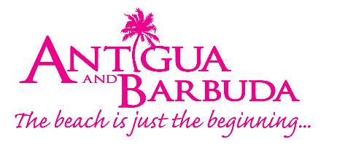

FOR IMMEDIATE RELEASE:

ANTIGUA AND BARBUDA TOURISM AUTHORITY LAUNCHES
D.E.E.R PROGRAMME TO SUPPORT BARBUDA TOURISM SECTOR GROWTH

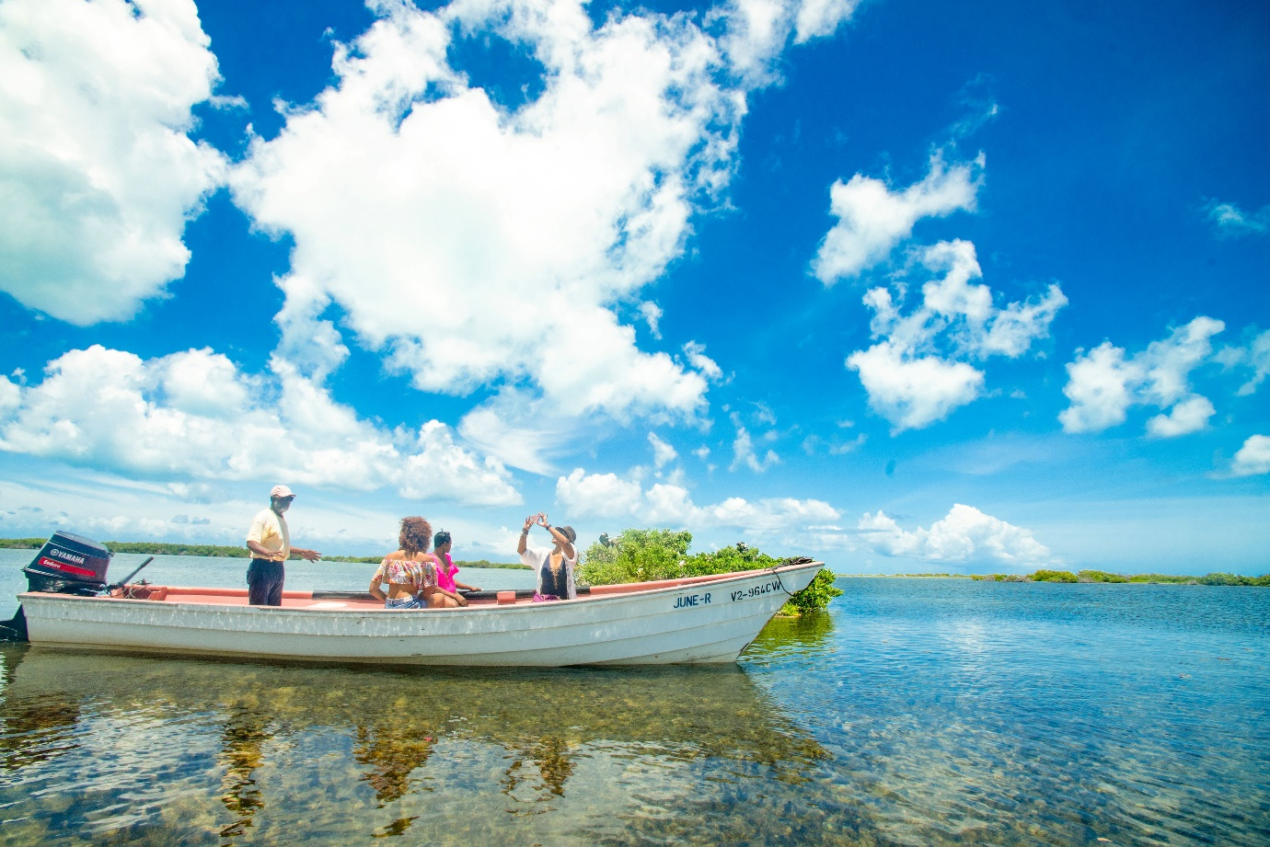
Photo Caption: Visitors to Barbuda can explore the Frigate Bird Sanctuary during an organized tour with one of Barbuda’s tour guides. (Photo Credits, The Antigua and Barbuda Tourism Authority)

ST. JOHN’S, ANTIGUA (July 6, 2022) – With Barbuda’s tourism sector poised for growth, tourism service providers in Barbuda, are taking advantage of the D.E.E.R training programme being offered by the Antigua and Barbuda Tourism Authority from July 12 – July 14, 2022, in Barbuda.
The country’s Minister of Tourism, The Hon H. Charles Fernandez said “I’m delighted with the rollout of this training initiative, as a follow up to the recent launch of a unique marketing campaign solely for Barbuda. This is another example of keeping our commitment given at an earlier meeting with officials of the Barbuda Council and the Tourism Authority. We pledged then to provide more tangible support and resources to Barbuda in the areas of Tourism Marketing, Product Development and Training and we’re delivering as promised”.
D.E.E.R which stands for both ‘Delivering Exceptional Experiences Repeatedly’ and ‘Delivering Excellence: Everyone’s Responsibility” is specifically aimed at supporting Barbuda tourism professionals keen to provide a high quality of customer service to their customers.
The bespoke programme was conceptualized and developed by Nibbs and Associates for the Antigua and Barbuda Tourism Authority. The D.E.E.R Customer Service oriented workshop will develop the participants understanding of: The concept of ‘Customer Experience’ and its ‘Importance to Barbuda’s Tourism Industry’. The workshop is geared at improving customer relations in Barbuda - through improved customer service, customer care, customer relations and communications and an understanding of human relations.
CEO of the Antigua and Barbuda Tourism Authority, Colin C. James said, “Barbuda is a unique and amazing destination, and the warmth and hospitality of Barbudans is unrivalled. As demand for Barbuda has increased, with the introduction of tourism developments and dedicated tourism marketing campaigns for the island, now is the time for those on the tourism frontline to strengthen the quality of service they offer. At the Antigua and Barbuda Tourism Authority, we look forward to supporting the Barbuda Council, and working with our Barbuda tourism stakeholders on this next stage of growth.”

Taxi and transportation operators, vendors, tour excursion employees and frontline service workers are being encouraged to attend the workshop.

Managing Director of Nibbs and Associates and Training Facilitator Shirlene Nibbs stressed that, “Delivering excellence every single time, is everyone’s responsibility.”

“The programme will focus on what it is that our customers expect today in 2022, within the context of a pandemic, and considering the value that persons now place on their interactions with others. When we are in a business that is built on interactions and engagements, we need to recognize that it is imperative that we give excellence, all the time”, she said.

Nibbs noted that, “The training aligns with the strategy laid out for the sustainable development of Barbuda and brings all Antiguans and Barbudans who will be making a significant contribution to the development of tourism in Barbuda together.”

The customer service training will cover a variety of topics such as customer service and customer experience, customer expectations, building customer relationships, and understanding problem resolution and recovery strategies.

“We know the D.E.E.R training workshop will improve the professionalism of each participant and result in enhanced customer service satisfaction in Barbuda”, said Calsey Joseph, Tourism & Culture Chairperson within the Barbuda Council.

The training will take place at the Sir McChesney George Secondary School. There will be two sessions, 8:00 a.m. – 12:00 noon and 1:00 p.m. – 5:00 p.m. daily. Participants can expect to experience engaging and immersive practical training.

On the completion of training, participants will receive a D.E.E.R Certificate of Completion awarded by the Antigua and Barbuda Hospitality Training Institute.

Persons wishing to register for the D.E.E.R programme can visit the Barbuda Tourism Office or contact Anreka Geness Barbuda Tourism Marketing Officer at the Antigua and Barbuda Tourism Authority on email at Anreka.Geness@visitaandb.com or by telephone at: 1 268 562 7600.

###

ABOUT THE ANTIGUA AND BARBUDA TOURISM AUTHORITY
The Antigua & Barbuda Tourism Authority is a statutory body dedicated to realizing the tourism potential of Antigua & Barbuda by promoting the twin island state as a unique, quality tourist destination with the overall objective of increasing visitor arrivals thereby providing sustainable economic growth. The Antigua and Barbuda Tourism Authority is headquartered in St. John’s Antigua, where regional marketing is directed. The Authority has three offices overseas in the United Kingdom, United States and Canada.

ABOUT ANTIGUA AND BARBUDA
Antigua (pronounced An-tee'ga) and Barbuda (Bar-byew’da) is located in the heart of the Caribbean Sea. The twin-island paradise offers visitors two uniquely distinct experiences, ideal temperatures year-round, a rich history, vibrant culture, exhilarating excursions, award-winning resorts, mouth-watering cuisine and 365 stunning pink and white-sand beaches - one for every day of the year. The largest of the English-speaking Leeward Islands, Antigua comprises 108-square miles with rich history and spectacular topography that provides a variety of popular sightseeing opportunities. Nelson’s Dockyard, the only remaining example of a Georgian fort a listed UNESCO World Heritage site, is perhaps the most renowned landmark. Antigua’s tourism events calendar includes the prestigious Antigua Sailing Week, Antigua Classic Yacht Regatta, and the annual Antigua Carnival; known as the Caribbean’s Greatest Summer Festival. Barbuda, Antigua’s smaller sister island, is the ultimate celebrity hideaway. The island lies 27 miles north-east of Antigua and is just a 15-minute plane ride away. Barbuda is known for its untouched 11-mile stretch of pink sand beach and as the home of the largest Frigate Bird Sanctuary in the Western Hemisphere. Find information on Antigua & Barbuda at: www.visitantiguabarbuda.com or follow us on Twitter: http://twitter.com/antiguabarbuda Facebook: www.facebook.com/antiguabarbuda; Instagram: www.instagram.com/AntiguaandBarbuda

For Antigua and Barbuda media enquiries, please contact:
Maria Blackman
Marketing Communications Manager
Antigua and Barbuda Tourism Authority
T: 1 (268) 562 7600/464-7601
E: maria.blackman@visitaandb.com

Antigua and Barbuda Images: aandbtourism.fotoseeker.com

