**ENJOY YOUR OWN SPACE THIS VALENTINE’S**

***Shop and win EC$500 Shopping Spree at Heritage Quay***

Enjoying *Your Own Space in the Sun* just got more exciting with the launch of a Valentine’s Campaign encouraging residents of Antigua and Barbuda to shop at the Heritage Quay complex and earn points for every purchase. These points called; **Space points** can be earned when residents purchase items from any of the participating Retail Stores. Racking up Space Points for purchases will also give shoppers the opportunity to win a $500 shopping Spree in the Quay.

The Campaign is a collaboration between the Antigua and Barbuda Tourism Authority, Antigua Cruise Ports, Antigua and Barbuda Hotels and Tourism Association and The Heritage Quay Merchants Association.

**How will it work?**

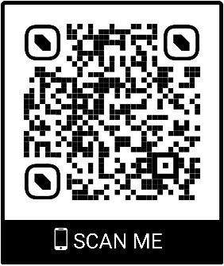

Scan the above barcode or sign up to Program at <https://eddypro.typeform.com/to/AHbvNEwA>

You will automatically be able to view all participating retail offers.

**Ready to Shop?**

Use our Smartphone and scan the barcode in participating stores after your purchase and automatically earn five (5) points. Get ten (10) bonus points when you post a picture of yourself with your purchase on Facebook or Instagram tagging @antiguacruiseport

Weekly winners of EC$50 Space bucks will be randomly selected from online pictures tagged with customer purchases. On February 15, there will be one **GRAND PRIZE WINNER** of $500 Space bucks for shopping in the Heritage Quay complex. Space bucks can only be redeemed at participating retailers.

Don’t delay this Valentine’s. Grab your smartphone, head on over to the Heritage Quay and shop, scan and win something extra for that special person you love.

**Enjoy offers of up to 50% off at participating stores.**  Last Shopping day for the campaign is February 13, 2021.