First cohort of hospitality employees are set for travel to Jersey, Channel Islands
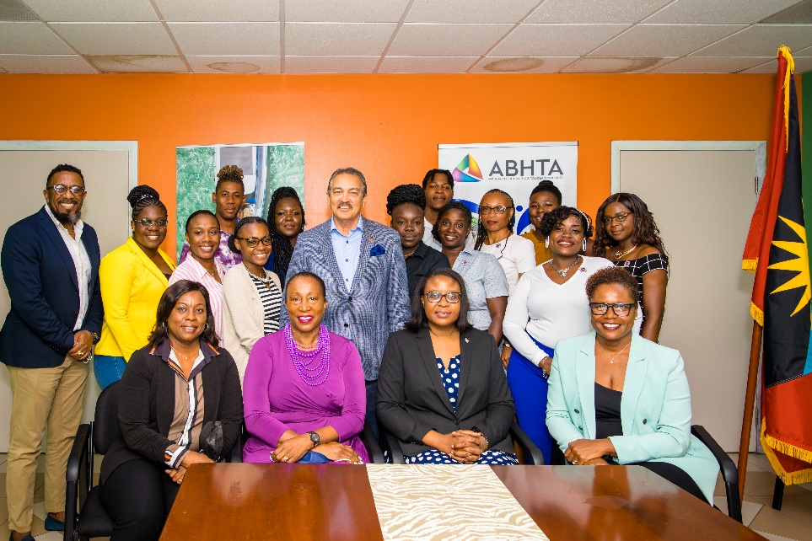
Photo Caption: The twelve successful candidates that attended today’s pinning ceremony are all smiles with Minister of Tourism and Investment, The Honourable Charles Fernandez (centre) along with Antigua and Barbuda Tourism Authority CEO Colin C. James (standing far left) and Executive Director of the Antigua and Barbuda Hospitality Training Institute (ABHTI) Ruthlyn Matthias, Chairman of the ABHTI Shirlene Nibbs, Antigua and Barbuda’s High Commissioner to the United Kingdom Karen-Mae Hill and Executive Director of the Antigua and Barbuda Hotels and Tourism Association Patrice Simon (front row seated).
Photo Caption: And they are off!! The excited hospitality professionals will leave Antigua shortly for 6-month work stints in Jersey, Channel Islands.
Tuesday April 19, 2022, Antigua and Barbuda: The partnership between Antigua and Barbuda and Jersey in the Channel Islands today marked another milestone as the first cohort of hospitality professionals from Antigua and Barbuda will be taking up positions this month at various properties in Jersey. Under the memorandum of Understanding between both Governments, the successful candidates will have the opportunity to work for six months in Jersey.
Fifteen hospitality professionals are now set to depart for Jersey to begin their work experience and gain international exposure.
The candidates were presented with their EASE (Exceeding all Service Expectations) certificates and pins during a pinning ceremony hosted by the Ministry of Tourism and the Antigua and Barbuda Hotels and Tourism Association. In attendance were Minister of Tourism and Investment, The Honourable Charles Fernandez, Executive Director of the Antigua and Barbuda Hotels and Tourism Association Patrice Simon, Antigua and Barbuda’s High Commissioner to the United Kingdom Karen-Mae Hill, Chairman of the Antigua and Barbuda Hospitality Training Institute/ABHTI Shirlene Nibbs, Executive Director of the ABHTI, Ruthlyn Matthias and CEO of the Antigua and Barbuda Tourism Authority Colin C. James, amongst other well-wishers.
The Honourable Charles ‘Max” Fernandez, Minister of Tourism and Investment in his congratulatory message to the candidates remarked, “You are all now Ambassadors for Antigua and Barbuda, paving the way for others to follow. As the first cohort, you have a very important role, because the future of other Antiguans and Barbudans being able to gain from this unique global experience lies with you. Focus on this as an exciting opportunity designed to allow you to learn new approaches, demonstrate your skillset and introduce the hospitality businesses you will be immersed in, to Antigua and Barbuda. Gain knowledge and experience that once acquired can be shared with your colleagues upon your return to Antigua and Barbuda”.

The Jersey Government experienced a shortage of employees due to Brexit and the Covid-19 pandemic. To fill that void, they approached the High Commissioner’s Office in the United Kingdom to forge a partnership whereby Antiguans and Barbudans can fill key roles to include Chefs, middle operation management roles in hotel and in restaurants and front-line staff across multiple disciplines including, but not exclusive to: Food & Beverage, Housekeeping, Front of House. The partnership was a great match, as Jersey’s high season for Tourism is April to September, our traditional off season.
Schena Drew, one of the successful candidates will take up the role of Front of House Supervisor at the Lookout Café and Restaurant in Jersey. She expressed appreciation to both the Governments of Antigua and Barbuda and Jersey for making the partnership possible and remarked that all candidates have been afforded this opportunity because “we have shown great strengths in our respective fields whether it be housekeeping, reception or Food and Beverage and we are thankful for the opportunity to showcase this and represent Antigua and Barbuda as the best in hospitality. We share a commitment to be true ambassadors of our country and this we pledge to do, through demonstrating a strong work ethic, exuding genuine warm Antiguan and Barbudan personalities, and remaining professional at all times”.
All of the candidates were required to participate in the EASE Training programme conducted by Corporate Training and Development Consultant Shirlene Nibbs.
Hospitality professionals who qualified for the Jersey work experience programme were required to be recent graduate of the Antigua and Barbuda Hospitality Training Institute, working at one of the members properties of the Antigua & Barbuda Hotels and Tourism Association or a hospitality professional with at least three years’ experience.
###

ABOUT ANTIGUA & BARBUDA
Antigua (pronounced An-tee'ga) and Barbuda (Bar-byew’da) is located in the heart of the Caribbean Sea. The twin-island paradise offers visitors two uniquely distinct experiences, ideal temperatures year-round, a rich history, vibrant culture, exhilarating excursions, award-winning resorts, mouth-watering cuisine and 365 stunning pink and white-sand beaches - one for every day of the year. The largest of the English-speaking Leeward Islands, Antigua comprises 108-square miles with rich history and spectacular topography that provides a variety of popular sightseeing opportunities. Nelson’s Dockyard, the only remaining example of a Georgian fort a listed UNESCO World Heritage site, is perhaps the most renowned landmark. Antigua’s tourism events calendar includes the prestigious Antigua Sailing Week, Antigua Classic Yacht Regatta, and the annual Antigua Carnival; known as the Caribbean’s Greatest Summer Festival. Barbuda, Antigua’s smaller sister island, is the ultimate celebrity hideaway. The island lies 27 miles north-east of Antigua and is just a 15-minute plane ride away. Barbuda is known for its untouched 11-mile stretch of pink sand beach and as the home of the largest Frigate Bird Sanctuary in the Western Hemisphere. Find information on Antigua & Barbuda at: www.visitantiguabarbuda.com

ABOUT THE ABHTA
The ABHTA collectively represents the hospitality industry by educating, advocating and promoting to increase visitation and the economic benefits for Antigua and Barbuda. The primary focus is on the needs and best interests of the members of the Association. The membership of the Antigua & Barbuda Hotels & Tourism Association is open to all hotels, restaurants, airlines, and companies directly or indirectly involved in the tourism sector of Antigua and Barbuda. Joining the Association is a way of showing your support of the island’s tourism product and helping us to further develop our tourism industry.

ABOUT THE JERSEY PARTNERSHIP
- The Government of Jersey’s Department for Economic Development, Tourism, Sport & Culture is responsible for creating the environment for Jersey to have a sustainable, vibrant economy, and a skilled workforce for the future. The Department works closely with industry partners to support the development and diversification of Jersey’s economy, including tourism and hospitality sectors.
- The Antigua and Barbuda Ministry of Tourism and Investment is charged with making policy and establishing policy guidelines within the tourism industry in Antigua and Barbuda. The Ministry holds responsibility for the overall marketing and promotion of the destination, in addition to the development of the tourism product on the Island.
- Noting the shared mutual objectives in relation to the continuation of a strong tourism and hospitality sector in both Island jurisdictions, the importance of a professional, skilled workforce to support both sectors, and the need to ensure career development opportunities for the same, EDTSC and ABMTI wish to establish a collaborative hospitality partnership.

- This MOU is valid for three years from the date it comes into effect. Upon renewal, both participants confirm they will consider the progress made on the cooperative programme during the tenure of the MOU. If either participant decides not to renew this MOU, a minimum of thirty days in advance notice in writing should be provided.

- Appropriate employment conditions that meet all Jersey Employment legislation will be met and remain at the responsibility of all employers under Jersey law.

- Applicants from Antigua and Barbuda will be required to return to their home Island following the successful completion of a workplace opportunity in Jersey, to continue to the development of their career in hospitality.
Application and acceptance to the Jersey Project will not be finalized until all participants have completed an EASE training. This program is provided FREE and is fully funded by The Antigua and Barbuda Tourism Authority and the Antigua and Barbuda Workers Union.
With E.A.S.E (Exceeding All Service Expectations) training, our aim is to ensure and to develop the participants understanding of: The concept of Customer Experience and its importance to organizations.
This training will be conducted virtually, for four (4) hours via the Zoom platform, facilitated by Ms. Shirlene Nibbs.
Ms. Nibbs has a solid track record of more than 40 years of experience in Tourism, Hospitality, Organizational Development and Training and Development. As a former Director General of Tourism, Head of multiple Organizations, and now, Managing Director of her own Leadership/Management Consulting, Corporate Training and Development Company she continues to leave a mark.
This course will provide the participants with the history, knowledge, and skills to deliver excellent customer service. Topics that will be covered:
- Customer Service in the Current Century
- Contributing to the Service Culture
- Communication Skills
- Encouraging Customer Loyalty
- Service Breakdowns and Service Recovery

