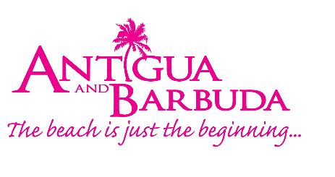
FOR IMMEDIATE RELEASE:

KIMOLISA MINGS WINS ANTIGUA AND BARBUDA TOURISM AUTHORITY ROMANCE WRITING CONTEST

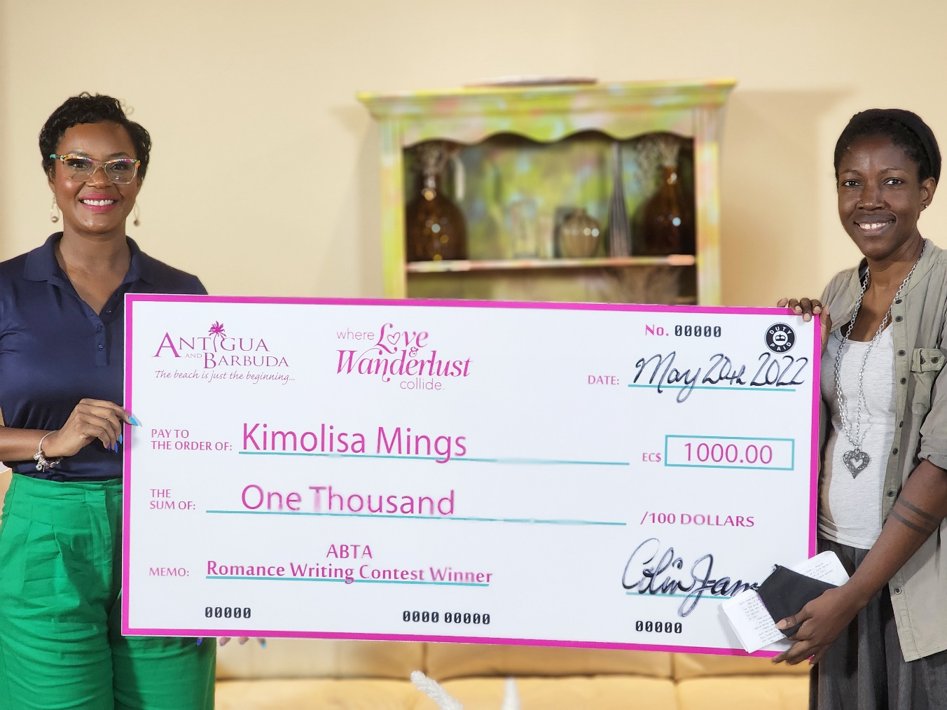

Photo Caption: Antigua and Barbuda Tourism Authority’s Romance Pillar Lead makes the presentation to Romance Writing Contest Winner, Kimolisa Mings (Photo courtesy: The Antigua and Barbuda Tourism Authority)

ST. JOHN’S, ANTIGUA (MAY 25, 2022) - The Antigua and Barbuda Tourism Authority has officially announced Kimolisa Mings, the winner of the local romance writing contest for her story entitled ‘Rule No. 3’. The contest was part of the ‘Love and Wanderlust’ Romance campaign that was launched by the Antigua and Barbuda Tourism Authority, on Valentine’s Day, as a way to involve local storytellers and writers in tourism, while offering Antigua and Barbuda’s writing talent an international platform for their work to be seen. The announcement comes days away from the start of Antigua and Barbuda Romance Month in June.

Mings wins EC$1000 as her prize. An elated Mings expressed appreciation to the Antigua and Barbuda Tourism Authority (ABTA) during the cheque presentation. "Thank you to the ABTA for this opportunity for us writers to showcase our abilities to the wider public. Hopefully similar initiatives will emerge for the talented creatives who call Antigua & Barbuda home."
Kimolisa Mings, who was born and currently lives in Antigua, writes contemporary fiction, primarily romance. According to her biography, “when she's not writing and generally living, she is watching too much shows on streaming services”. Three of her books are available locally at the bookstores ‘Best of Books’ and ‘Ten Pages’ and internationally through Amazon. She is currently working on a new novel.

Shermain Jeremy, lead on the organization's romance pillar initiative says, "The ABTA is dedicated to making tourism a community effort and this writing contest has allowed us to tap a very creative pool of local storytellers and writers whose talents we plan to weave into our romance messaging and stories".

Joelle Edwards’ ‘Take My Hand Darling’ and Travis Defreitas’ ‘Love Island’ placed 1st and 2nd runners-up respectively. The writers will receive free access to the Jhohadli Writing Project Workshop Series in June hosted by acclaimed Antiguan author Joanne Hillhouse. Hillhouse whose published work includes: The Jungle Outside, Musical Youth, Lost, The Boy from Willow Bend and Dancing Nude in the Moonlight has partnered with the ABTA to offer both runners-up the opportunity to expand their craft through her year-long writing series.

“I appreciate the opportunity given to writers in Antigua and Barbuda and the privilege of reading the entries. I would like to congratulate the winner Kimolisa Mings’ whose entry Rule No. 3 winningly frames love as the most daring adventure within a very tight and well-shaped rom-com, rich with pilot tension, character depth and chemistry, and a real sense of place”, said the consulting judge for the contest, Joanne Hillhouse.

The panel of judges included Joel Henry from the Authority’s UK office, Abena Merchant, Digital Platform Manager, Carolyn Punter, Marketing Officer in the New York Office and Donald Watkins of Watkins Multimedia in addition to Joanne Hillhouse.

Entries which received Honorable Mention were ‘Secret Paradise (Island)’ by Petranilla Estraeda-Jospeh and ‘The Viola Pan’ by Dr. Lester Simon.

Other entries included:
‘Finding Love in Silence’ by Hilesha Humphreys
‘Love Meets Paradise’ by Mene Lewis
‘It’s A Fairytale’ by Dalisha Spencer
‘My Love’ by Brenda Cochrane
‘A Letter to My Wife’ by Jeffrey Williams
‘Beneath the Tamarind Tree’ by Zemilia Ishana Lashanda Samuel
‘A Life Worth Living’ by Nicole Leyva

The Antigua and Barbuda Tourism Authority intends to create a short video of the winning entry for video and television as well as a romance booklet of all entries for circulation in all Antigua and Barbuda’s source markets to help promote the destination’s romance agenda.

For more information on romantic escapes to Antigua and Barbuda, visit: www.visitantiguabarbuda.com
###
ABOUT THE ANTIGUA AND BARBUDA TOURISM AUTHORITY
The Antigua & Barbuda Tourism Authority is a statutory body dedicated to realizing the tourism potential of Antigua & Barbuda by promoting the twin island state as a unique, quality tourist destination with the overall objective of increasing visitor arrivals thereby providing sustainable economic growth. The Antigua and Barbuda Tourism Authority is headquartered in St. John’s Antigua, where regional marketing is directed. The Authority has three offices overseas in the United Kingdom, United States and Canada.
ABOUT ANTIGUA AND BARBUDA
Antigua (pronounced An-tee'ga) and Barbuda (Bar-byew’da) is located in the heart of the Caribbean Sea. The twin-island paradise offers visitors two uniquely distinct experiences, ideal temperatures year-round, a rich history, vibrant culture, exhilarating excursions, award-winning resorts, mouth-watering cuisine and 365 stunning pink and white-sand beaches - one for every day of the year. The largest of the English-speaking Leeward Islands, Antigua comprises 108-square miles with rich history and spectacular topography that provides a variety of popular sightseeing opportunities. Nelson’s Dockyard, the only remaining example of a Georgian fort a listed UNESCO World Heritage site, is perhaps the most renowned landmark. Antigua’s tourism events calendar includes the prestigious Antigua Sailing Week, Antigua Classic Yacht Regatta, and the annual Antigua Carnival; known as the Caribbean’s Greatest Summer Festival. Barbuda, Antigua’s smaller sister island, is the ultimate celebrity hideaway. The island lies 27 miles north-east of Antigua and is just a 15-minute plane ride away. Barbuda is known for its untouched 11-mile stretch of pink sand beach and as the home of the largest Frigate Bird Sanctuary in the Western Hemisphere. Find information on Antigua & Barbuda at: www.visitantiguabarbuda.com or follow us on Twitter: http://twitter.com/antiguabarbuda Facebook: www.facebook.com/antiguabarbuda; Instagram: www.instagram.com/AntiguaandBarbuda

For Antigua and Barbuda media enquiries, please contact:
Maria Blackman
Marketing Communications Manager
Antigua and Barbuda Tourism Authority
T: 1 (268) 562 7600/464-7601
E: maria.blackman@visitaandb.com
Antigua and Barbuda Images: aandbtourism.fotoseeker.com

