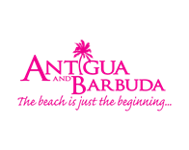
FOR IMMEDIATE RELEASE:
ANTIGUA AND BARBUDA RELEASES NEW ADVERTS FOR
‘YOUR SPACE IN THE SUN’ TOURISM CAMPAIGN
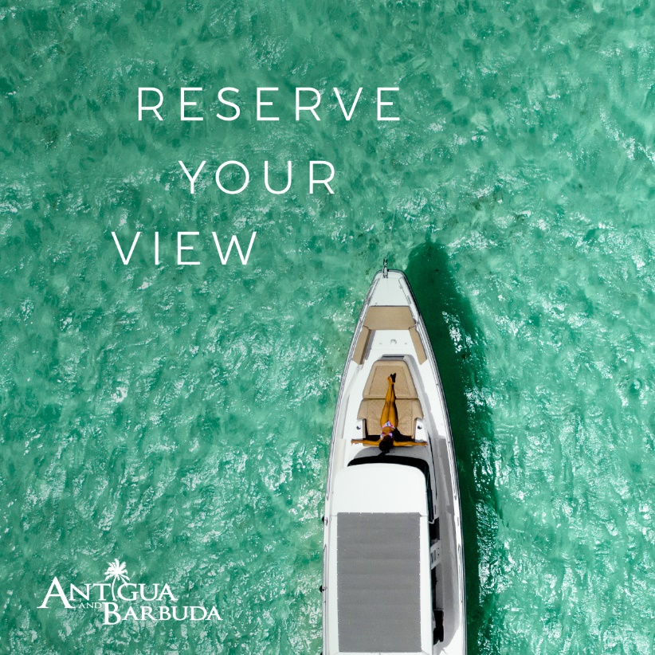

(ST. JOHN’S, ANTIGUA) July 14, 2021 - The Antigua and Barbuda Tourism Authority has intensified marketing efforts with the rollout of the next phase of Antigua and Barbuda’s 'Your Space In The Sun' campaign.

From July through to September, consumers in the United States and the United Kingdom will see Antigua and Barbuda advertising in-stadia, on radio – traditional, digital and streaming, in print – with advertising in major publications, through online programmatic and retargeting adverts and via strategic influencer social media campaigns.

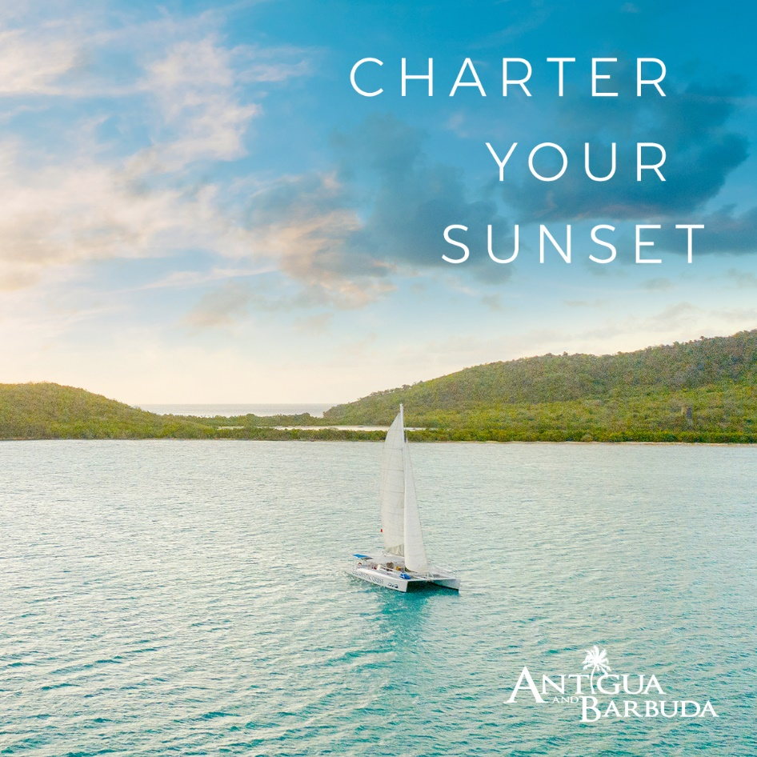
Building on the concept of the ‘Your Space In the Sun’ campaign launched in July 2020, new creatives have been designed to entice persons to book Antigua and Barbuda. The 2021 ‘Your Space In The Sun’ thirty and sixty second campaign videos feature stunning imagery and invitations to visitors to lose track of time, broaden their horizons and enjoy all the space they need in the destination.

This latest advertising push by the Antigua and Barbuda Tourism Authority, comes immediately following the relaxing of Covid-19 travel restrictions in the United States and United Kingdom, that have opened up travel to Antigua and Barbuda.

“We have seen a rapid increase in demand for Antigua and Barbuda from these regions and expect to have a busy summer season. Our focus now is to build on this momentum with enhanced marketing activity that will take us through to the Fall”, said CEO of the Antigua and Barbuda Tourism Authority, Colin C. James.

As more tourism markets for Antigua and Barbuda re-open with flights available to the destination, ‘Your Space In The Sun’ advertising will roll out in these locations.

###
ABOUT ANTIGUA AND BARBUDA
Antigua (pronounced An-tee'ga) and Barbuda (Bar-byew’da) is located in the heart of the Caribbean Sea. Voted the World Travel Awards 2015, 2016, 2017 and 2018 Caribbean’s Most Romantic Destination, the twin-island paradise offers visitors two uniquely distinct experiences, ideal temperatures year-round, a rich history, vibrant culture, exhilarating excursions, award-winning resorts, mouth-watering cuisine and 365 stunning pink and white-sand beaches - one for every day of the year. The largest of the Leeward Islands, Antigua comprises 108-square miles with rich history and spectacular topography that provides a variety of popular sightseeing opportunities. Nelson’s Dockyard, the only remaining example of a Georgian fort a listed UNESCO World Heritage site, is perhaps the most renowned landmark. Antigua’s tourism events calendar includes the prestigious Antigua Sailing Week, Antigua Classic Yacht Regatta, and the annual Antigua Carnival; known as the Caribbean’s Greatest Summer Festival. Barbuda, Antigua’s smaller sister island, is the ultimate celebrity hideaway. The island lies 27 miles north-east of Antigua and is just a 15-minute plane ride away. Barbuda is known for its untouched 17 mile stretch of pink sand beach and as the home of the largest Frigate Bird Sanctuary in the Western Hemisphere. Find information on Antigua & Barbuda at: www.visitantiguabarbuda.com
For media enquiries, please contact:
Maria Blackman
Antigua and Barbuda Tourism Authority
T: 1 (268) 562 7600/464-7601
E: maria.blackman@visitaandb.com

