FOR IMMEDIATE RELEASE:

NEW TOURISM EXPERIENCES OPEN UP AS VACCINATION RATES INCREASE IN ANTIGUA AND BARBUDA
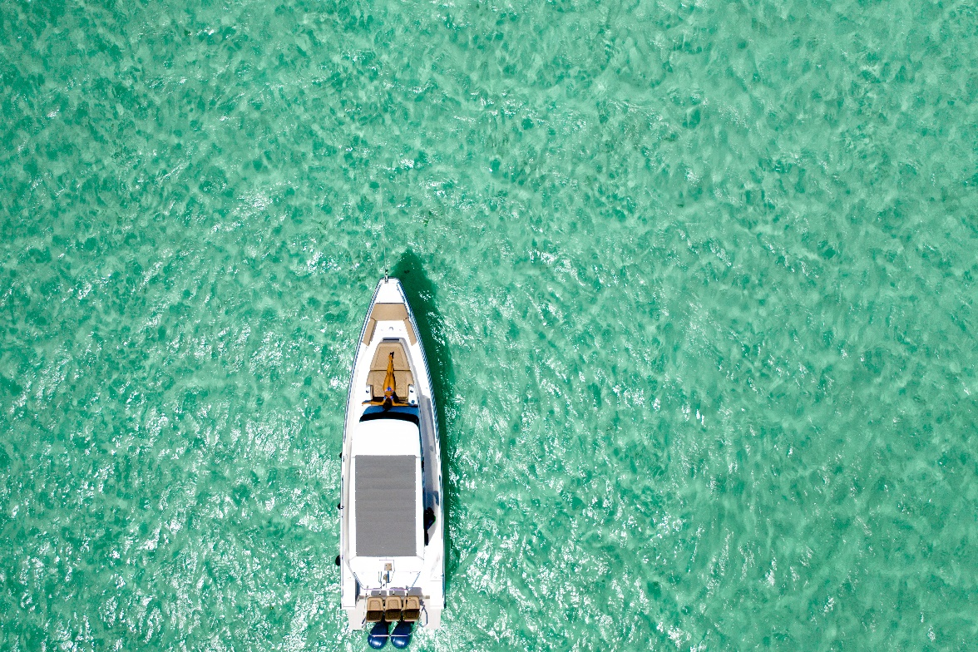
Photo Caption: With progress made in vaccination rates, covid-19 restrictions are being relaxed in Antigua and Barbuda (Photo in Barbuda, courtesy Antigua and Barbuda Tourism Authority)

(ST. JOHN’S, ANTIGUA) October 19, 2021 - The twin-island paradise of Antigua and Barbuda continues to be the perfect place for visitors seeking a well-needed vacation. With increased vaccination rates for Covid-19 in the country, on-island restrictions have been eased. This means visitors can look forward to enjoying some newly re-opened tourism experiences.

Plan your perfect day, on one of Antigua and Barbuda’s gorgeous beaches. The warm and crystal-clear waters are therapeutic, and there is lots of room for social distancing. New opening hours for all 365 beaches are from 5 a.m. – 7 p.m. daily, providing lots of time to unwind under flowing palm trees.

Water excursions are also now officially open, for those eager to leave the sun-kissed shores behind and jet-off on the water for an exhilarating adventure. Sail to Antigua’s sister-island Barbuda, for a visit to the Magnificent Frigatebird Sanctuary or drop anchor within reach of a deserted beach. Back in Antigua, enjoy relaxed kayaking, a circumnavigation cruise, snorkelling in clear, turquoise waters and the abundance of available water-based activities that stretch across the coastline. Land-based excursions continue to operate.

Following a short break, restaurant tables are now set for re-opened dine-in service. Fully vaccinated food aficionados can completely immerse themselves in Antigua and Barbuda’s rich, culinary experience in picturesque settings with extraordinary service.

Keen to take in the beauty of Antigua and Barbuda at night? With shortened curfew hours, visitors are welcomed to spend more time under the stars as businesses open late into the night. Present curfew hours are from 11 p.m. – 5 a.m.

Visitors should observe all covid-19 protocols during their stay and are encouraged to book only Covid-19 certified businesses such as restaurants and excursions during their trip.

Before travelling to Antigua and Barbuda, visitors should ensure that they have reviewed the Government of Antigua and Barbuda’s latest travel advisory.

All travellers, 18 years and older are now required to have received at least one dose of a World Health Organization (WHO) or Antigua and Barbuda Ministry of Health, Wellness, and the Environment (MOHWE) approved 2-dose Covid-19 vaccine or a single dose vaccine to be permitted entry into Antigua and Barbuda. All arriving passengers by air, ages 5 years and older, are also required to present a negative Covid- I9 RT-PCR taken within four (4) days of their flight.

For the full travel advisory, destination updates and details on covid-19 certified businesses, go to: www.visitantiguabarbuda.com

###

ABOUT THE ANTIGUA AND BARBUDA TOURISM AUTHORITY
The Antigua & Barbuda Tourism Authority is a statutory body dedicated to realizing the tourism potential of Antigua & Barbuda by promoting the twin island state as a unique, quality tourist destination with the overall objective of increasing visitor arrivals thereby providing sustainable economic growth. The Antigua and Barbuda Tourism Authority is headquartered in St. John’s Antigua, where regional marketing is directed. The Authority has three offices overseas in the United Kingdom, United States and Canada.
ABOUT ANTIGUA AND BARBUDA
Antigua (pronounced An-tee'ga) and Barbuda (Bar-byew’da) is located in the heart of the Caribbean Sea. Voted the World Travel Awards 2015, 2016, 2017 and 2018 Caribbean’s Most Romantic Destination, the twin-island paradise offers visitors two uniquely distinct experiences, ideal temperatures year-round, a rich history, vibrant culture, exhilarating excursions, award-winning resorts, mouth-watering cuisine and 365 stunning pink and white-sand beaches - one for every day of the year. The largest of the Leeward Islands, Antigua comprises 108-square miles with rich history and spectacular topography that provides a variety of popular sightseeing opportunities. Nelson’s Dockyard, the only remaining example of a Georgian fort a listed UNESCO World Heritage site, is perhaps the most renowned landmark. Antigua’s tourism events calendar includes the prestigious Antigua Sailing Week, Antigua Classic Yacht Regatta, and the annual Antigua Carnival; known as the Caribbean’s Greatest Summer Festival. Barbuda, Antigua’s smaller sister island, is the ultimate celebrity hideaway. The island lies 27 miles north-east of Antigua and is just a 15-minute plane ride away. Barbuda is known for its untouched 17 mile stretch of pink sand beach and as the home of the largest Frigate Bird Sanctuary in the Western Hemisphere. Find information on Antigua & Barbuda at: www.visitantiguabarbuda.com or follow us on Twitter. http://twitter.com/antiguabarbuda Facebook www.facebook.com/antiguabarbuda; Instagram: www.instagram.com/AntiguaandBarbuda

For Antigua and Barbuda media enquiries, please contact:
Maria Blackman
Antigua and Barbuda Tourism Authority
T: 1 (268) 562 7600/464-7601
E: maria.blackman@visitaandb.com

