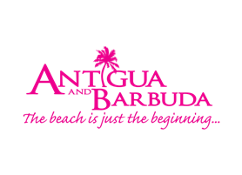

**FOR IMMEDIATE RELEASE:**

**THE RETURN OF ANTIGUA AND BARBUDA ANNUAL CELEBRITY DESTINATION WEDDING A SUCCESS**

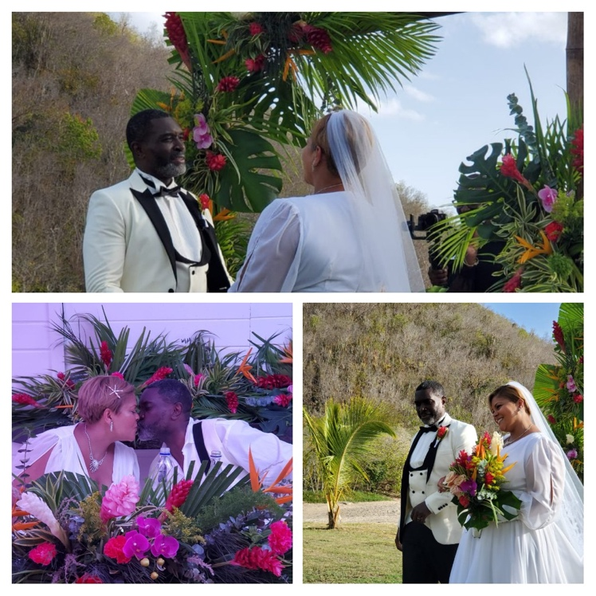

**Photo Caption:** Jeffery Redd and his new wife, Theresa O'Neal, tied the knot at the romantic Carlisle Bay Resort & Spa in Old Road

**June 27, 2022 (ST. JOHN’S, ANTIGUA) -** The Antigua and Barbuda Tourism Authority(ABTA) continued its month-long Romance Month activities with the highly anticipated annual celebrity destination wedding. This year, former 90's R&B crooner, Jeffery Redd and his new wife, Theresa O'Neal, PR guru to some of New York’s popular Broadway Shows, tied the knot at the romantic Carlisle Bay Resort & Spa in Old Road this past Saturday to a guest list of media, friends and family and ABTA supporters.

The blushing bride could be seen walking down the aisle in a custom-made couture bridal ensemble designed and created by local designer Noreen Phillips. This collaboration has since led to the designer now setting plans in place to launch her own bridal line.

Elena George, who has Antiguan and Barbudan roots and is a makeup artist to the stars including Robin Roberts, of ABC-TV’s *Good Morning America*, and Former First Lady, Michelle Obama, was the official makeup artist of the bride.

The enchanting beach wedding will be covered by *Ask Us Beauty Magazine* and by *World Bride Magazine,* whose Publisher and Editorial Director Myrdith Leon-McCormack was on-island to cover the festivities.

Abbott’s Jewelers were the presenting ring sponsors of the wedding and provided the couples wedding bands free of cost. Other local supporters included Creative Blush Floral Designs Sheena Samuel, and Sweet Dreams cakes by Danielle George-John.

The wedding ended with cocktails on the beach and a private bon-fire dinner. The celebrity destination wedding is a highlight of Antigua and Barbuda’s annual Romance Month in June and positioning the destination as a leader in romance.

Romance Month ends with a global webinar tomorrow June 28th, 2022.

###

**ABOUT THE ANTIGUA AND BARBUDA TOURISM AUTHORITY**

The Antigua & Barbuda Tourism Authority is a statutory body dedicated to realizing the tourism potential of Antigua & Barbuda by promoting the twin island state as a unique, quality tourist destination with the overall objective of increasing visitor arrivals thereby providing sustainable economic growth. The Antigua and Barbuda Tourism Authority is headquartered in St. John’s Antigua, where regional marketing is directed.  The Authority has three offices overseas in the United Kingdom, United States and Canada.

**ABOUT ANTIGUA AND BARBUDA**

Antigua (pronounced An-tee'ga) and Barbuda (Bar-byew’da) is located in the heart of the Caribbean Sea. The twin-island paradise offers visitors two uniquely distinct experiences, ideal temperatures year-round, a rich history, vibrant culture, exhilarating excursions, award-winning resorts, mouth-watering cuisine and 365 stunning pink and white-sand beaches - one for every day of the year. The largest of the English-speaking Leeward Islands, Antigua comprises 108-square miles with rich history and spectacular topography that provides a variety of popular sightseeing opportunities. Nelson’s Dockyard, the only remaining example of a Georgian fort a listed UNESCO World Heritage site, is perhaps the most renowned landmark. Antigua’s tourism events calendar includes the prestigious Antigua Sailing Week, Antigua Classic Yacht Regatta, and the annual Antigua Carnival; known as the Caribbean’s Greatest Summer Festival. Barbuda, Antigua’s smaller sister island, is the ultimate celebrity hideaway. The island lies 27 miles north-east of Antigua and is just a 15-minute plane ride away. Barbuda is known for its untouched 11-mile stretch of pink sand beach and as the home of the largest Frigate Bird Sanctuary in the Western Hemisphere.  Find information on Antigua & Barbuda at: [www.visitantiguabarbuda.com](http://www.visitantiguabarbuda.com) or follow us on **Twitter**: <http://twitter.com/antiguabarbuda>   **Facebook**: [www.facebook.com/antiguabarbuda](http://www.facebook.com/antiguabarbuda); **Instagram**: [www.instagram.com/AntiguaandBarbuda](http://www.instagram.com/AntiguaandBarbuda)

**For Antigua and Barbuda media enquiries, please contact:**

Maria Blackman

Marketing Communications Manager

Antigua and Barbuda Tourism Authority

T: 1 (268) 562 7600/464-7601

E: maria.blackman@visitaandb.com

**Antigua and Barbuda Images:** aandbtourism.fotoseeker.com