THIS IS WHAT COOL LOOKS LIKE
The Antigua and Barbuda Tourism Authority Celebrates
Summer Campaign in London with Ice Cream Delivery
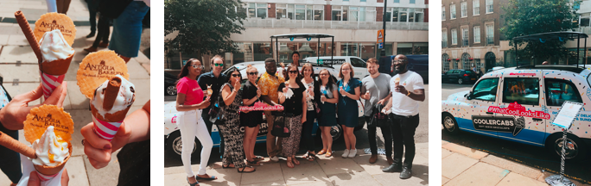

Friday 5 July, London: On a scorching summer’s day in London, the Antigua and Barbuda Tourism Authority brought a dose of Caribbean cool with an ice cream delivery to the city’s top trade and media spots.

Celebrating the #WhatCoolLooksLike campaign, the leaders of the UK’s trade and media industry were tempted from their desks for a refreshing snack and to learn about the island’s summer messaging.

Starting at the Travel Weekly offices in Victoria, the trade media were out in full force for a midday pick-me-up. The cool-cab then made its way to London’s Vogue House, home to Conde Nast titles Tatler, GQ and CN Traveller. The last stop for the day was at the Virgin Atlantic and Virgin Holidays offices.

A welcome treat on what turned out to be one of the hottest days of the year, the travel industry indulged in vanilla ice-cream drizzled with salted caramel and passionfruit and topped with an Antigua and Barbuda branded wafer, all served from the roof of a traditional London taxi cab. And leaving with branded goodie bags packed with sunglasses and reusable water bottles, the ice-cream and Antigua’s summer campaign is sure to leave a lasting taste.

Notes to editors
Antigua and Barbuda
Antigua (pronounced An-tee'ga) and Barbuda (Bar-byew’da) is located in the heart of the Caribbean Sea. The largest of the Leeward Islands, Antigua & Barbuda comprises 108-square miles. The 365 white and pink sand beaches, one for every day of the year, are just the beginning of the treasures that await visitors.
Antigua’s rich history and spectacular topography provide a variety of popular sightseeing opportunities. Nelson’s Dockyard, the only remaining example of a Georgian fort commissioned by the British in 1755, is perhaps the most renowned landmark. Betty’s Hope, built in 1674, is the site of one of the first full-scale sugar plantations on Antigua, and offers a chance to step back into time by visiting the restored mills.
Another unique attraction is Devil’s Bridge, located at the eastern tip of the island in Indian Town National Park, where Atlantic breakers have carved out a natural limestone arch. Antigua boasts a varied tourism calendar including events such as the World Class Antigua Sailing Week, Classic Yacht Regatta, Antigua Sports Fishing and also the annual Carnival; known as the Caribbean’s Greatest Summer Festival.
Island accommodation ranges from luxury resorts and all-inclusive hotels to smaller more intimate boutique guesthouses and cottages.

