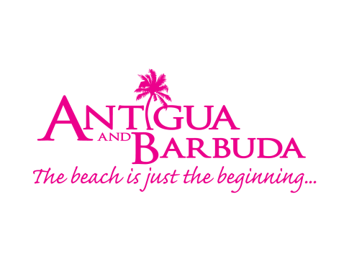

**FOR IMMEDIATE RELEASE**

**Antigua and Barbuda Celebrates World Wellness Weekend with an Exciting Lineup of Wellness Activities**

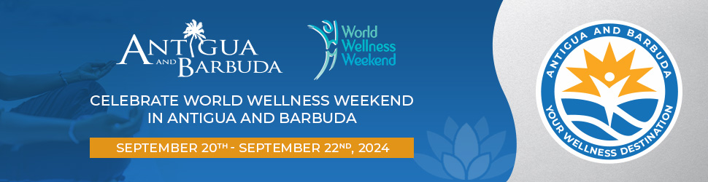

*(Antigua, September 16, 2024)* – In celebration of World Wellness Weekend, The Antigua and Barbuda Tourism Authority is inviting visitors and locals alike to embrace health, well-being, and mindful living with a series of exciting wellness-focused activities from **September 20th to 22nd.** Whether you are looking to relax, energize, or rejuvenate, the destination’s wellness marketing team along with various wellness and tourism stakeholders, have curated a weekend of events designed to uplift the body, mind, and spirit.

The 8th World Wellness Weekend, celebrated globally by 9,000 wellness professionals in 160 countries, encourages individuals to adopt a healthier lifestyle, practice mindfulness, and connect with nature. As part of our commitment to promoting well-being and sustainability, Antigua and Barbuda is proud to offer an array of fun and free activities that cater to all ages, interests, and fitness levels.

**Featured Activities**

***Date:* September 20th**

***Time:***9:00 - 11:00 a.m.

***Event:* Tree Planting with the Environmental Division at the Christian Agricultural Centre.**

***Description:***The Antigua and Barbuda Tourism Authority partners with the Environmental Division to plant 365 trees at the islands Agricultural Centre, Christian Valley.

***Date:* September 21st**

***Time:***5:00 a.m.

***Event:* Road Hike from Cedar Grove Playing Field and back via Sid's Road, Jabberwock main road, Country Club Road and Matthias Road. The hike is expected to last 1-2 hours.**

***Description:***The entire island is invited to this fitness walk participants follow the designated route safely, while navigating varying terrains such as sidewalks, shoulders, or marked pedestrian lanes. These walks promote fitness, community engagement, or awareness for a cause, with participants of all fitness levels.

***Time:***8:00 a.m.

***Event:* Kickboxing with member of Team Antigua Island Girls Kevinia Francis followed by Mindful Meditation with Keisha Schahaff our very own Astronaut. Transportation will be available to return participants to their vehicles after the session. Please bring water or a reusable bottle to refill.**

***Description:***Fun Fitness event where attendees learn kickboxing techniques, improve cardiovascular conditioning, all while moving to the sweet sounds of soca music. Mindful meditation involves paying attention to your thoughts, feelings, and physical sensations as they arise, often using techniques like deep breathing.

***Time:***12:00 p.m.

***Event:* Tricia Greenaway, the destination's World Wellness Weekend Ambassador, will host a Spa Day with the girls at The Sunshine Home for Girls charity.**

***Time:***2:00 p.m. - 6:00 p.m.

***Event:* Family Fun Day at the John E. St. Luce Financial & Conference Centre. This free event will feature games, activities, entertainment, and educational talks for the general public.**

***Description:***This free event will feature games and activities for the youth and provide them a safe environment to play. The evening will also showcase the talent of young Antiguans and Barbudans to include music, song, poetry, and dance and will end with an interactive session for the general public as they are reminded how to healthily communicate their feelings and manage conflict. Donations will be accepted at this event from attendees to benefit the Sunshine Home for Girls, a local charity with a holistic program that assists girls in reaching their full potential through building self-worth and empowerment.

***Date:* September 22nd**

***Time:***4:00 p.m.

***Event*: Art and Paint with the Sunshine Home for Girls at Turners Beach Bar.**

Gerron Farquharson will be the artist instructor. Art supplies and refreshments will be provided.

**Our Sister Island Barbuda will be celebrating World Wellness Weekend with the activities below:**

***Date****:* **September 20th**

**Time**:10:00 a.m. - 2:00 p.m.

**Free Health Screening & Nutrition Talk**

*Venue:* Barbuda Community Wellness Center, Ginnery Street

***Time:*** 4:30 p.m. - 6:30 p.m.

***‘*Fitness Fusion’ A combination of Exercise and Endurance**

*Venue:* Holy Trinity School Ground

**Date*:* September 21st**

**Time:** 6:00 a.m.

**Community & Coastal clean-up, beautification, and tree planting**

**Date *:* September 21st**

**Time:** 6:00 p.m

**'Movie on the Lawn' - Gates open at 6:00 p.m and movie starts at 7:00 p.m. Bring your entire family, friends, and neighbors, bring your snacks, water, healthy drinks, and be entertained.**

***Venue:***Fisheries Complex

**Date*:* September 22nd**

**We invite you to join us for special services at your local churches, dedicated to fostering wellness both spiritually and physically. Come be a part of this uplifting experience as we grow together in faith and health!**

"As a leading destination of wellness in the Caribbean, we are thrilled to sponsor World Wellness Weekend 2024. Our participation showcases some of the best of what Antigua and Barbuda has to offer for physical, mental, spiritual, and emotional well-being," said, Tameka Wharton, Wellness Pillar Marketing Lead, "We invite everyone to join us for a weekend of self-care, fun, and rejuvenating experiences in safe, and uplifting settings."

**Participation**

Activities are free and open to the public. For more details, please visit www.visitantiguabarbuda.com

Telephone: 1(268) 562-7600 Email: info@visitaandb.com

Celebrate wellness with The Antigua and Barbuda Tourism Authority this World Wellness Weekend.

**###**

***ABOUT ANTIGUA AND BARBUDA***

*Antigua (pronounced An-tee'ga) and Barbuda (Bar-byew’da) is located in the heart of the Caribbean Sea. The twin-island paradise offers visitors two uniquely distinct experiences, ideal temperatures year-round, a rich history, vibrant culture, exhilarating excursions, award-winning resorts, mouth-watering cuisine and 365 stunning pink and white-sand beaches - one for every day of the year. The largest of the English-speaking Leeward Islands, Antigua comprises 108-square miles with rich history and spectacular topography that provides a variety of popular sightseeing opportunities. Nelson’s Dockyard, the only remaining example of a Georgian fort a listed UNESCO World Heritage site, is perhaps the most renowned landmark. Antigua’s tourism events calendar includes the Antigua and Barbuda Wellness Month, Run in Paradise, prestigious Antigua Sailing Week, Antigua Classic Yacht Regatta, Antigua and Barbuda Restaurant Week, Antigua and Barbuda Art Week and the annual Antigua Carnival; known as the Caribbean’s Greatest Summer Festival. Barbuda, Antigua’s smaller sister island, is the ultimate celebrity hideaway. The island lies 27 miles north-east of Antigua and is just a 15-minute plane ride away. Barbuda is known for its untouched 11-mile stretch of pink sand beach and as the home of the largest Frigate Bird Sanctuary in the Western Hemisphere. Find information on Antigua & Barbuda at:*[*www.visitantiguabarbuda.com*](http://www.visitantiguabarbuda.com)*or follow us* on **Twitter**: <http://twitter.com/antiguabarbuda>   **Facebook**: [www.facebook.com/antiguabarbuda](http://www.facebook.com/antiguabarbuda); **Instagram**: [www.instagram.com/AntiguaandBarbuda](http://www.instagram.com/AntiguaandBarbuda)